CE 3372 Water Systems Design

Exercise Set #5

Three problems using USEPA-NET modeling program. Each problem is a network of successive complexity introducing a different hydraulic component. The problems should be solved in order so the first problem is a framework for the second and so on.

1. Compute the discharge in each pipe and the pressure at each junction node for the
8-pipe system shown in Figure 1. The water surface elevation in the storage tank is
315.0 ft. Prepare your solution using EPA-NET. Report your results in U.S. Customary
units.
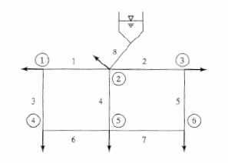
Figure 1. Problem 1 Network Layout

The pipe and demand data are as supplied in the problem statement. The next several pages are an annotated output report and a screen capture to illustrate a successful model.

This particular problem explores a simple network with nodal demands (in GPM converted to CFS for the program) and a single supply reservoir.

### HEADER REMOVED FOR BREVITY ###
Input File: exercise005-1-1.net
Link - Node Table:
----------------------------------------------------------------------
Link Start End Length Diameter
ID Node Node ft in
----------------------------------------------------------------------
1 2 3 4000 10
2 3 4 6000 10
3 2 5 6000 12
4 3 6 6500 24
5 4 7 7000 10
6 5 6 3000 18
7 6 7 5000 10
8 9 3 300 12
Node Results:
----------------------------------------------------------------------
Node Demand Head Pressure Quality
ID CFS ft psi
----------------------------------------------------------------------
2 1.11 284.88 49.78 0.00
3 1.11 292.57 48.77 0.00
4 1.11 258.00 40.29 0.00
5 3.33 284.86 56.27 0.00 <<< demand at a node
6 2.22 286.92 59.33 0.00
7 3.33 249.00 45.06 0.00
9 -12.21 315.00 58.50 0.00 Tank

Link Results:
----------------------------------------------------------------------
Link Flow VelocityUnit Headloss Status
ID CFS fps ft/Kft
----------------------------------------------------------------------
1 -1.18 2.15 1.92 Open
2 2.06 3.79 5.76 Open
3 0.07 0.08 0.00 Open
4 7.86 2.50 0.87 Open
5 0.95 1.75 1.29 Open
6 -3.26 1.85 0.69 Open
7 2.38 4.36 7.58 Open
8 12.21 15.55 74.78 Open <<< flow from reservoir IN

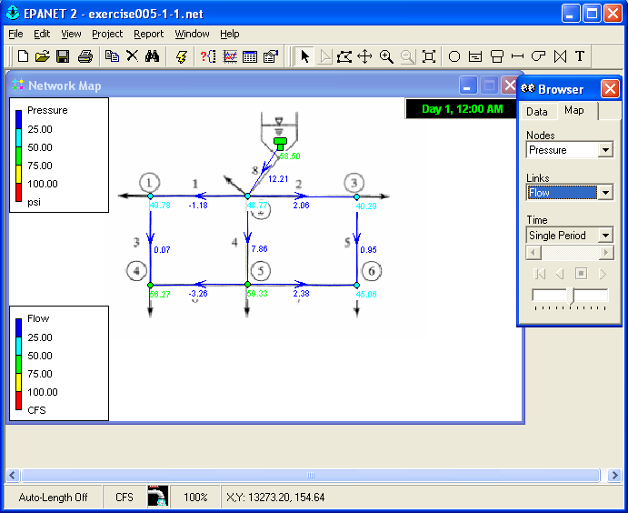
Figure 2. Problem 1 screen capture. Node values are pressure in PSI, link values are flows in CFS.

2. The pipe network in problem 1 is expanded to a 14-pipe system and includes a ground level reservoir near junction node 4 as depicted in Figure 2. A pump is installed in an 18-inch diameter pipe extending 500 feet from the ground-level reservoir (WSE = 155 ft.) to junction node 4. A booster pump pushes water into the network; three points on the pump curve are listed below. Compute the flow in each line and the pressure at each junction node. Report your results in U.S. Customary units.

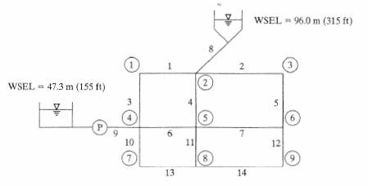
Figure 3. Problem 2 network topology
The pipe and demand data are as supplied in the problem statement. The input data are repeated in the annotated modeling report. A screen capture is included to illustrate a successful model run.

This problem extends the previous problem, introduces a second reservoir with water boosted into the system by a pump. It requires the creation of a pump curve in EPA-NET.

###HEADER REMOVED ###
Input File: exercise005-2-1.net
Link - Node Table:
----------------------------------------------------------------------
Link Start End Length Diameter
ID Node Node ft in
----------------------------------------------------------------------
1 2 3 4000 10
2 3 4 6000 10
3 2 5 6000 12
4 3 6 6500 24
5 4 7 7000 10
6 5 6 3000 18
7 6 7 5000 10
8 9 3 300 12
9 12 5 500 18
10 5 8 4000 10
11 6 10 4000 24
12 7 11 4000 12
13 8 10 3000 8
14 10 11 5000 12
15 1 12 #N/A #N/A Pump

Node Results:
----------------------------------------------------------------------
Node Demand Head Pressure Quality
ID CFS ft psi
----------------------------------------------------------------------
2 1.11 311.58 61.35 0.00
3 1.11 311.30 56.89 0.00
4 1.11 292.89 55.42 0.00
5 3.33 317.21 70.29 0.00
6 2.22 310.67 69.62 0.00
7 3.33 291.30 63.39 0.00

----------------------------------------------------------------------
Node Demand Head Pressure Quality
ID CFS ft psi
----------------------------------------------------------------------
8 1.11 309.55 62.63 0.00
10 2.22 309.47 60.43 0.00
11 1.11 294.75 56.22 0.00
12 0.00 321.41 139.27 0.00 << HIGH PRESSURE
1 -11.73 155.00 0.00 0.00 Reservoir
9 -4.92 315.00 58.50 0.00 Tank

Link Results:
----------------------------------------------------------------------
Link Flow VelocityUnit Headloss Status
ID CFS fps ft/Kft
----------------------------------------------------------------------
1 0.20 0.38 0.07 Open
2 1.50 2.74 3.07 Open
3 -1.31 1.67 0.94 Open
4 2.52 0.80 0.10 Open
5 0.39 0.71 0.23 Open
6 5.92 3.35 2.18 Open
7 1.69 3.09 3.87 Open
8 4.92 6.26 12.34 Open
9 11.73 6.64 8.39 Open << HIGH Q and V
10 1.17 2.15 1.92 Open
11 4.53 1.44 0.30 Open
12 -1.26 1.60 0.86 Open
13 0.06 0.18 0.03 Open
14 2.37 3.02 2.94 Open
15 11.73 0.00 -166.41 Open Pump

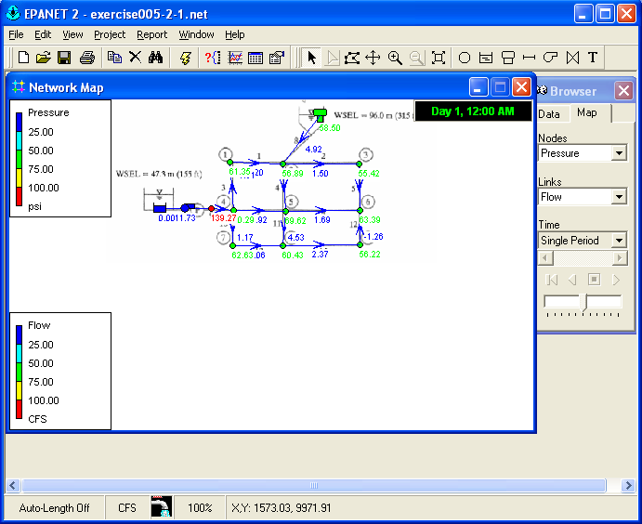
Figure 4. Problem 2 screen capture. Values at nodes are pressures in PSI, values at links are flow in CFS.

3. The pipe network in problem 2 is expanded to a 24-pipe system depicted in Figure 3. The water levels in the two elevated storage tanks are 315 ft. The water levels in the two ground-level reservoirs are 155 ft. The pump characteristics for the new pump in line 17 are the same as the existing pump in line 9. Compute the flow in each line and the pressure at each junction node. Report your results in U.S. Customary units.
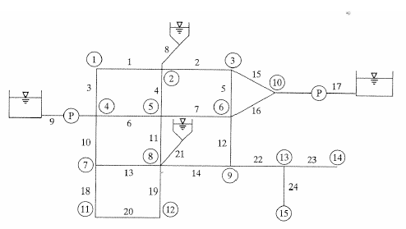
Figure 5. Problem 3 pipe network topology
The pipe and demand data are as supplied in the problem statement. The input data are repeated in the annotated modeling report. A screen capture is included to illustrate a successful model run.

This problem adds tanks and another pump. Pump link direction is important. A second pump curve is entered as is storage tank information. In this example the tanks are taken as static water sources; in practical models, we would also specify volume/depth information for computing fill/drain behavior in an extended period simulation (the subject of project 1).

####HEADER REMOVED FOR BREVITY #####
Input File: exercise005-3-A.net
Link - Node Table:
----------------------------------------------------------------------
Link Start End Length Diameter
ID Node Node ft in
----------------------------------------------------------------------
1 2 3 4000 10
2 3 4 6000 10
3 2 5 6000 12
4 3 6 6500 24
5 4 7 7000 10
6 5 6 3000 18
7 6 7 5000 10
8 9 3 300 12
9 12 5 500 18
10 5 8 4000 10
11 6 10 4000 24
12 7 11 4000 12
13 8 10 3000 8
14 10 11 5000 12
16 4 13 6000 18
17 7 13 6000 18
18 13 19 500 24
19 8 14 5000 12
20 10 15 5000 12
21 14 15 3000 10
22 22 10 300 12
23 11 16 3000 12
24 16 17 3000 12
25 16 18 1000 6
15 1 12 #N/A #N/A Pump
26 20 19 #N/A #N/A Pump
Node Results:
----------------------------------------------------------------------
Node Demand Head Pressure Quality
ID CFS ft psi
----------------------------------------------------------------------
2 1.11 314.77 62.73 0.00
3 1.11 314.65 58.34 0.00
4 1.11 322.61 68.29 0.00
5 3.33 319.81 71.41 0.00
6 2.22 314.42 71.24 0.00
7 3.33 308.15 70.69 0.00
8 1.11 309.53 62.63 0.00
10 2.22 313.62 62.23 0.00
11 1.11 297.89 57.58 0.00
12 0.00 323.70 140.26 0.00 << high pressure at left pump
13 2.22 326.82 65.79 0.00
14 1.11 307.72 57.51 0.00
15 1.11 308.18 55.54 0.00
16 0.00 278.39 51.30 0.00
17 3.33 261.19 48.18 0.00
18 0.22 277.35 50.85 0.00
19 0.00 327.38 66.02 0.00
1 -11.29 155.00 0.00 0.00 Reservoir
20 -8.90 155.00 0.00 0.00 Reservoir
9 -1.48 315.00 58.50 0.00 Tank
22 -2.97 315.00 58.50 0.00 Tank

Link Results:
----------------------------------------------------------------------
Link Flow VelocityUnit Headloss Status
ID CFS fps ft/Kft
----------------------------------------------------------------------
1 0.13 0.24 0.03 Open
2 -0.97 1.78 1.33 Open
3 -1.24 1.58 0.84 Open
4 1.47 0.47 0.04 Open
5 1.22 2.24 2.07 Open
6 5.36 3.03 1.80 Open
7 0.94 1.73 1.25 Open
8 1.48 1.88 1.17 Open
9 11.29 6.39 7.78 Open <<high Q and V at left pump
10 1.37 2.50 2.57 Open
11 3.66 1.17 0.20 Open
12 2.21 2.81 2.57 Open
13 -0.54 1.56 1.36 Open
14 2.45 3.12 3.15 Open
16 -3.30 1.87 0.70 Open
17 -3.38 1.91 3.11 Open
18 -8.90 2.83 1.11 Open
19 0.80 1.02 0.36 Open
20 1.42 1.81 1.09 Open
21 -0.31 0.57 0.15 Open
22 2.97 3.79 4.59 Open
23 3.55 4.52 6.50 Open
24 3.33 4.24 5.73 Open
25 0.22 1.12 1.04 Open
15 11.29 0.00 -168.70 Open Pump
26 8.90 0.00 -172.38 Open Pump

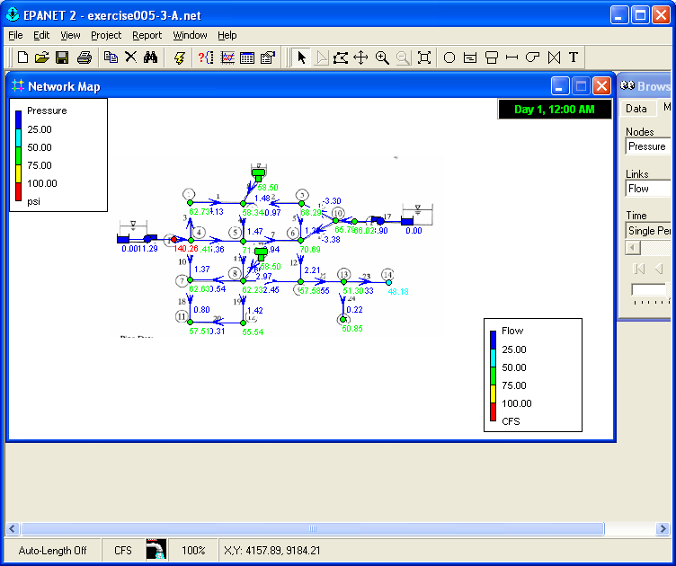
Figure 6. Exercise 3 screen capture. Node values are pressure in PSI; Link values are flow in CFS.

