The Fate of Electro-catalyst in Regenerative Polymer
Electrolyte Membrane Fuel Cell Systems

Executive summary

Currently the highest density fuel cells use a solid polymer electrolyte as a proton exchange media. The use of these polymer membranes in a regenerative system has been established, however degradation of the performance over time is observed. Deterioration of the materials used to support the catalyst in the gas diffusion electrodes and the subsequent removal of these catalyst, from the electrodes, are characterized in this report. The effects on a regenerative system and the final location of the catalyst are the focus of this research.
A simple system comprised of a proton exchange membrane fuel cell (PEMFC), a proton exchange membrane water electrolyzer (PEMWE), hydride storage system, and photovoltaic cell is used in proof of principle and performance degradation studies. The analysis includes energy density plots for the PEMFC and PEMWE, including current density and cyclic voltammetry plots. The PEMWE product gas was analyzed for qualitative hydrogen and oxygen production using a Hewlett Packard 6890 series gas chromatography. Analysis of the product water from the PEMFC is crucial since it represents the transport mechanism in the system. PEMFC product water was probed for metal content and any organic leachates from the carbon substrates typically used for the PEMFC test fixture. A Perkin-Elmer inductively coupled plasma mass spectrophotometer (ICP-MS 6000) was used for metal analysis. A Shimadzu TOC-5050A total organic carbon meter was used for the carbon content measurements. The completion of the analysis includes pH and dissolved oxygen measurements.
Introduction
In order to meet legislation mandated by California to have Zero Emission Vehicles (ZEV’s) on the road, by the year 2000, car manufactures can feasibly utilize batteries, fuel cells, or hybrid power sources. As a parallel to the automotive energy crisis facing the global economy due to the shortage of fossil fuels, the development of the “soft path” residential power production will also usher in the regenerative fuel cell / battery systems for home power production. Regenerative systems have the highest energy density production capabilities and are expected to dominate the power generation systems of the next century. The focus of this developing power system is the type and amount of electro-catalyst used for the reactions that produce electric current.
Batteries are energy storage devices, which have fixed and relatively constant energy densities and variable power densities¹. Advanced battery systems have the unique challenge of enhancing energy densities to compete with internal combustion engines in increasing vehicle range. Fuel cells, in contrast, are similar to the internal combustion engines having relatively constant power densities and variable energy densities.
The PEMFC is an ion exchange membrane (perflourinated sulfonic acid polymer or similar polymer) which is an excellent proton conductor. The only liquid in this fuel cell is water thus corrosion problems are minimal. Hydration and thermal management of the membrane is critical for efficient performance; the fuel cell must operate under conditions where the byproduct water evaporation rate is slower than the production rate. The hydration limitations of the polymer in the fuel cell also affect the operation temperature, usually less than 120 C, and a hydrogen rich gas with little or no carbon monoxides used in conjunction with higher Platinum loadings for the anode and cathode electrodes. The composition and control of water in the PEMFC and subsequently the regenerative system is the focus of this paper.
The principle investigation is the composition of the product water and intensity of the contaminants present. The performance of the PEMFC and PEMWE will be significantly impacted by the water constituents. Furfal based resins are impregnated into the carbon blocks of the fuel cell test fixture to halt gas diffusion out of the fuel cell system. Leaching of these resins into the aqueous phase of the system is a potential source of catalyst poisoning and a possible carbon substrate for microbial growth. Analysis of fuel cell performance by current density and cyclic voltammetery will be the basis of the PEMFC and PEMWE efficiency. The amount and presence of impurities, either from the carbon blocks or the gas diffusion electrodes, will be measured by an ICP-MS and TOC analyzer.

Proton Exchange Membrane Fuel Cell Experimental

PEMFC’s were prepared and tested for this investigation. The electrodes were provided by GlobeTech, Inc. (Bryan, TX) with a 20% Pt/C and a loading of 0.4 mg/cm². Nafion® 1135 membranes (DuPont de Neimours, Fayetteville, PA) were used as the proton conducting membrane. The fuel cell test fixtures were provided by GlobeTech, Inc. including the resin impregnated graphite blocks (AXF-5Q from POCO Graphite Inc., Decatur, TX). A series parallel flow pattern was machined into the graphite blocks for reactant distribution. The membranes and electrode require treatment prior to the assembly. The same type of fixture was used for the PEMWE, however the reactant flow field was filled with water, which was recycled, on the cathodic side of the reaction. The following section describes the preparation of the membrane material, gas diffusion electrodes, and the assembly of the fuel cell.

Preparation of the membrane

The preparation of the membrane material requires pretreatment for organic and metallic contaminant removal.
  - Rinse the membrane in purified water (~18 mOhm);
  - boil the membrane in 1 liter of 3% USP hydrogen peroxide for a period of at least 1 hour;
  - remove and boil membrane in purified water bath for a period of 30 minutes, repeat this step twice;
  - remove the membrane and transfer it to 1 liter of 10-15% nitric acid solution (by volume) and boil for 1 hour;
  - remove membrane material and rinse in purified water bath for a period of 30 minutes, repeat this step twice;
  - Store treated membrane material in purified water until usage.
The gas diffusion electrodes from GlobeTech, Inc., with low platinum loading (0.4 mg/cm² Pt), require the impregnation of Nafion® to maximize the platinum electro-catalyst utilization of the carbon supported in the electrodes. The pretreatment of the electrode is as follows:
  - Place carbon electrode in oven for 30 minutes at 70°C to remove moisture;
  - measure and record the dry weight of the electrodes;
  - impregnate DuPont Nafion solution (5% wt Nafion) into electrodes -optimum dry weight of Nafion 0.6 mg/cm²;
  - place carbon electrodes in oven for 1 hour at 100°C to remove moisture and organic solvent residue;
  - measure and record the final weight of the electrodes; the dry weight should be approximately 0.6mg/cm² ±0.1mg/cm².
The preparation of the membrane and electrode (MEA) requires hot pressing at 145°C. Using two aluminum plates, Teflon coated gaskets, and Teflon sheets to hold the MEA together prior to pressing, the electrode are aligned onto the membrane. The assembly is placed into the hot press and heated from 100°C to 150°C, in 5°C increments, and hot-pressed at 3000 psi for a period of 90 seconds.

Assembly of the fuel cell test fixture

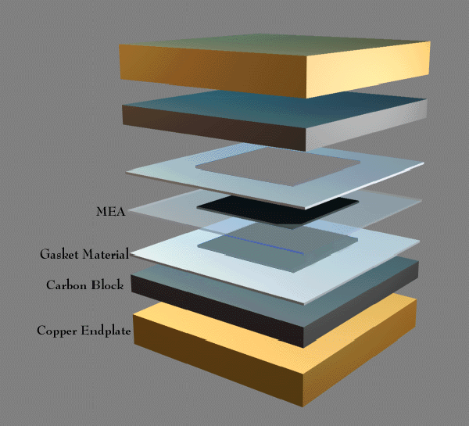 The MEA is confined between two graphite plates with series parallel flow channels for the reactant distribution. Silicon based gasket material, approximately 15 mils thick, are placed between the exposed border area of the membrane and the electrodes to prevent gas leakage and excess compression of the electrodes. Please See Figure 1.
Figure 1. Single Cell Test Fixture

Installation of Single cell in Fuel Cell Test Station and performance evaluation

The fuel cell test fixture is installed in the fuel cell test station, equipped with reactant temperature controllers, back pressure regulators, mass flow controllers, electronic load system, and computer data acquisition system. FuelCell Software® 1.4h, and Microsoft Excel® are used for data acquisition. The single cell test fixture is connected to anode and cathode sense leads, reactants, back- pressure regulators, and the electronic load respectively. Please See Figure 2.
The fuel cell is conditioned using hydrogen and oxygen as reactants at 50°C and atmospheric pressure, with a voltage of 0.6 volts for a period of 24 hours. The reactant gas humidifiers are maintained at a temperature at least 10°C above the cell temperature, for the anode, and 5°C for the cathode. The purity of the fuel used is 99.98% for all gases. The water used in the humidification bottles is pre-purified (18 mOhm) by a U.S. Filters Millipore water purification system.
Figure 2. Fuel Cell Test Station

Polarization Curves

The energy density plots, commonly called polarization curves, are plots of the fuel cell potential (E) in volts vs. the current density(i/cm²) in amperes. The polarization curves are obtained using a personal computer and the fuel cell test station. The gas flow rate is set for a minimum flow of 75cc, system parameter, and had a load based flow rate of 7cc per an ampere. The cathode maintained a flow rate of 100cc with a load based flow of 5cc per ampere. The stochiometery was held constant at these levels throughout the experiments. Table 1 lists the different experimental parameters.

Active Electrode Surface Area | Electrodes and Loading | Proton Exchange Membrane | Reactant Gas State | Anode Temperature | Cathode Temperature | Fuel Cell Temperature
5 cm² | E-Tek  0.4 mg/cm²  5% Nafion  0.6 - 0.7 mg/cm² | Nafion®  1135 | External Humid-ification | 90°C, 3 bar | 85°C, 3 bar | 70°C
 |  |  |  | 90°C, 1 bar | 90°C, 1 bar | 70°C
 |  |  |  | 70°C, 3 bar | 65°C, 3 bar | 50°C
 |  |  |  | 70 C, 1 bar | 65 C, 1 bar | 50 C
 |  |  |  | 70 C, 0 bar | 65 C, 0 bar | 50 C
Table 1. Fuel Cell Experimental Parameters
Several empirical models have been developed to explain the behavior of the PEMFC’s in the activation controlled, ohmic , and mass transport regions. The accepted relationship of the cell potential to current density in these regions for a PEMFC are modeled by the equation¹⁰:

E=E₀ – b log i – R i (1)
where
E₀ = E_{r} – b log i₀ (2)

E_{r} is the reversible potential for the fuel cell; b is the Tafel slope for the oxygen reduction region and i₀ is the exchange current density for the oxygen reduction reaction. R represents the resistance which results in a linear variation of E with i. The resistance is predominantly ohmic and electronic but there is a small contribution due to charge transfer resistance of the hydrogen electrode reaction. Since equation (1) does not cover the entire region of the E versus i plot, a more complete analytical equation was used which accounts for the departure from linearity due to mass transport limitations. It has been shown that a 5 parameter equation:
E=E₀ – b log i – Ri - m exp. (ni) (3)
fits experimental data to a high degree of precision over the entire E vs. i plot²³. The correlation between parameters of equation (1) and (3) can be demonstrated by the linearization of the exponential term in equation (3), reducing to:
E=(E₀ – m) - b log i – (R + mn)i (4)
then the coefficient of the parameters can be compared as:

1. E_{eq1} = E_{eq3} - m
2. B_{eq 1} = b_{eq 3}
3. R_{eq 1} = R_{eq 3} + mn

Since the values of m and n are positive, E_{eq 3} will be higher, R_{eq 3} will be lower and the Tafel slope (b) remains the same compared to the parameter values in equation (1). The term exp.(ni) models the higher current density region, where the E vs. i plot departs from linearity. Behavior in this region is mainly due to mass transport overpotential, primarily in the electrodes, however in some cases it will be due to mass transport problems resulting from protons and water molecules in the membrane. Please see Graph 1. Cell potential vs. current density plot for a typical PEMFC illustrating the predominantly activation, ohmic, and mass transport controlled regions. Graphs 2, 3, and 4 are experimental results that reflect the expected behavior of Nafion® Membrane. Although the results exemplify a n extended linear region of ohmic losses.

Graph 1. Typical PEMFC Performance

Activation Overpotential
Linear Drop Due to Ohmic Losses
Mass Transport Losses
Ideal Cell Performance
Graph 2. Low Temperature PEMFC Experimental Average
Graph 3. High Pressure PEMFC Experimental Average
Graph 4. High Temperature PEMFC Experimental Average
Cyclic Voltammetric technique is used to ascertain the electrochemically active surface areas of the electrodes². The percent platinum utilization is based on a roughness factor for platinum. Assuming that smooth platinum surfaces have a factor of 220 μC/cm² the amount of platinum that was introduced into the electrodes correlates to a specific roughness factor that is calculated based on the columbic charge required for hydrogen adsorption or desorption per unit area (cm²). The amount of columbic charge is based on the cyclic volmammetric plots. Please see Graphs 5, 6, and 7. The amount of charge and the corresponding roughness factors are listed in Table 2. Roughness factor calculations. Since the BET surface area of the 20% Pt/C is 112 M²/g, the corresponding roughness factor for a 0.4 mg Pt loading is 448.

Pt. Loading | Fuel Cell | Roughness Factor | Percent Utilization
20%Pt/C, 0.4 mg/cm² | 1 | 50.31 | 11.23
20%Pt/C, 0.4 mg/cm² | 2 | 55.6 | 12.41
20%Pt/C, 0.4 mg/cm² | 3 | 59.2 | 13.21
Table 2 . Roughness Factors

Graph 5. Cyclic Plot for Fuel Cell 1
Graph 6. Cyclic Plot for Fuel Cell 2
Graph 7. Cyclic Plot for Fuel Cell 3
The percent utilization is lower than anticipated. The presence of organic contaminants is grounds for the poor performance and the high ohmic resistance found in Graphs 2, 3, and 4.

Proton Exchange Membrane Water Electrolyzer Experimental
An advanced design PEMWE was prepared and tested for this investigation. The Ti mesh electrodes substrate was provided by GlobeTech, Inc. The electro-deposition of Pt on the Ti mesh is accomplished using Dihydrogen Hexachloroplatinate Acid(IV) dissolved in 1M HCL acid and passing a current of 1-10 mA/cm² for a period of 6 hours per an electrode. Nafion® 1135 membranes is utilized as the proton conducting membrane. The membranes and electrode require treatment prior to the assembly. The treatment was the same as the PEMFC for the membrane, however the electrodes are treated with 8-1.2 mg/cm² of Nafion® Solutions. The PEMWE was assembled in the same fashion as the PEMFC single cell test fixture, however the MEA is fabricated from the Ti mesh electrodes rather than the gas diffusion electrodes. Please see Figure 3. Water Electrolyzer.
Figure 3. Water Electrolyzer

Polarization Curves

Water electrolysis, using a proton exchange membrane (PEM) as the electrolyte, is a very promising alternative to the conventional process using an alkaline solution, because of significantly higher operational current densities are possible³. The ability to use less energy to produce ultra high purity fuel for a fuel cell is the reason for pursuing this design. The current density of the water electrolyzer attained is lower than the published values, however the experimental electrolyzer is operating at a temperature not published. The results are displayed in Graph 8. Higher current densities are expected to prevail at higher temperatures. The low temperature operation of the fuel cell has prevented the removal of organic contaminants that are typically oxidized at the higher temperatures.
Graph 8. Current Density Plot of Water Electrolyzer

G.C. Analysis
The quality of the product gas is of a ultra high purity grade. The water electrolyzer production gas compares to high purity, filtered lab cylinder hydrogen. The G.C. analysis provides experimental evidence of the product gas purity. Please refer to Graphs 9 and 10.
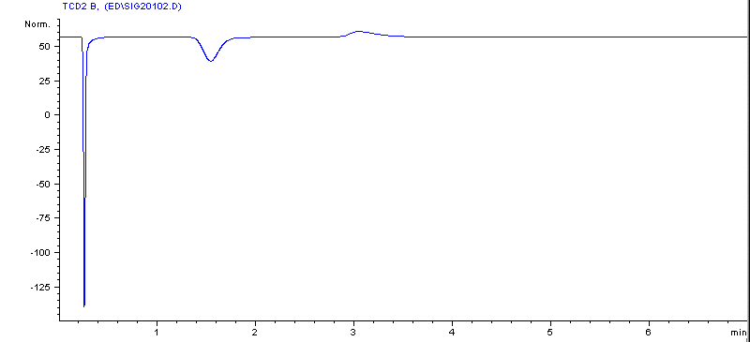
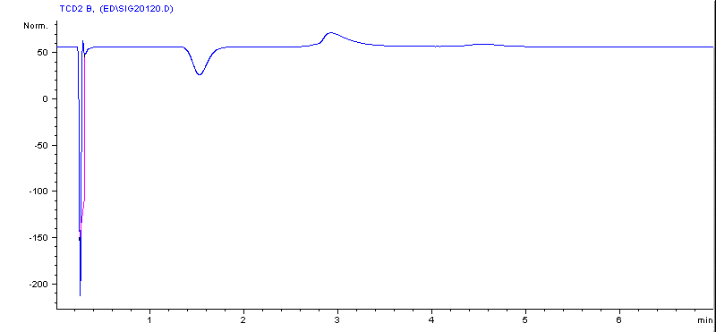
99.98% Hydrogen from Lab Cylinder
Product Hydrogen from Electrolyzer
Graph 9. Standard (above) & Graph 10. Product (below)
The hydrogen produced by the electrolyzer has the same distinctive negative peak at 1.5 minutes. The additional peak found at approximately 3 minutes has been identified as water. The final peak found at 4.6 minutes is background from the injection vessel used for the G.C. collection.

Additional Experimentation

The use of a total organic carbon measurement instrument and an ICP-MS will define the precise route of the catalyst and the fate of the electro-catalyst found in the system. Shimadzu TOC-5050A total organic carbon meter used for the carbon content measurements can expose any organic compounds that may be present in the system. The amount of carbon present will determine the rate of power degradation for the system. Independent experiments for the Carbon blocks of the single cell test fixture and the carbon cloth gas diffusion electrodes can specify the majority of the carbon substrate present in the transport phase (water). The amount of carbon will have a significant impact on the viability of microbial life existing in the system.

The ICP-MS allows the analysis of a specific type and amount of trace contaminants in the system. Preliminary analysis of the product water has extremely high amount of rare earth elements and accelerated amounts of Platinum. The recovery of the electro-catalyst and control of its motility will provide an insight to engineering a large scale regenerative system.
In conclusion the completion of the TOC and ICP Analysis along with proof of principle experiments will provide a basis for engineering a large scale model capable of sustained power for extended periods of time.

