This document is an instruction guide to accessing web pages when your e-mail thinks it sent a link, but just sent a URL. Microsoft always thinks http://any_character_stream is a link, even when it is not. WinXP thinks the URL is pointing to //chaos, when in fact the URL is actually 129.7.204.231. This is why you should type the URL exactly as written. In fact whenever links fail, you should type the URL before you assume it is a bad link.

Suppose you received this e-mail:

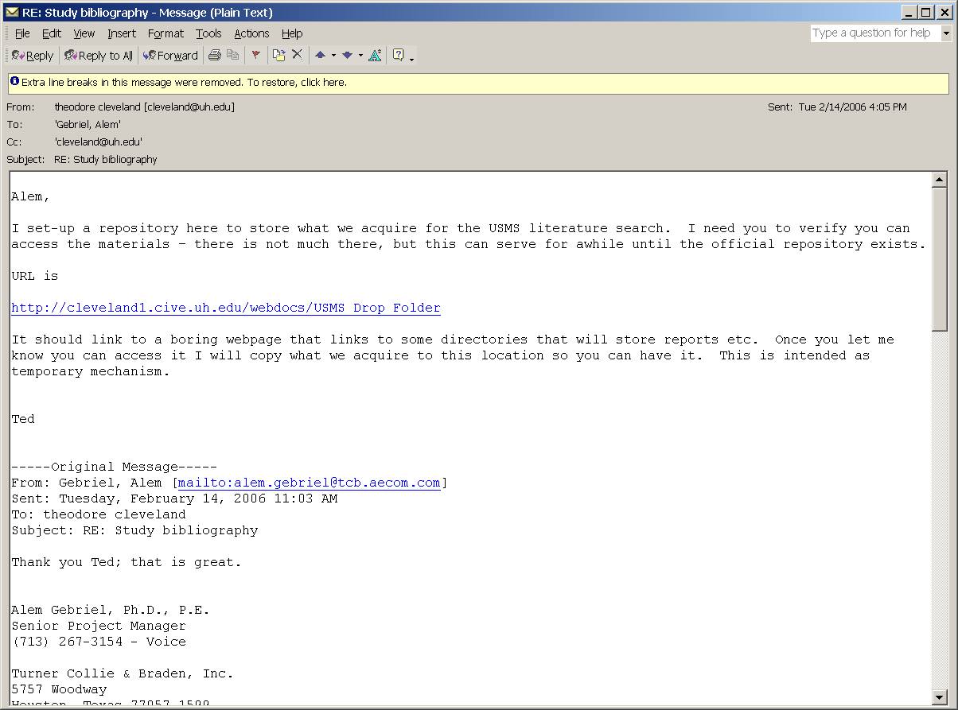

Do not “click” on the URL, but instead select it and “copy” the text to the clipboard, as below:

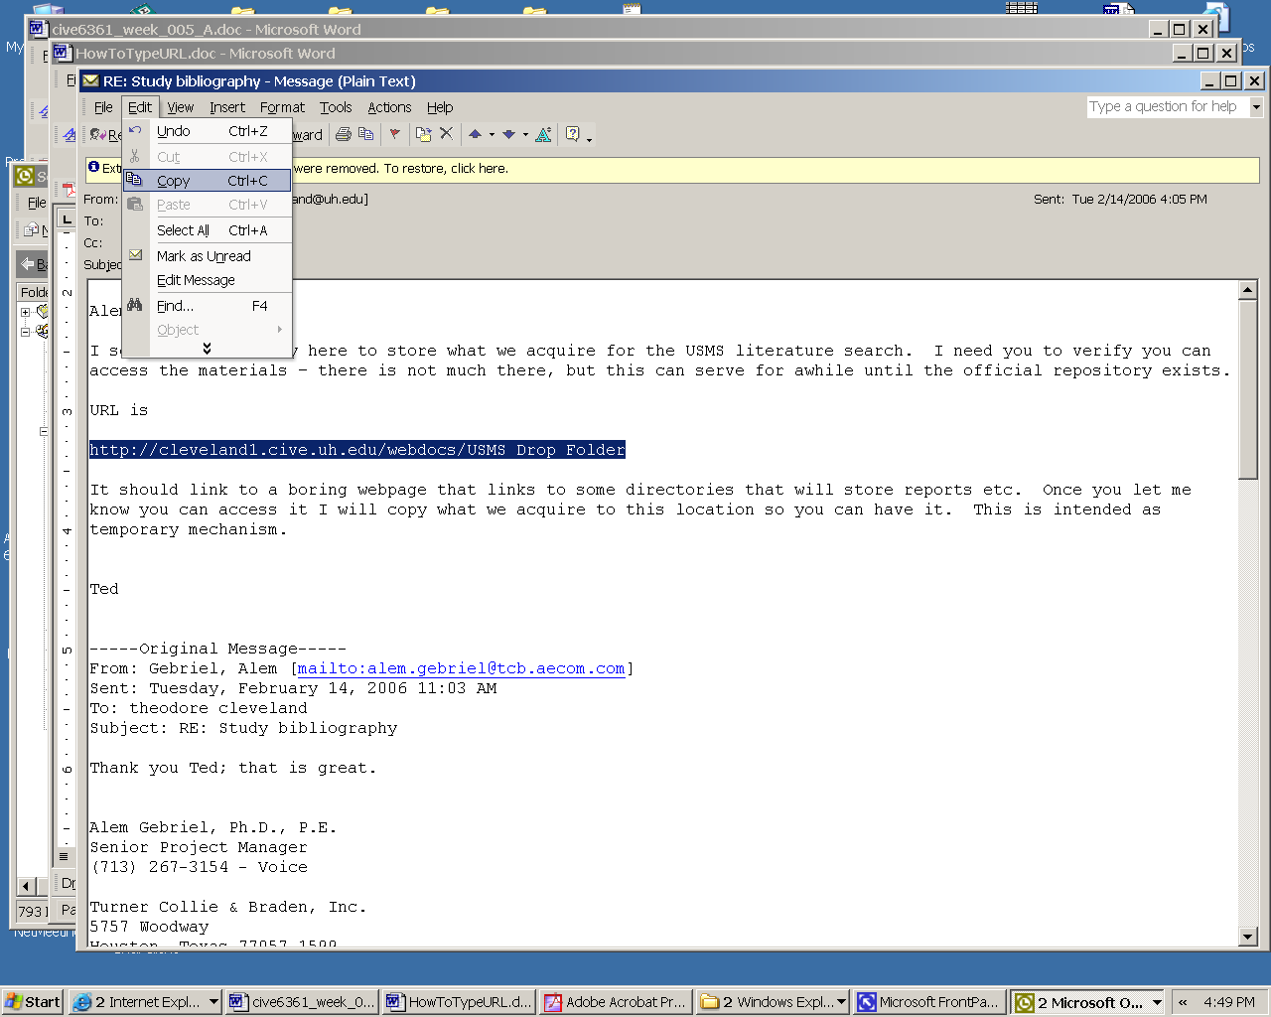

Next, open your web browser and “paste” the URL into the address line.

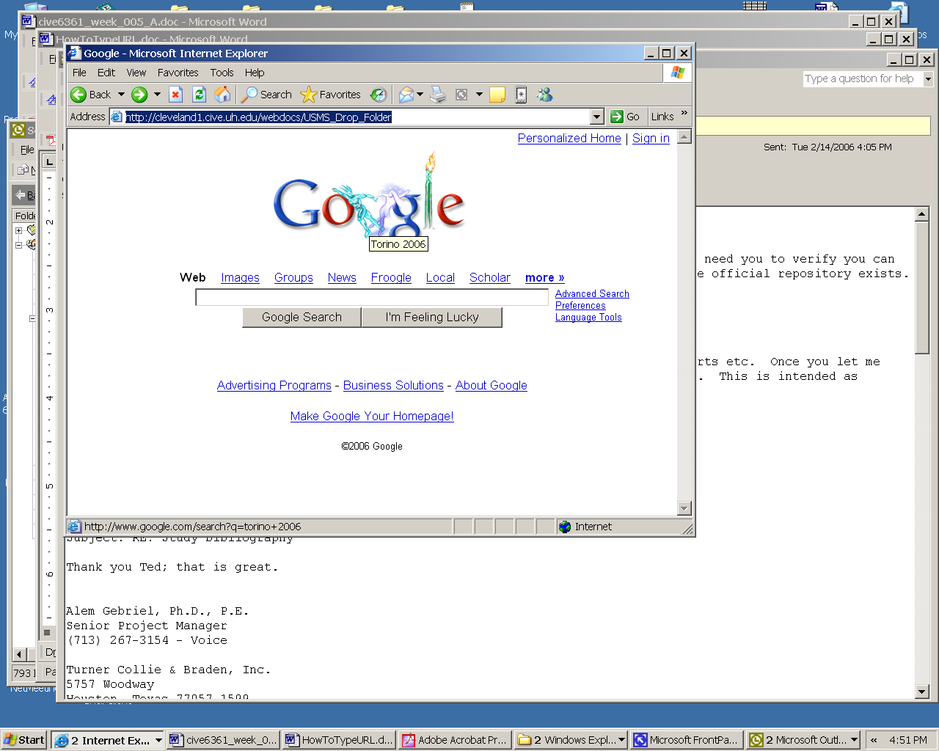

Then choose go (or just press return) and it should send you to the correct web page.

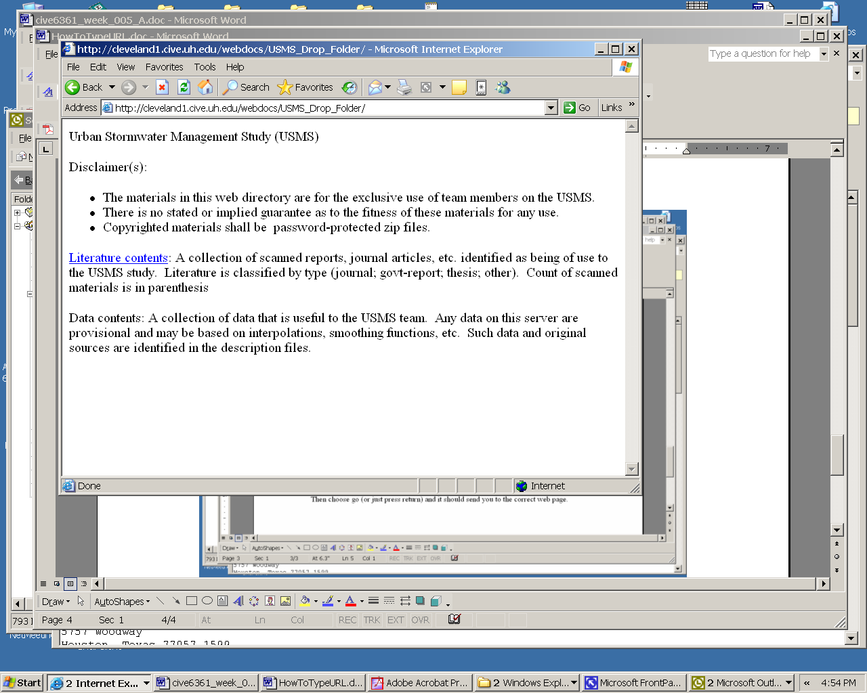

Notice the browser window has the URL as

http://cleveland1.cive.uh.edu/webdocs/USMS_Drop_Folder

