Starting a Real-Time Process on the Win32 platform

There are two ways to have a Real-Time process in Windows. Here they are.
- Create a new process that is Real-Time priority by command-line
- Alter a processes priority, using process manager, during runtime

WARNING: Even a single Real-Time process can hog all the usable resources on a Windows computer and make general GUI use incredibly slow.

Creating a new Real-Time priority process:
- Find the Run item on the start menu:

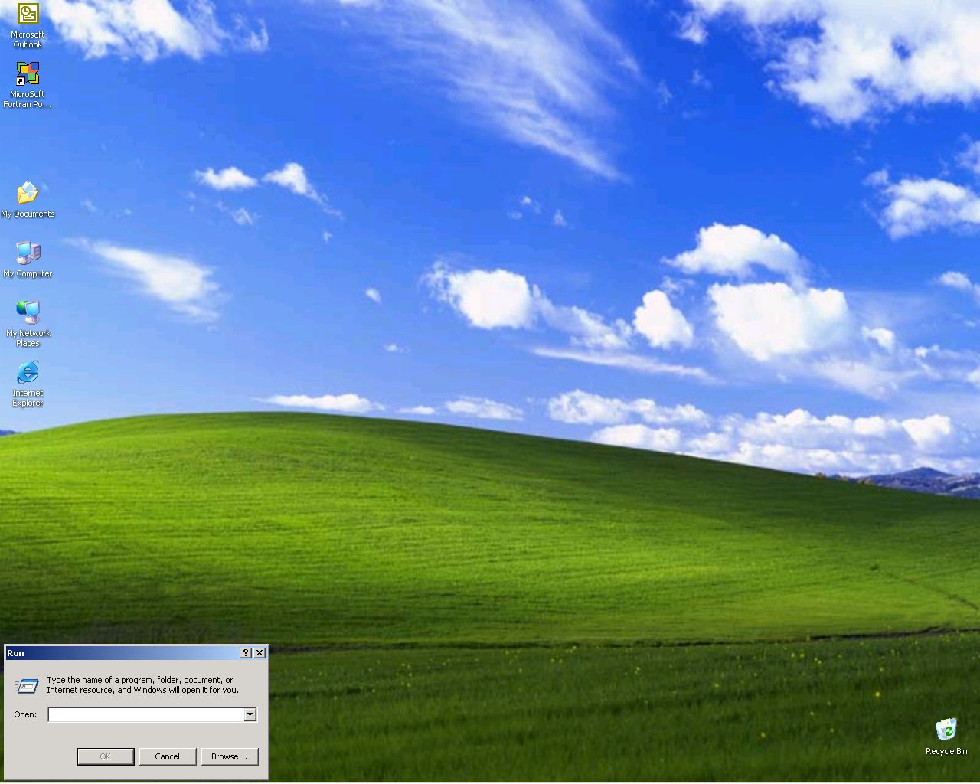

- Browse for the program executable file:

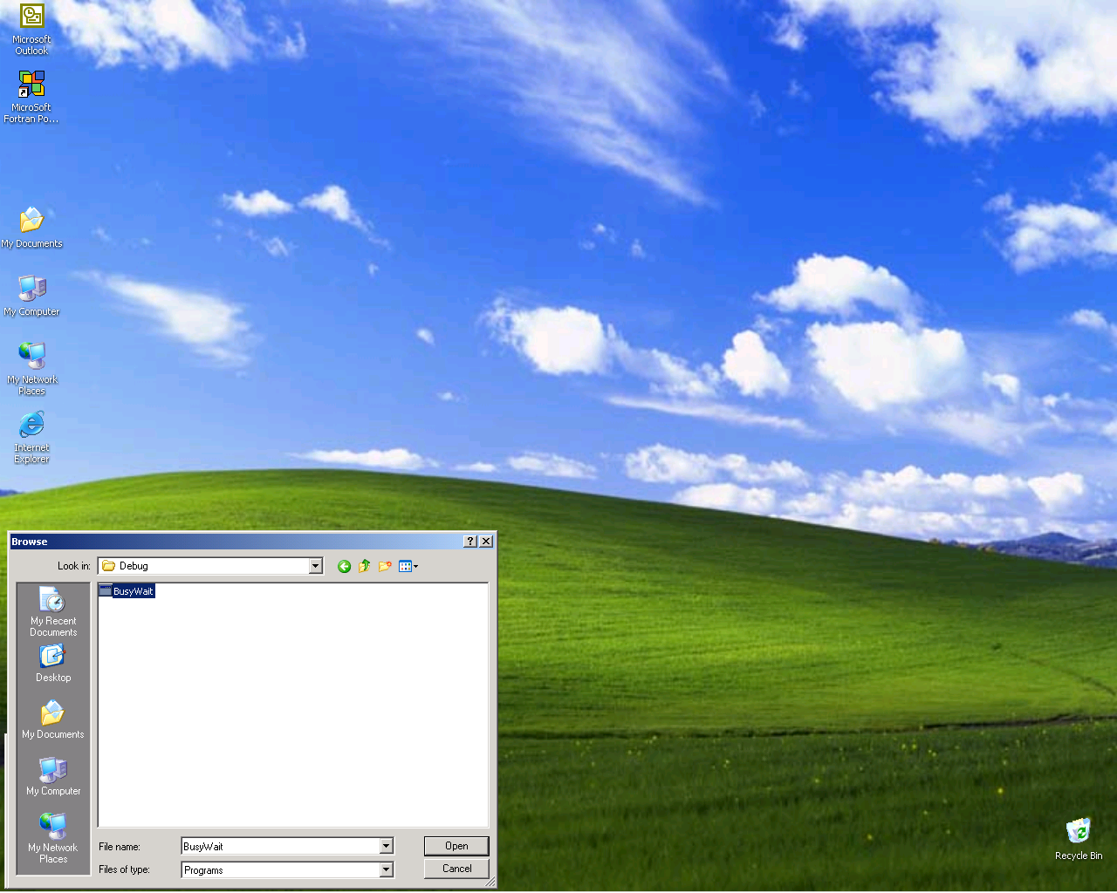

- Type in the following text before the absolute path to the program executable on the run command (BusyWait.exe is the program binary):

cmd /c start /realtime C:\MSDEV\Projects\BusyWait\Debug\BusyWait.exe

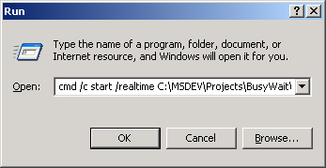

- Click OK (you have a running Real-Time process):

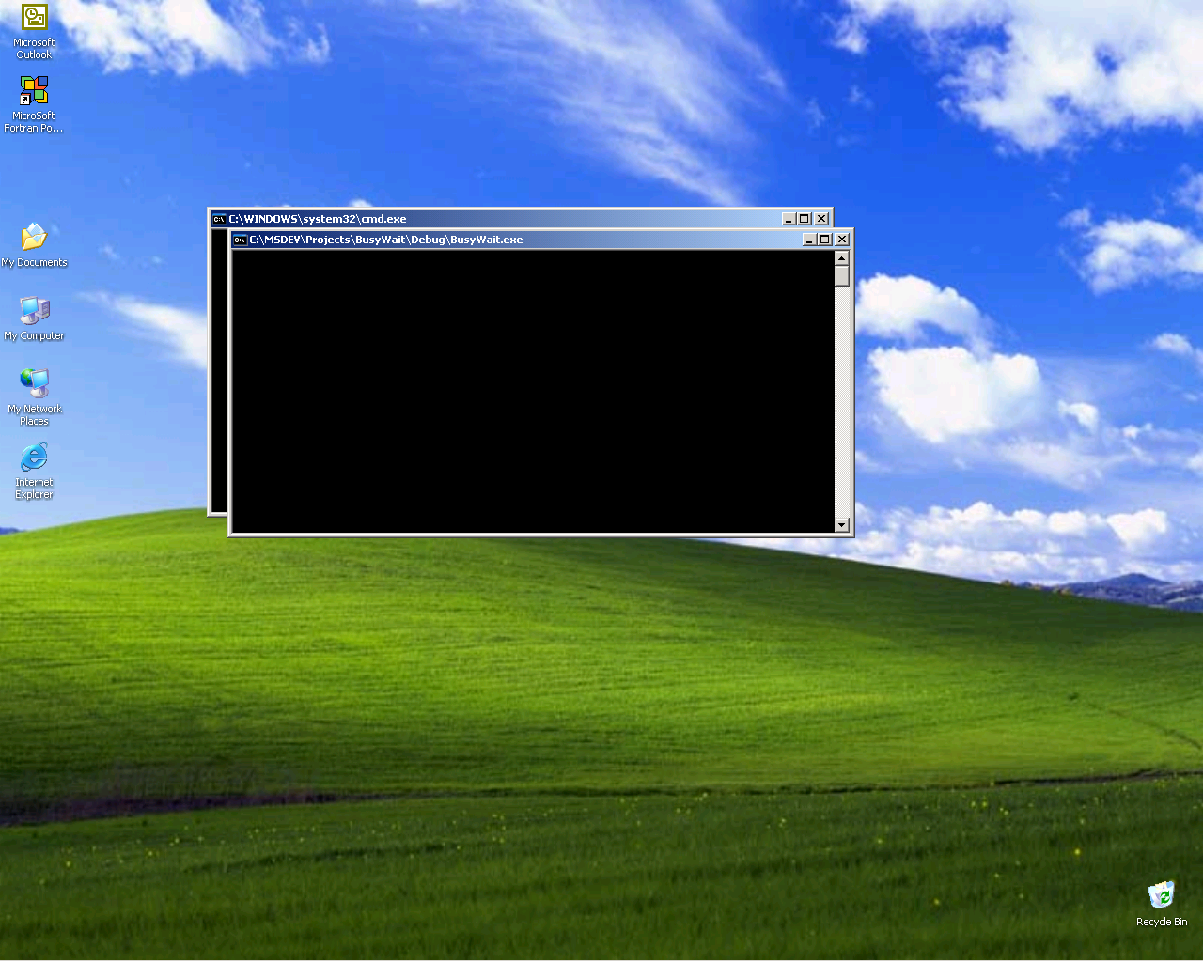

To alter the priority of a running process to Realtime, which effectively converts the process to Real-Time, do the following:

- Start the process in question (either by clicking an icon or command-line):

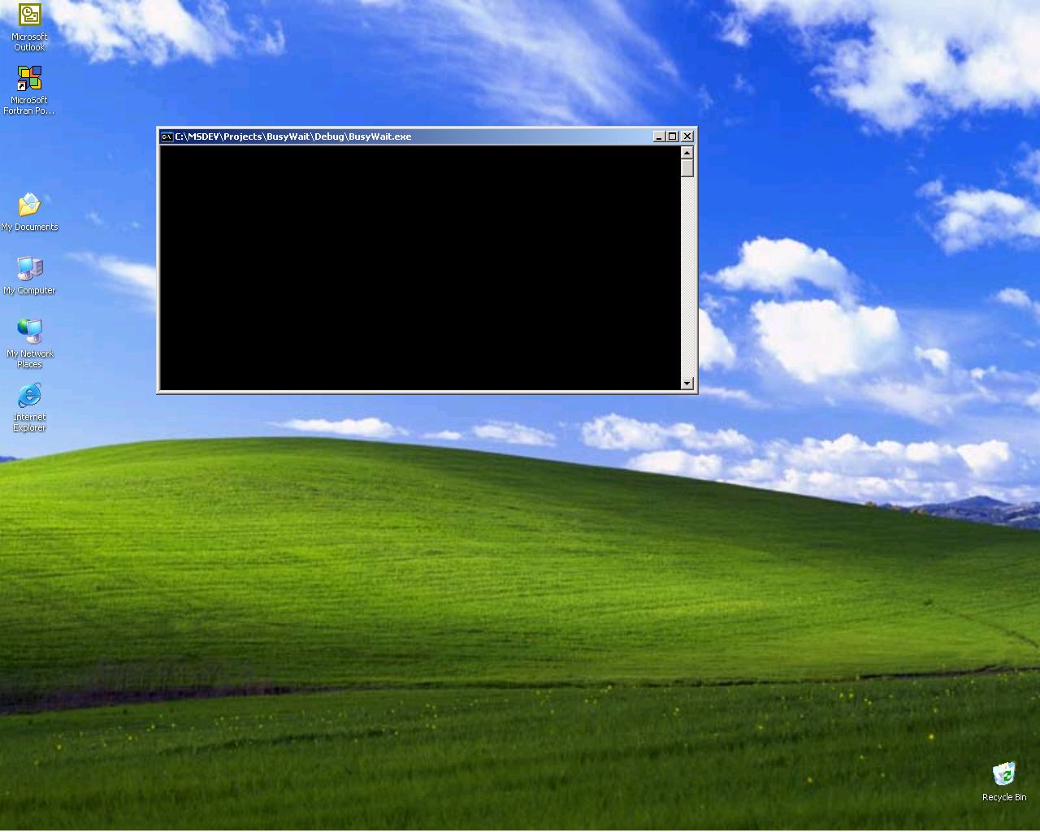

- Identify the process in the Process manager (Cnt-Alt-Del):

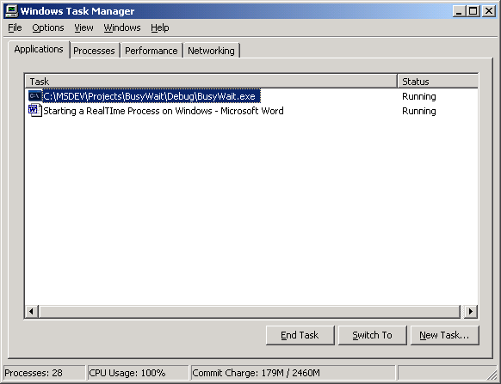

- Under the Processes tab, right-click the process in question:
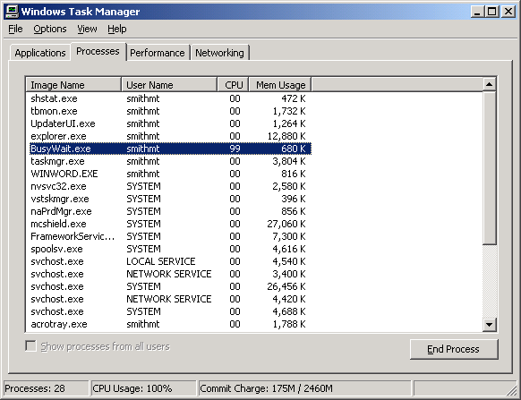

- Left-click Set Priority then left-click Realtime:

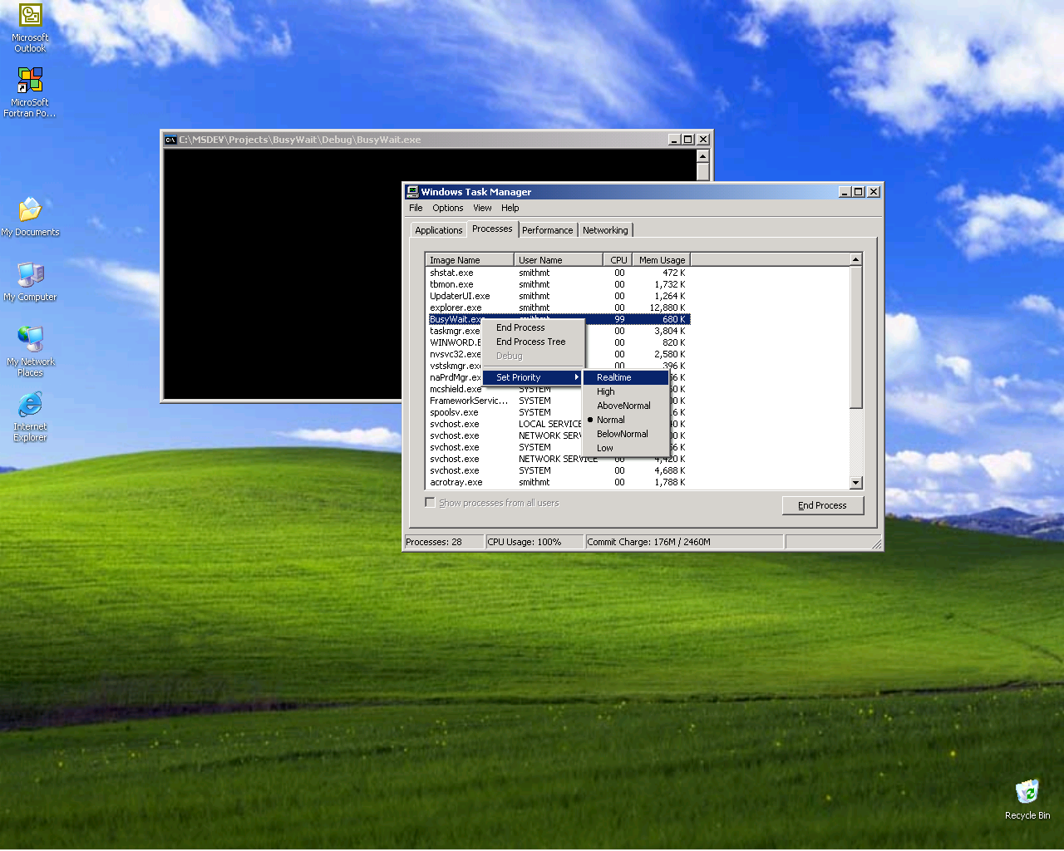

- You’ll be warned this could make the system effectively unusable (although the system is crunching away on the process).
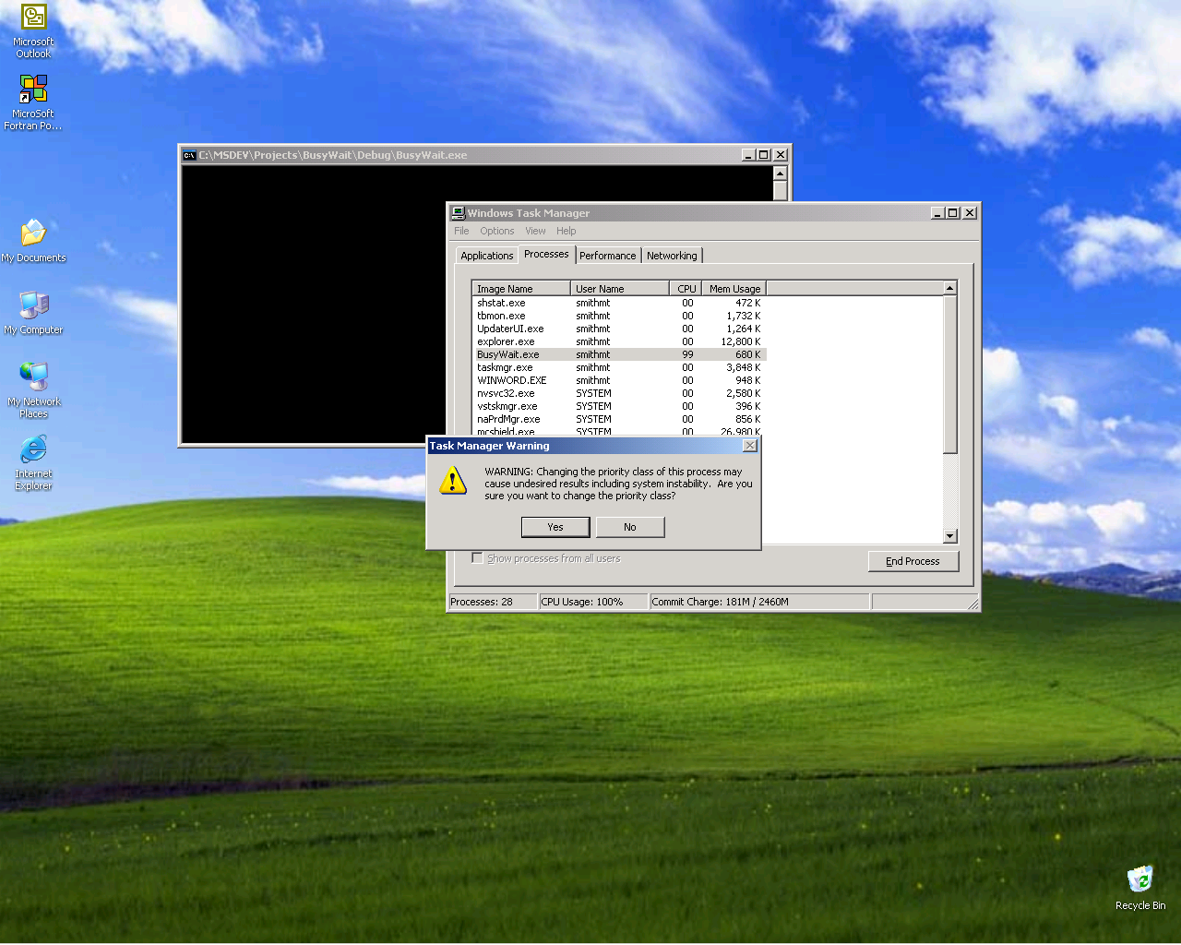

- Click OK. You have a running Real-Time process.

