Methods for Obtaining Watershed Characteristics

Purpose: This report describes the manual procedures used to determine selected watershed properties in the Central Texas Database that are to be used for development of synthetic hydrograph methods. This report does not discuss automated methods using tools such as a Geographic Information System. A GIS based effort is underway by other members of the research consortium.

Background: Each station in the database was considered as an “outlet” for a watershed. U.S.G.S. 7.5’ Topographic Quadrangle maps were used at the data source for the measurements. Original maps were obtained from the University of Houston Library, and 1:1 photocopied onto large width sheets. The original maps are returned and all measurements and markings are made on the photocopies. The characteristics were selected/invented to reflect the kind of measurements that would be available to any civil engineer and are thought to convey some hydrologic behavior. Traditionally area, distance, and slopes are hydrologically important.

Station Location: Station location is determined by the latitude and longitude reported in the station_id data file. These latitudes and longitudes are plotted on the paper maps using linear interpolation between the latitude and longitude increments actually marked on the map. The interpolation weights are written on each paper copy because the latitude and longitude distances are different. The interpolation distances are plotted using an engineer scale, typically the 1/50 scale. Once the station is plotted the location is confirmed by using geo-referenced images of the U.S.G.S. maps displayed at www.topozone.com. These images are visually compared with the paper copies to assist in locating the gaging station on the paper map.

Engineering inference is used to locate the station for determining drainage area, for instance if the location is near a road and a stream channel, we locate the “outlet” in the stream channel adjacent to the road at the grade separation (bridge or culvert). If the location is somewhere in the middle of nowhere, we try to identify the nearest stream channel or topographic feature that makes sense from a runoff path point of view. Most of the station locations made sense without appealing to such inference adjustments.

Drainage-Area Delineation: Once the outlet is located the watershed is delineated in a trial and error fashion. Initially the delineation is made using the following guidelines (manual delineation):
- Draw a circle at the outlet or downstream point of the watershed (Figure 1). In the example, a wetland is displayed just upstream of the outlet – in many of the watersheds in the database, the gaging locations are at outlets of tanks which impound some water (like a wetland).
- Put small "X's" at the high points along both sides of the watercourse, working upstream towards the headwaters of the watershed.
- Starting at the circle that was made in step one, draw a line connecting the "X's" along one side of the watercourse (Figure 2). This line should cross the contours at right angles (i.e. it should be perpendicular to each contour line it crosses).
- Continue the line until it passes around the head of the watershed and down the opposite side of the watercourse. Eventually it should connect with the circle from which you started.
- At this point you have delineated the watershed. (Figure 2)

The delineation appears as a solid line around the watercourse. Surface water runoff from rain falling anywhere in this area should flow out of the watershed at the indicated outlet.

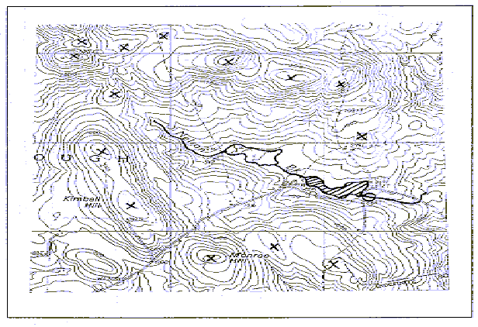  Figure 1. Topographic map for watershed delineation. | 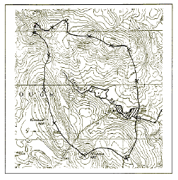  Figure 2. Map with delineated watershed.

Once the initial delineation is completed the area is determined by planimetry. There are several widely available methods for manual measurement the area of a watershed: a) Dot Grid Method, b) Mechanical Planimeter, and c)Numerical Planimetry.
- The dot grid method is a simple technique that does not require any expensive equipment. In this method the user places a sheet of acetate or mylar, which has a series of dots about the size of the period at the end of this sentence printed on it, over the map area to be measured. The user counts the dots which fall within the area to be measured and multiplies by a factor to determine the area. A hand held, mechanical counting device is available to speed up this procedure. A grid can be used instead of dots.
- The second of these methods involves using a mechanical planimeter, which is a small device having a hinged mechanical arm. One end of the arm is fixed to a weighted base while the other end has an attached magnifying lens with a cross hair or other pointer. The user spreads the map with the delineated area on a flat surface. After placing the base of the planimeter in a convenient location the user traces around the area to be measured with the pointer. A dial or other readout registers the area being measured.
- Numerical planimetry determined area by marking the boundary of the watershed and recording the coordinates of the markings. The coordinates can be either actual distances on the map (scale is built-in to the calculations) or simply increments on an engineer scale. Once the coordinates are recorded a contour integral is evaluated using trapezoidal integration and the area can be evaluated. Numerical planimetry is not truly a manual method, and the data entry is tedious, but it is useful as a bridge to GIS based systems.

In the present effort we used a mechanical planimeter. The marked area is measured and compared to the area in the station_id file. We adjust the boundary until the mechanical result and the station_id file differ by less than 10%. When reducing or adding area in the drawn boundary, use of engineering judgement is required. As a guideline, we move the boundary in relatively flat areas (if they exist) because flow direction is hard to determine anyway. In most cases adjustments were relatively minor to achieve the required area match. The area is recorded in square miles.

Once the area match is achieved the following measurements are recorded

Watershed Measurements:

Perimeter: Navigation dividers are used to determine the perimeter of the drainage area by counting the number of known increments required to traverse the perimeter (solid line drawn on the map). The watersheds adopt a relatively consistent shape, intermediary between ovoid and pear shaped. Typically we set the diameter of the divider at 5 cm, and count the numbers of this unit length along with outline of the watershed, the count number multiplied by 5 cm is then transferred into the perimeter of the watershed using the map scale. The value is recorded in units of feet.

Stream-length: The length the main stream is determined in a two part process. First the stream is drawn using a colored highlighter and Horton’s rules for navigating bifurcations. Specifically, to delineate the main stream at bifurcation the following rules were used: a) Starting below the junction, the main stream was projected upstream from the bifurcation in the same direction. The stream joining the main stream at the greatest angle was the lower order. b) If both streams were at about the same angle to the main stream at the junction, the shorter was taken as the lower order. Once the lowest order stream is marked, navigation dividers are used in the same fashion as for perimeter. The value is recorded in units of feet.

Max-distance: The maximum distance is the straight-line distance from the station location to the furthest point of the drainage area. A string-type compass is used to locate on the watershed boundary the point furthest from the outlet (without regard to flow path). A straightedge is used to join these tow points, and then the distance along this line segment is measured with the navigation dividers. The value is recorded in units of feet.

NS-Range: The width of the watershed from the most north point to the most south point. A rectangle is drawn that encloses the watershed. The NS-Range is the NS dimension of this rectangle. The unit of the NS-range is feet.

EW-Range: The width of the watershed from the most east point to the most west point. A rectangle is drawn that encloses the watershed. The EW-Range is the EW dimension of this rectangle. The unit of the EW-range is feet.

Hi-elevation: The highest elevation within the watershed. Read from the topographic maps. The unit is feet.

Low-elevation: The lowest elevation within the watershed – typically this should be at the outlet. Read from the topographic maps. The unit is feet.

NS-High point elevation: The highest elevation of the watershed along a North-South line. It typically will be at the North or South intersection of the NS-EW rectangle that encloses the watershed. Read from the topographic maps. The unit is feet.

NS-Low point elevation: The lowest elevation of the watershed along a North-South line. It typically will be at the North or South intersection of the NS-EW rectangle that encloses the watershed. Read from the topographic maps. The unit is feet.

EW-High point elevation: The highest elevation of the watershed along an East-West line. It will typically be at the East or West intersection of the NS-EW rectangle that encloses the watershed. Read from the topographic maps. The unit is feet.

EW-Low point elevation: The lowest elevation of the watershed along an East-West line. It will typically be at the East or West intersection of the NS-EW rectangle that encloses the watershed. Read from the topographic maps. The unit is feet.

Database Structure

The watersheds database is organized into a single flat file in MS Excel. It is also saved as an ASCII comma-delimited file. Figure 3 is an example of the first few records of the watersheds database. The file names are watersheds_data.xls and watersheds_data.dat, respectively.

The file structure attempts to adhere to the same structure as the unit*.dat and the hyet*.dat files of the txdoccvs database in the sense that the header records are preceeded by the # symbol, the first record without “#” symbol are the column headings, and the subsequent rows are actual values in the database.

Link to data files:

MS Excel File: watersheds_data.xls

ASCII File: watersheds_data.dat

Figure 3. Excerpt from Watersheds_Data.xls file. File contains geometric properties of selected Texas watersheds.

