Historical Rainfall Data

Go to the NWS website, browse until you get to the historical data web page.

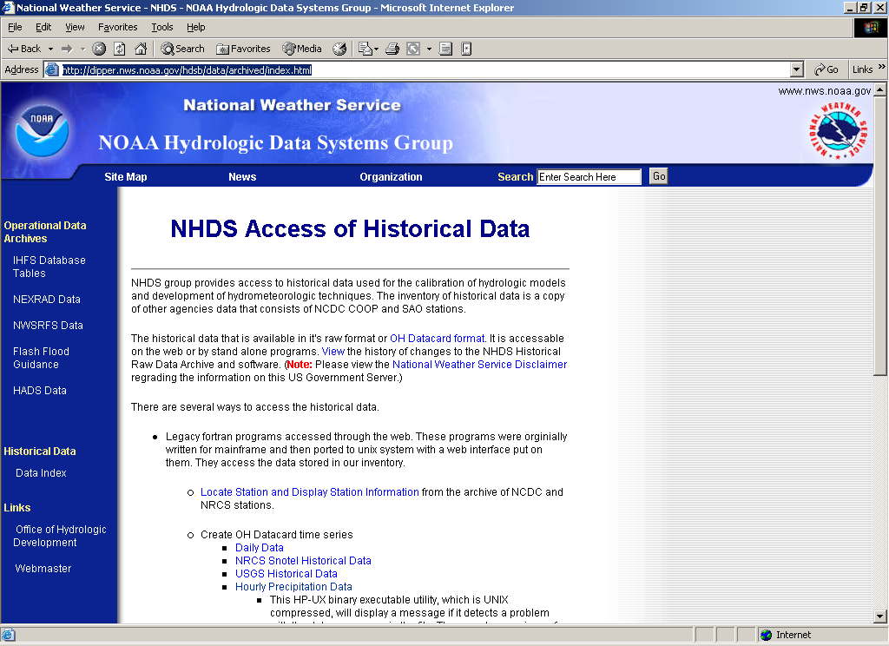
Figure 1. NWS Historical Data Server

Select kind of data you want (precipitation), and you will be redirected to a browser window to enter a query of their database. First you need a station name, select the “Locate Station” link. Figures 2 and 3 are the data form. Notice it requests a Lat-Lon box to define the search range. So you need a decent estimate of where your station is. Lets use Junction Texas as your target (S. Llano river).

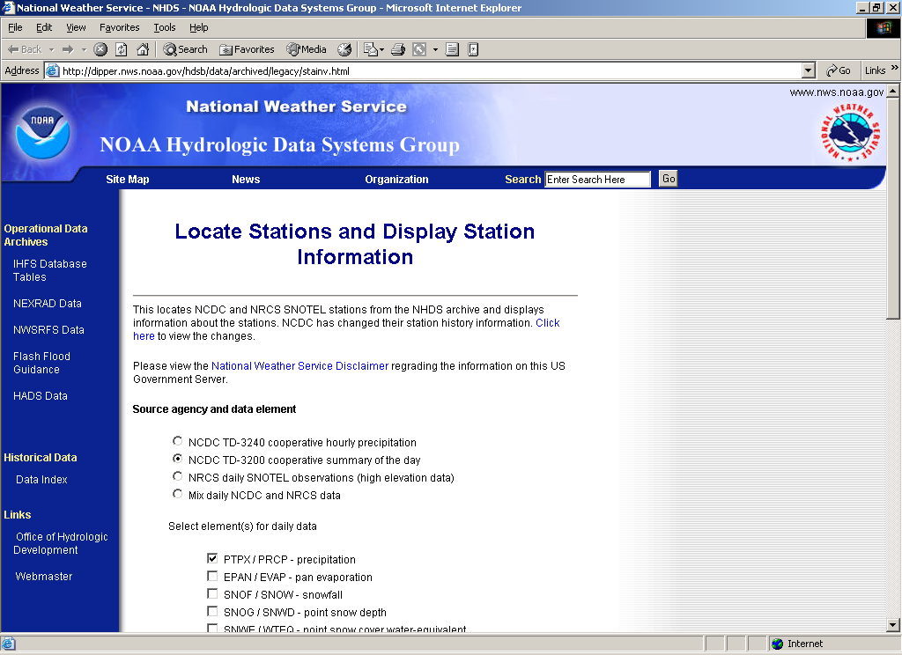
Figure 2. Locate Stations Utility (cgi/bin query)

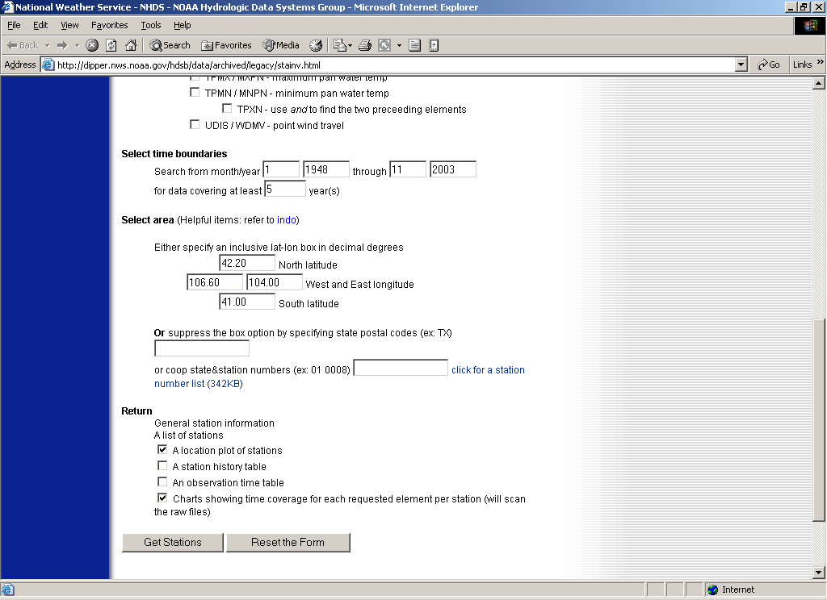
Figure 3. Geographical search area (part of cgi/bin query).

Go to topozone.com or some other map to get a lat-lon to center your search.

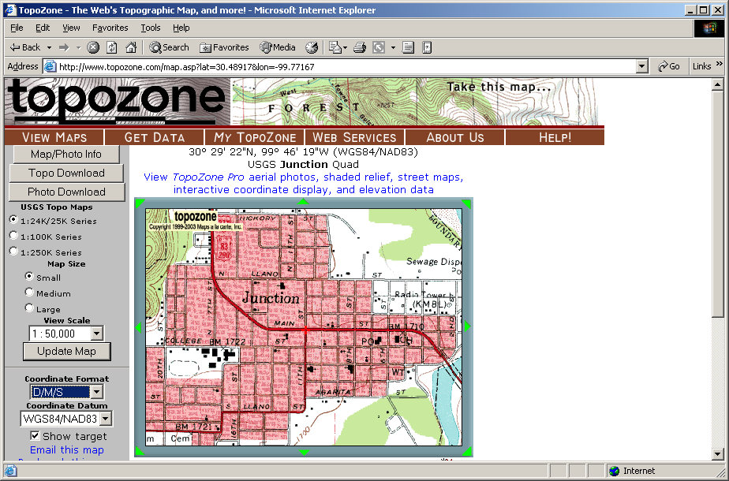
Figure 4. Topozone.com geo-reference for Junction TX.

So Junction is at 30()29’22N and 99()46’19”W. A one degree search box should get some stations, so search from 101()00’00”W to 99()00’00”W and 30()00’00”N to 31()00’00”N and see what stations come up:
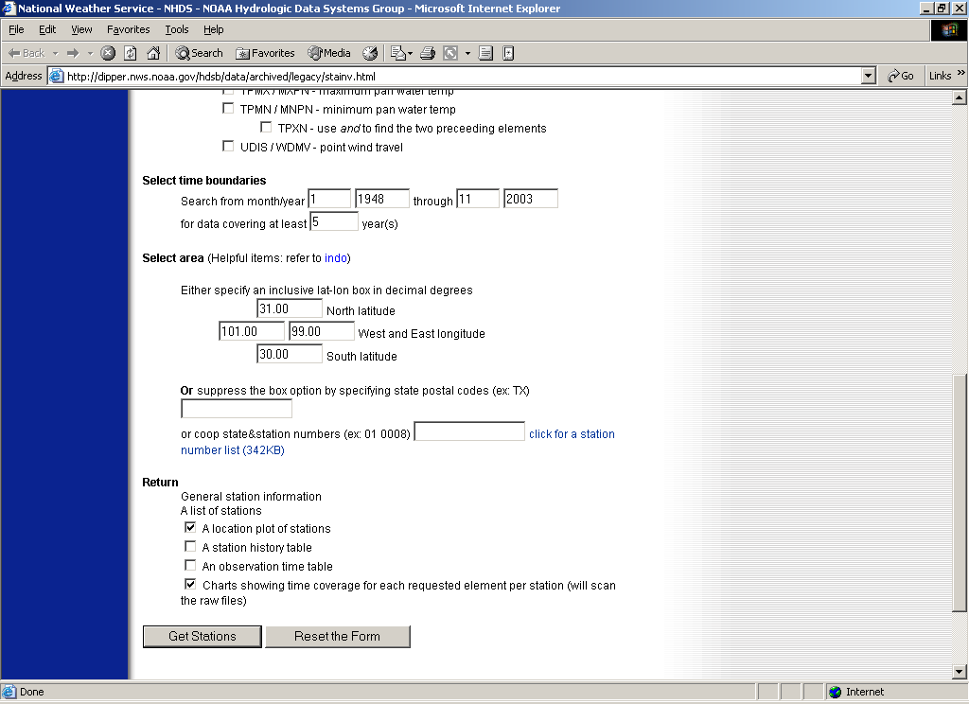
Figure 5. Search rectangle for Junction Texas

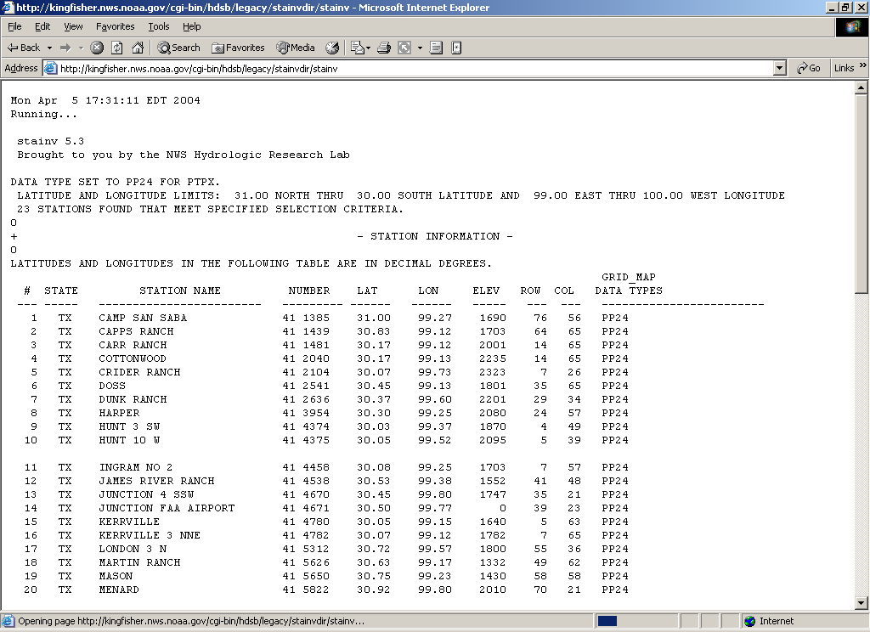
Figure 6. Station ID information within search rectangle.
Lets pick Junction SSW as the station to get rainfall data (as an example). The NWS station ID is 41 4670. So now enter this number into the data search engine to extract the precipitation data.

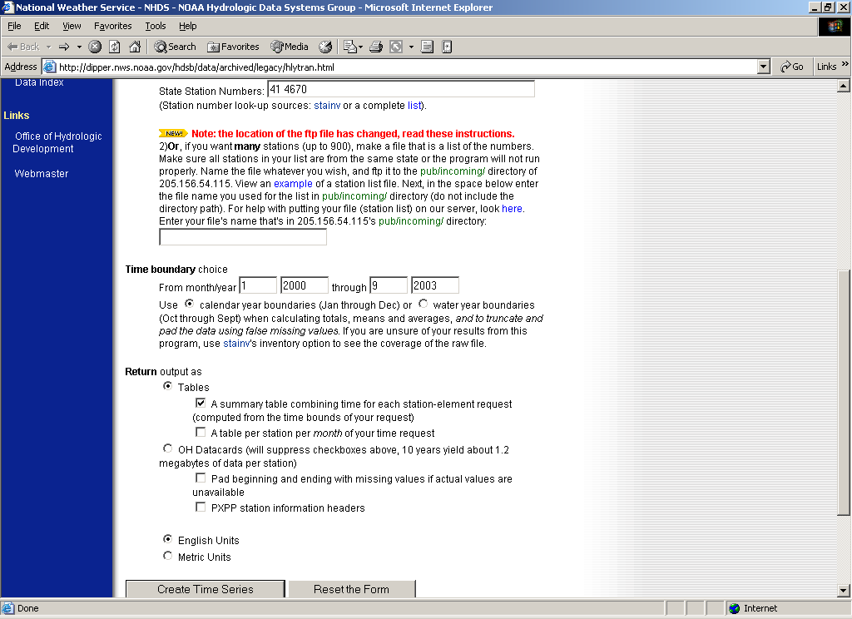
Figure 7. Specify data recovery
First get a summary to see what might be available

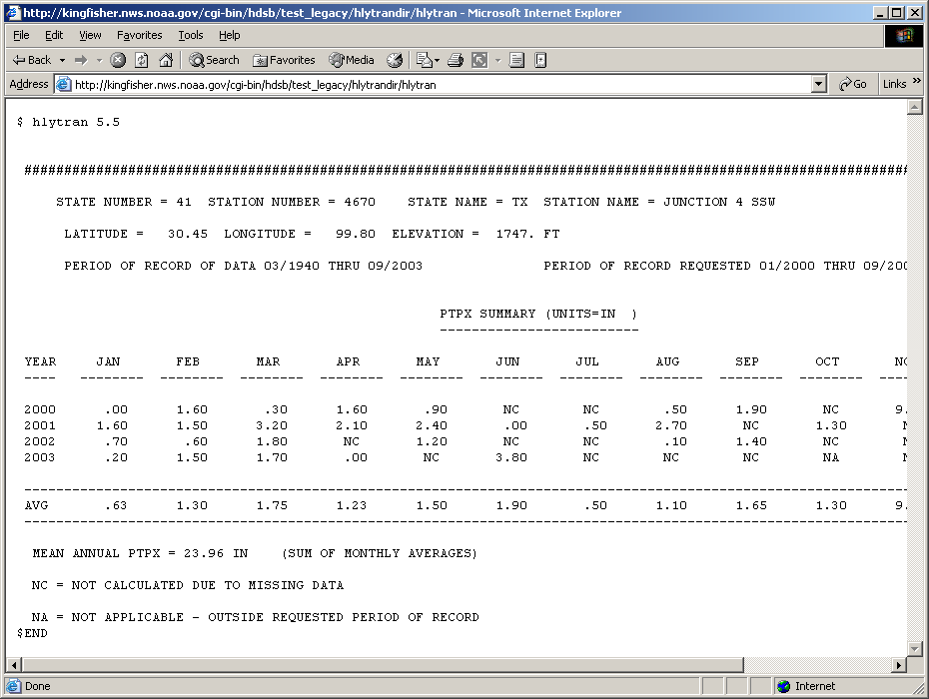
Figure 8. Summary table (note search dates specified)

Then try to get some hourly data

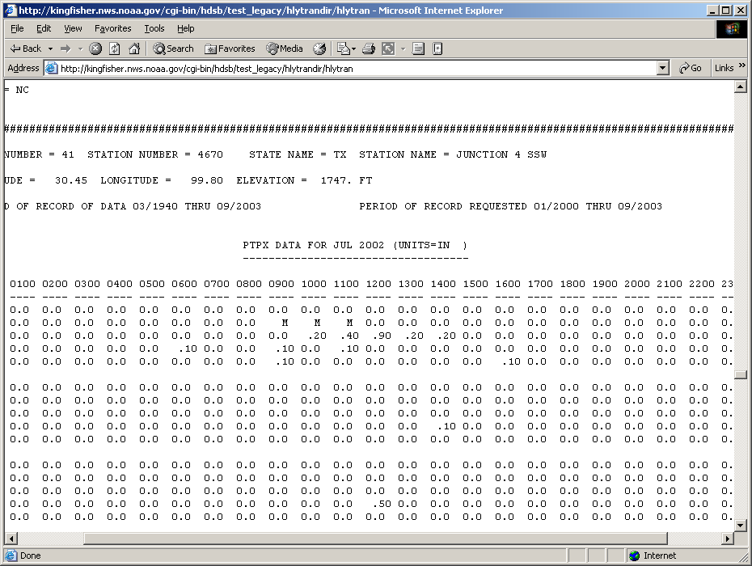
Figure 9. Hourly precipitation by month of search, July 2002 is shown, but entire page is many months.

You might want to explore the OH card image download, it produces six data columns, but YOU will have to write some programs to parse the ASCII data to your needs, as it simply counts in hours from your begin and end search range.

Other data sources are:

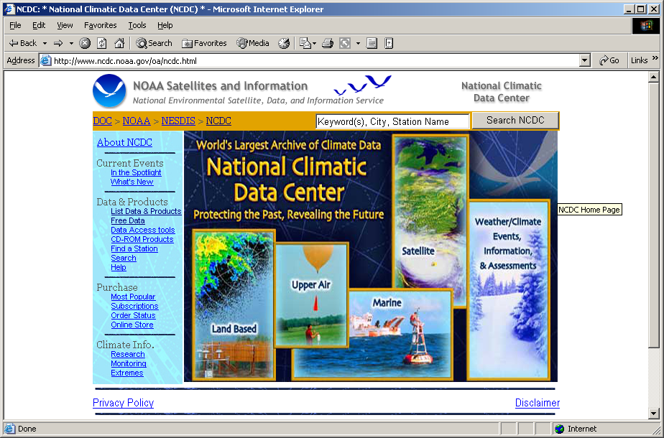
Figure 10. National Climatic Data Center (NCDC)

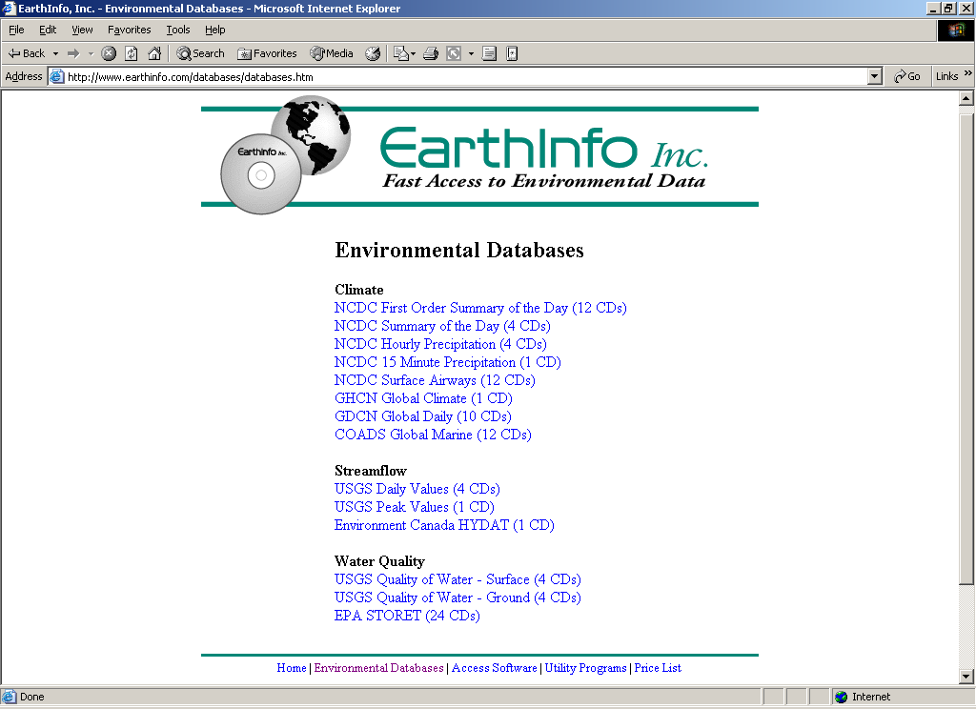
Figure 11. EarthInfo, Inc.

