Content: Step-by-Step instructions to duplicate MS Outlook e-mail files to a file.

Purpose: To move e-mail content from one computer to another.

Definitions:

Old Computer == the computer you want to copy files FROM.

New Computer == the computer you want to copy files TO.

Assumptions:

- You have an account on the “Old Computer”
- You have transfer media. (i.e. CD-ROM with functioning writer; FlashDrive, etc.

Method#1: Transfer to a Flash Drive.

Step#1: Install the flash drive into a vacant USB port.

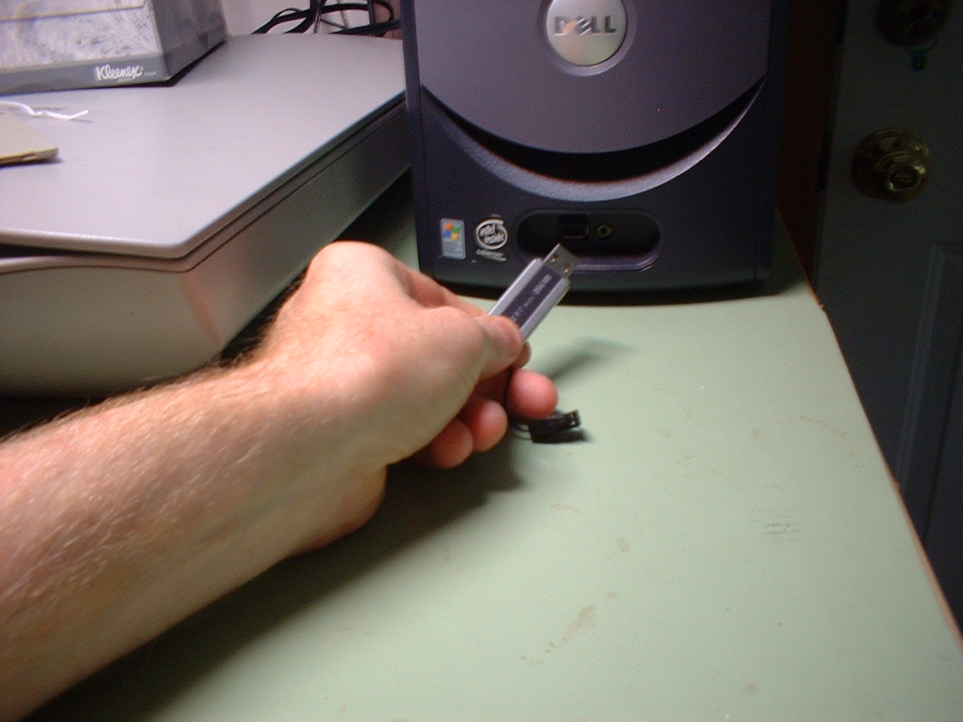
Figure 1. Typical flash drive. Size and shape varies.

Step #2) Verify flash drive installs.
a) If installation is successful (it may take some time, about a minute) the hardware removal icon should appear in the system tray.

Figure 2. Hardware removal icon, Typical location. We will use this to dismount the flash drive at the end of the file transfer.
b) The drive should appear in the “MyComputer” directory or in Windows Explorer (not Internet Explorer).

Figure 3. Flashdrive will appear as a removable drive. Drive letter will be DIFFERENT on EVERY machine.
Step#3 Verify you can copy files to the flash drive. Select a single file on your computer, nothing elaborate, and drag that file to the flash drive. If it copies OK, then proceed to the next step.

Figure 4. Select a file to copy.

Figure 5. File copied. OK to proceed.

If you are reading here, you have successfully mounted a flash drive to store data.

Step#4: Exporting your “Inbox” in MS Outlook. Open your Outlook program.

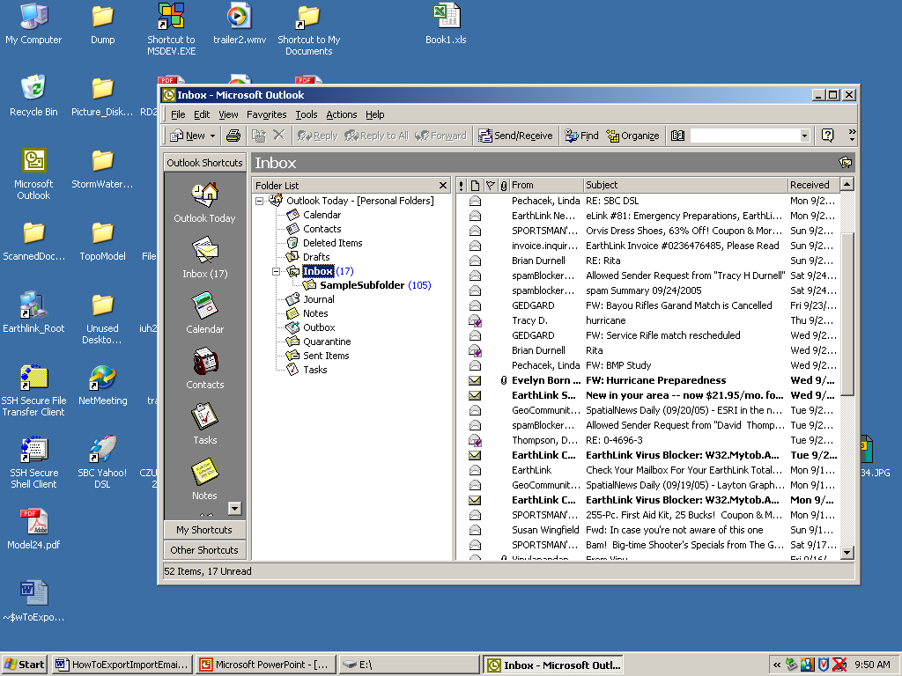
Figure 6. Outlook e-mail client. Notice the inbox has a subfolder.

Step#5: In the file menu of outlook, choose Import/Export.

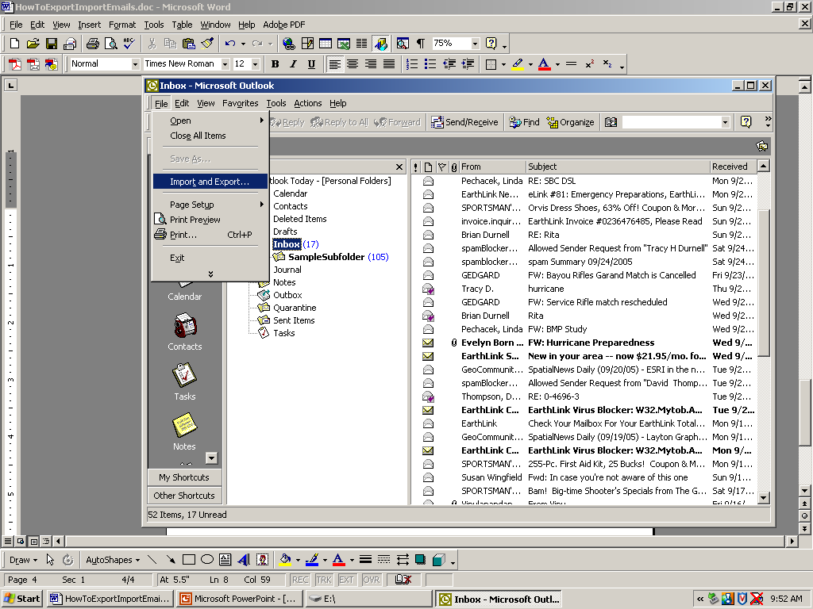
Figure 7. Import/Export item. Extend the menu (double caret at bottom) if the menu item is hidden.

Step#5 (continued)

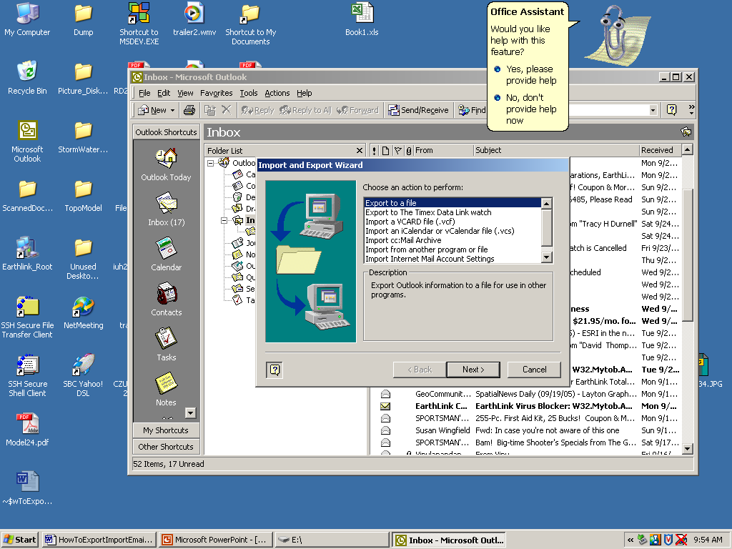
Figure 8. Import/Export options. Choose "EXPORT TO A FILE". Don't choose anything else (unless you know what you are doing, in which case you wouldn't be reading this).

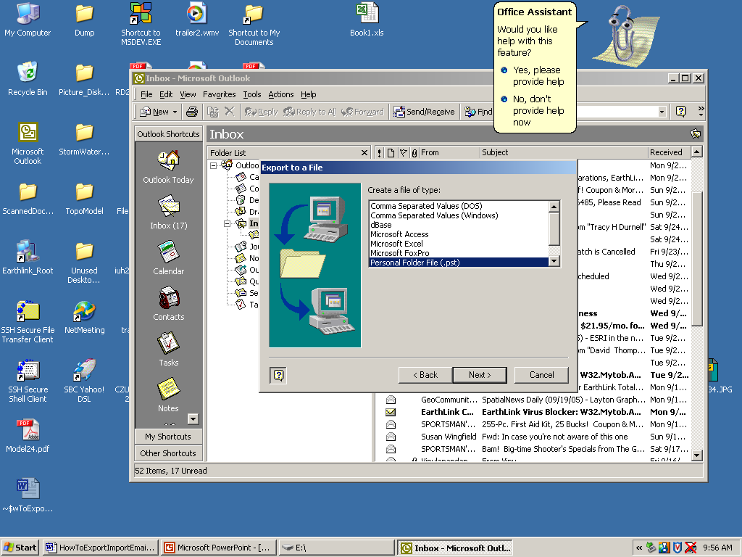
Figure 9. Choose "Personal Folder FIle" as the file type. This How-To assumes you will import the file into Outlook on the New Computer.

Step #5 (continued). The next task is very important. Read and proceed slowly. You need to tell the program what you want to export. In this example, your Inbox. Also you need to select “Include Subfolders”

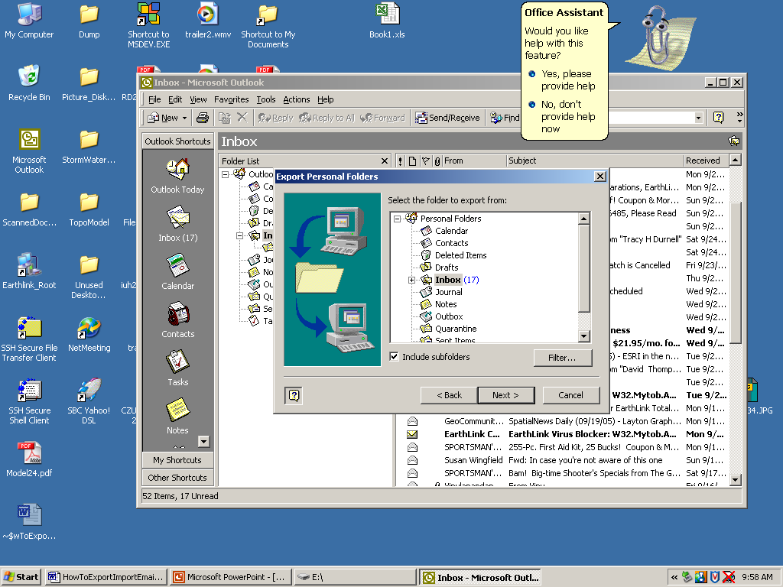
Figure 10. Select what to export, and to include the subfolders.

The next task is complex. Again read first. You will be presented with a dailog box where you will tell the program WHERE you want it to put the Exported file, as well as how to handle duplicate items. It is very important that you specify where correctly, otherwise you will not be able to find the file. To specify where you want the program to save the file, click the “BROWSE” button, and then browse to the destination directory (in this case the flashdrive!). The next couple of images illustrate these actions.
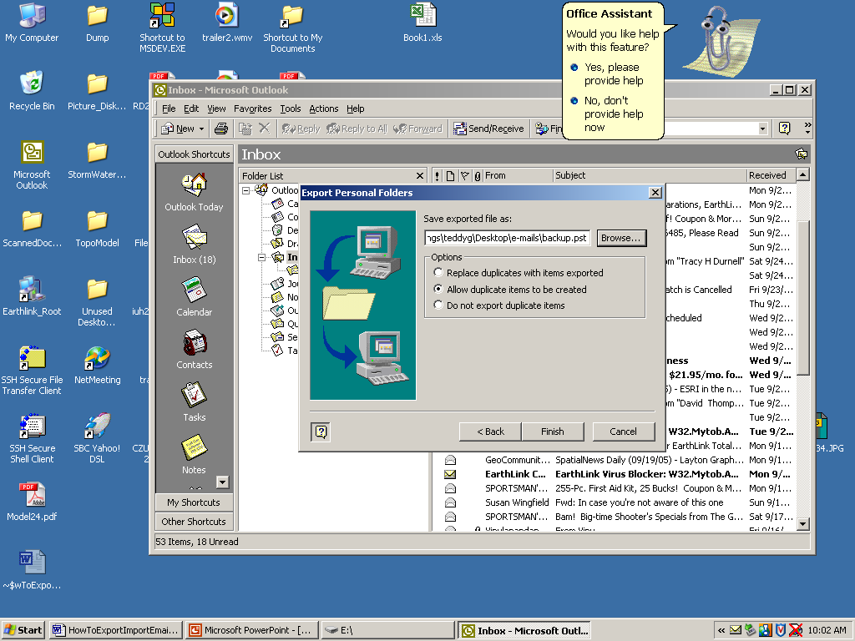
Figure 11. Dialog where we specify where to put the export file and how to handle duplicates. I recommend that you allow the program to "ALLOW DUPLICATES"

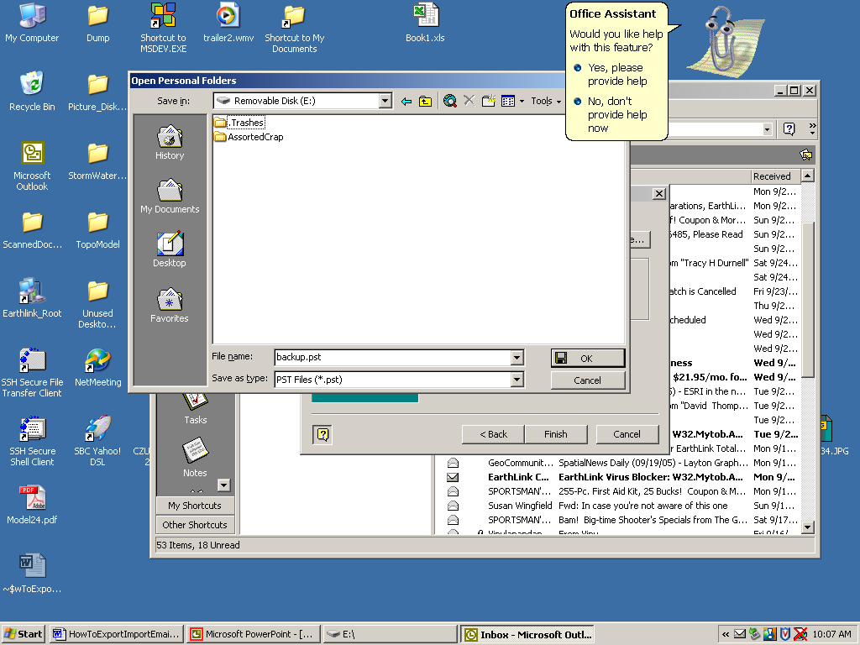
Figure 12. Browse to the destination directory using your usual navigation techniques.

Once you have the correct destination, click OK. The next part of the export will take some time. You will be returned to the dialog box, which should be all set up now. When you click FINISH the program will start to create the file, which may be quite large. If the file is too big for the flash drive the process will fail, and you will have to manually reorganize the inbox so that several files are used instead of a single file.
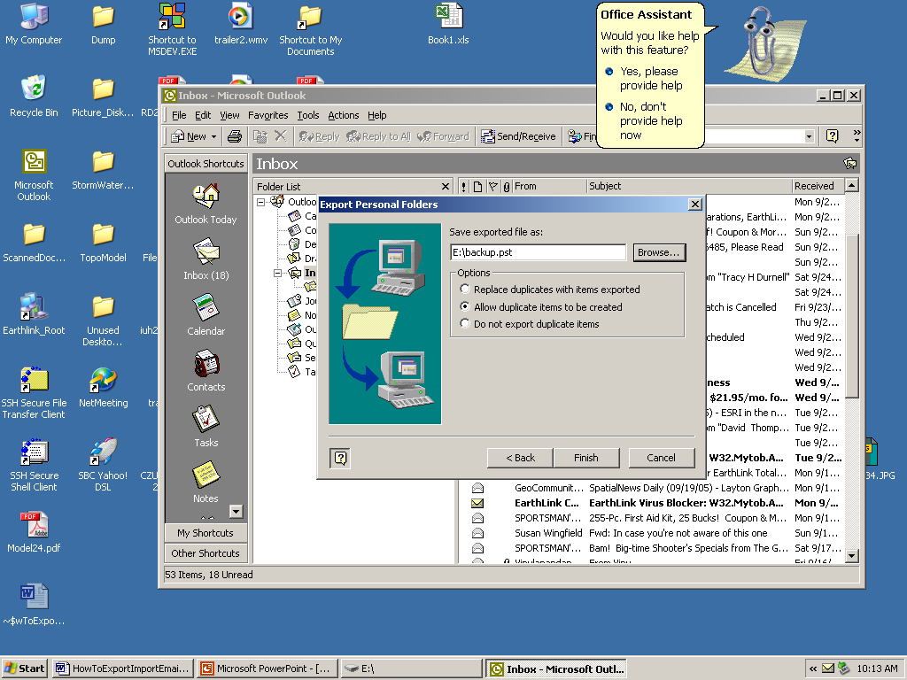
Figure 13. Dialog ready to select "FINISH"

Step #6. Click “FINISH” and the process will begin. It will take a fair amount of time. If the process fails it will be because the file gets too large or something similar. Copy the error message if it fails. (PrintScreen then paste into Word then print the document).

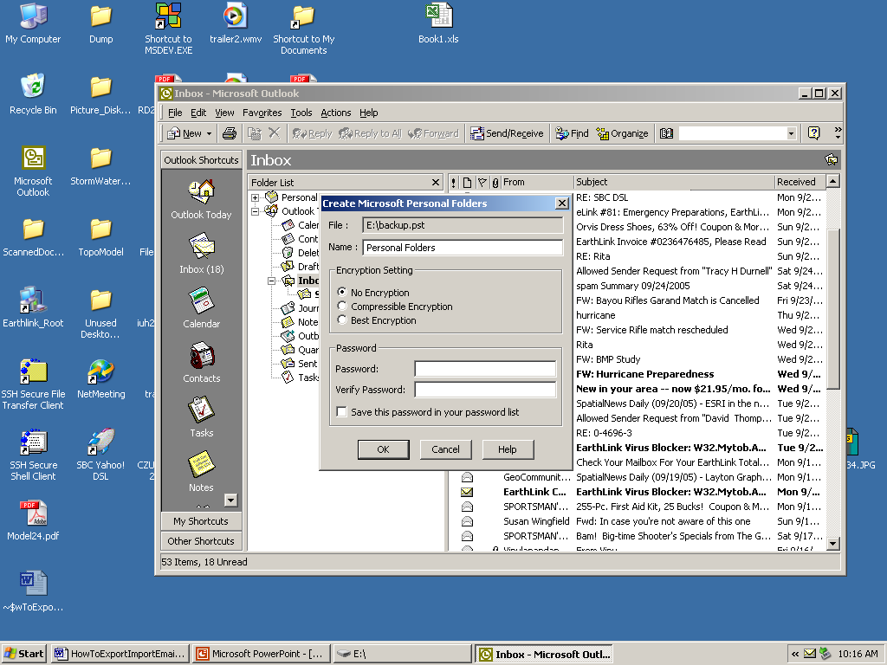
Figure 14. Verify that you want to export data. Select NO ENCRYPTION. Do not password protect anything. You will forget your password and thus waste your time when you try to import onto the "New Computer."

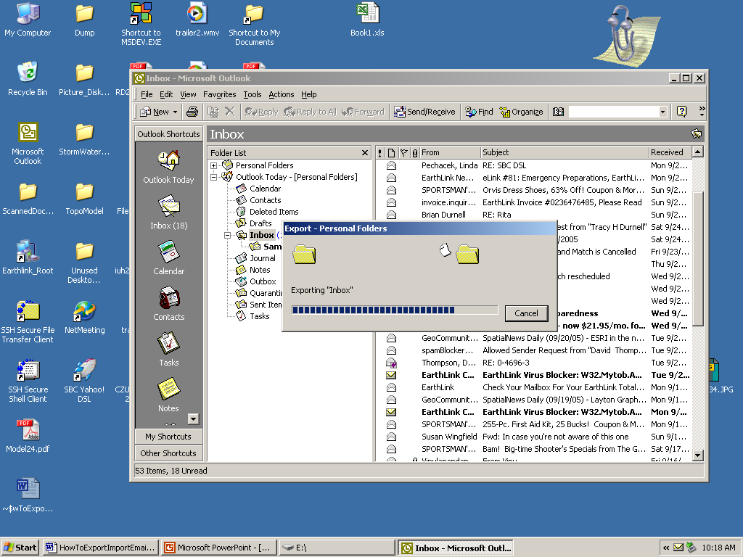
Figure 15. Creating the export file. Just wait.

Once the process is complete check the destination directory to be sure a file was created and the file is NON-Empty.

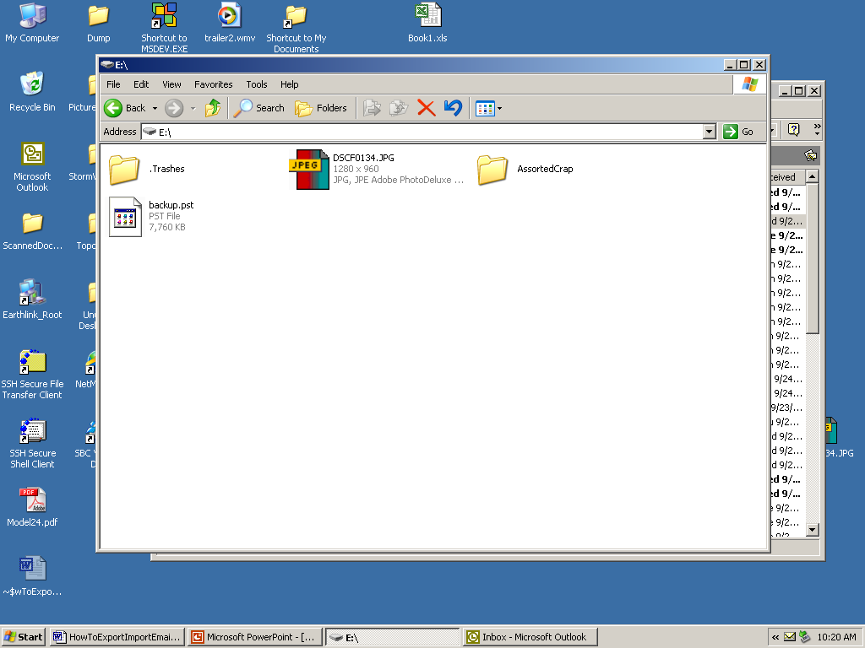
Figure 16. Export is complete, file appears large and thus you are done.

Step #7 ) Close the Outlook program.
Step #8 ) Close the flash drive directory.
Step #9) Dismount the flash drive.

Move the mouse cursor to the hardware icon (Figure 2), and click the RIGHT button. The hardware icon has a callout box that says “Remove Hardware Safely”

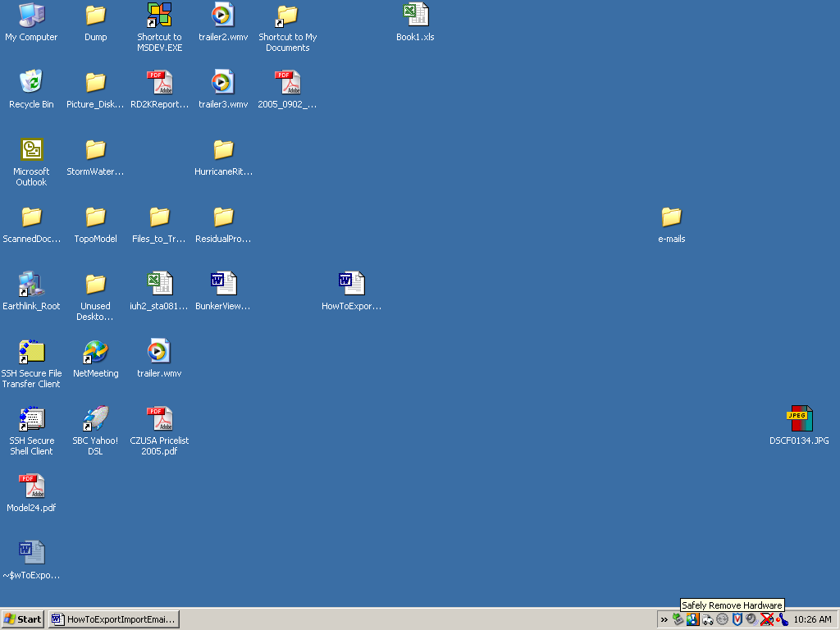
Figure 17. Hardware removal icon. Extend the tray if it is not visible. Right-click the mouse on the icon.

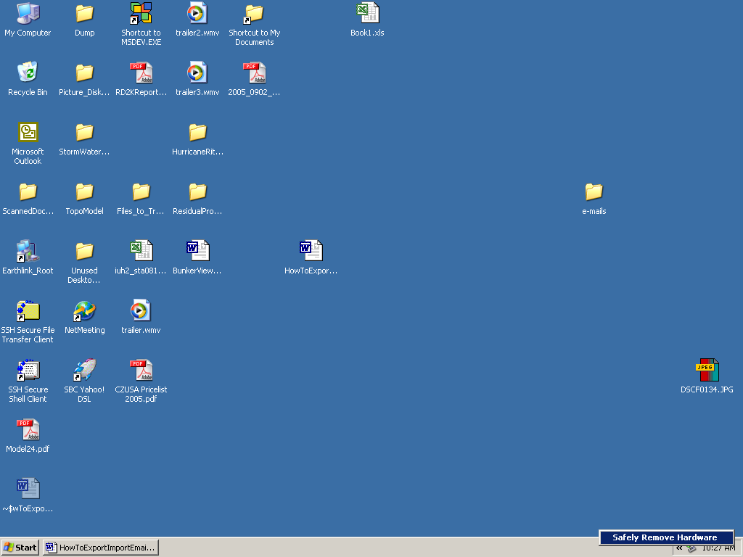
Figure 18. Click the "Safely Remove Hardware" botton.

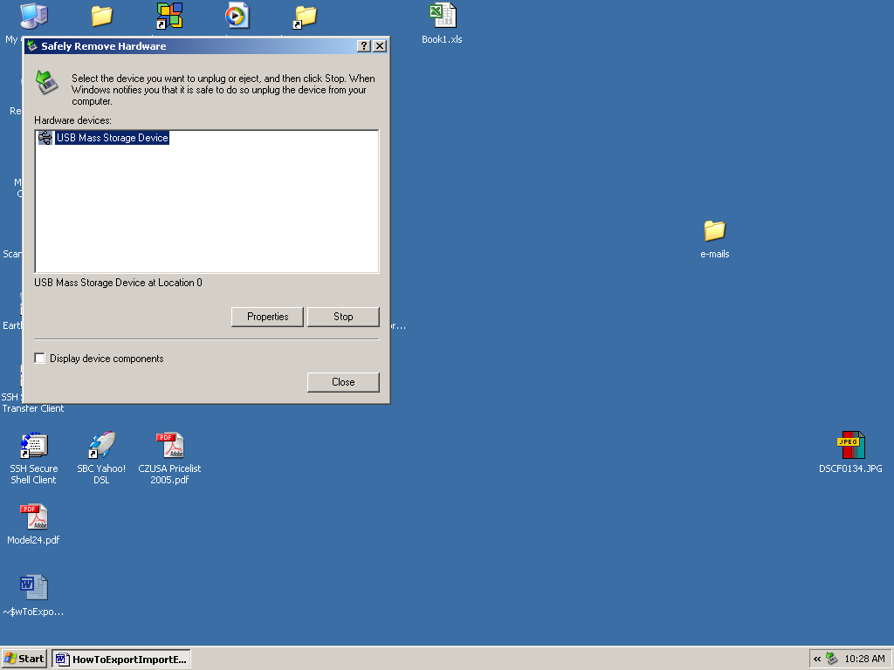
Figure 19 . Dialog box showing removable hardware. There may be multiple devices. The flash drive is a USB Mass Storage Device. Click on the device to highlight it, then select STOP.

The computer will then present a dialog box that identifies the device and drivers that will need to be halted. This is normal. If you fuck up, you will not damage anything – just reboot the computer if you think you did something wrong.

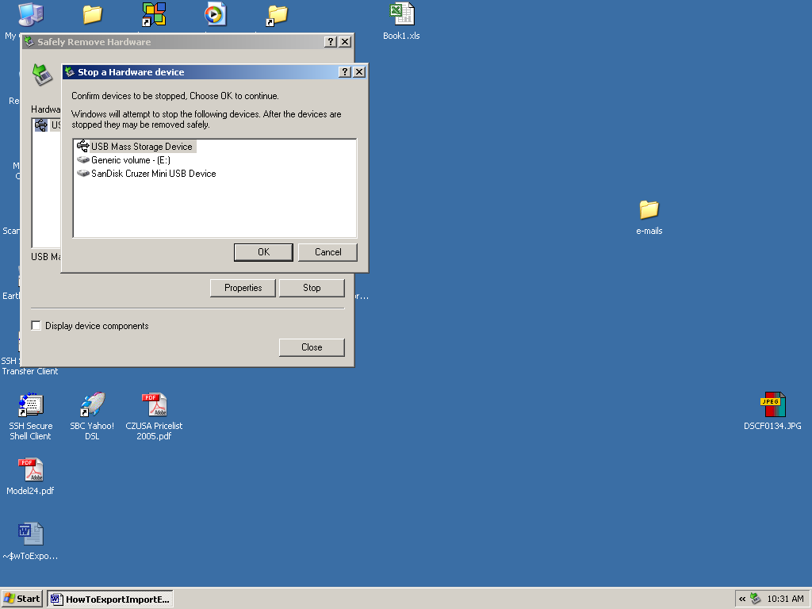
Figure 20. Device name, various drivers. Choose "OK"

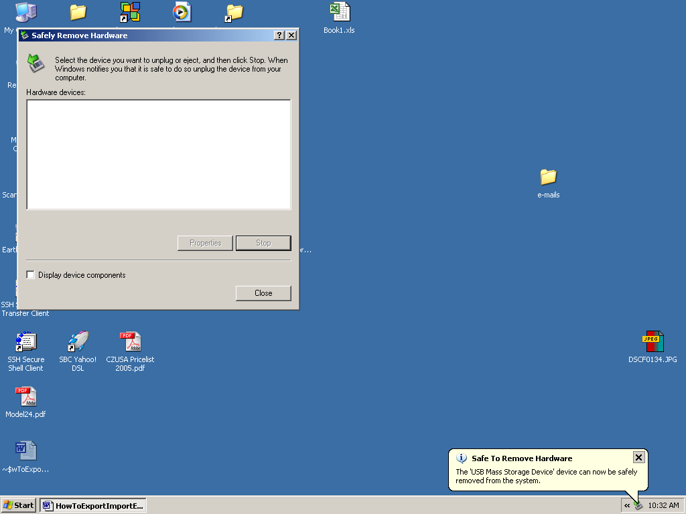
Figure 21. The device can now be removed. Simply pull it out of the USB port. The computer might burp or make a funny noise, but otherwise it is OK.

Close the dialog, and you are done. You have now made a duplicate of your Inbox in a file that you can transfer to the New Computer.

How to import the file onto the new computer is the subject of another How-to.

