Purpose: The purpose of this document is to demonstrate how to get “R” running on a Windows computer.

Assumptions: This document assumes the following:

- You have internet connection.
- You have sufficient user privileges to install software on your machine. (If you need someone else to install, I did my install by running the installer as a local administrator – obviously you need the password)
- You have 60MB or so of vacant disk space on the system directory.

Step-by-Step: Getting and Installing “R”

Step 1: Google “R”

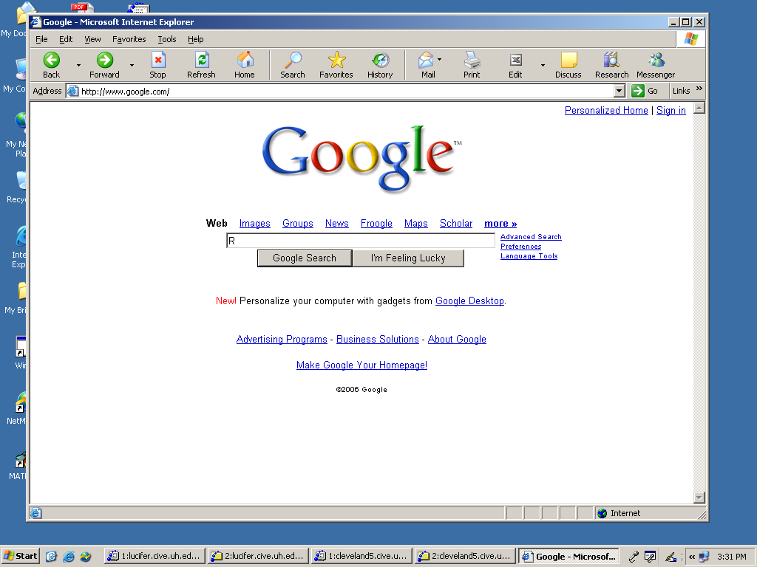

Step 2: Select “R” GNU project

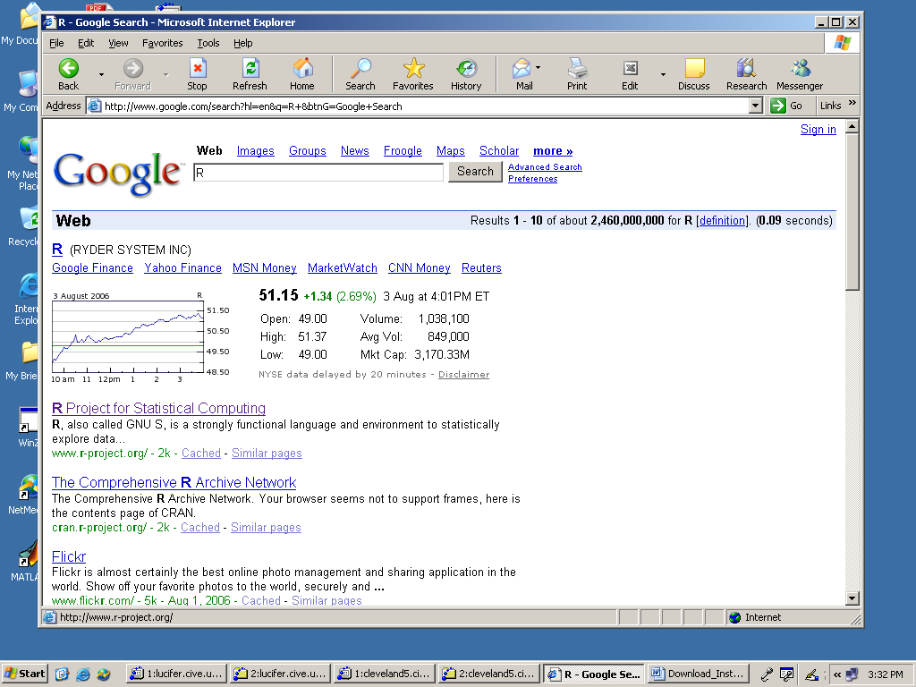

Step 3: Select Download in the Left Frames (CRAN)
(Actually, do some reading on the R pages – it has extensive “How-to”)

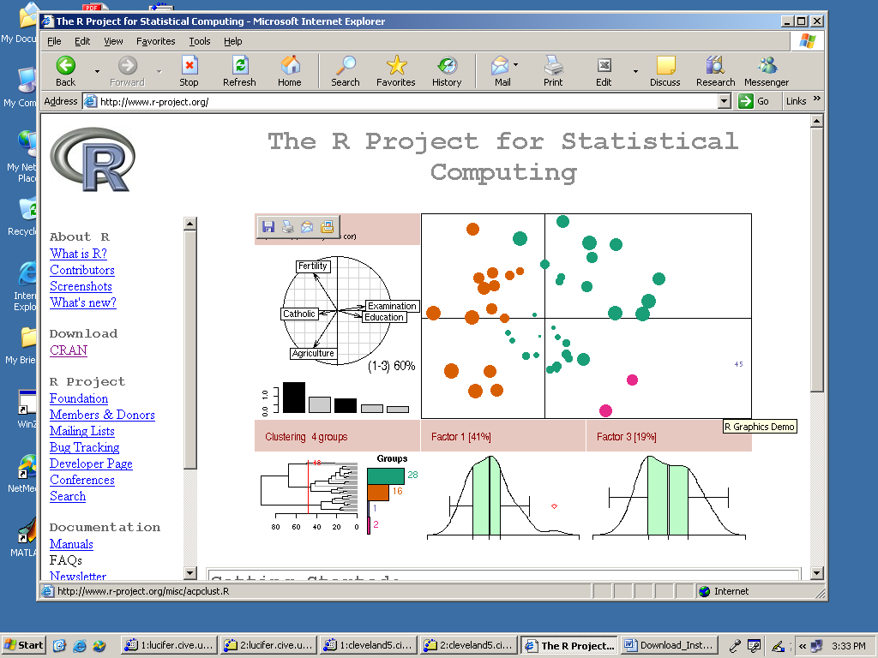

Step 4: Choose a repository.
USA, Canada, and UK are usually fast downloads.
Also “.edu” are usually good choices.
I used the UCLA source (because I graduated from there!)

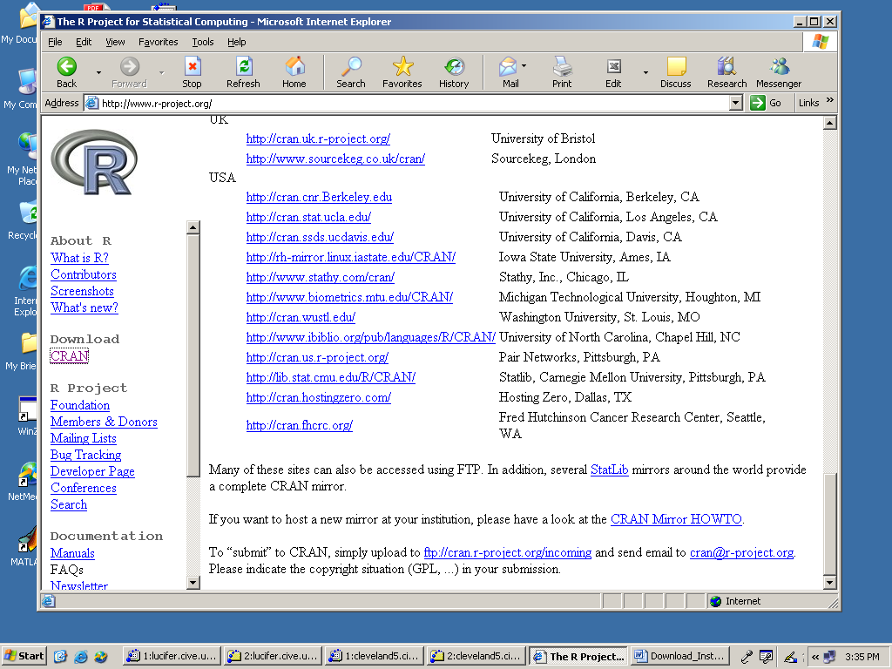

Step 5: Select your platform
Windows; MacOSX; Linux

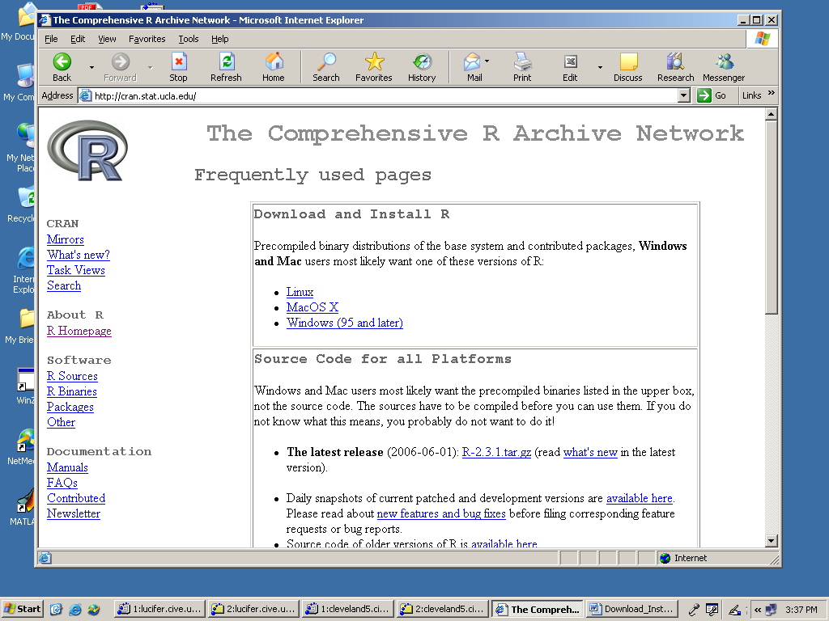

Step 6: Select “base” to get the base packages.

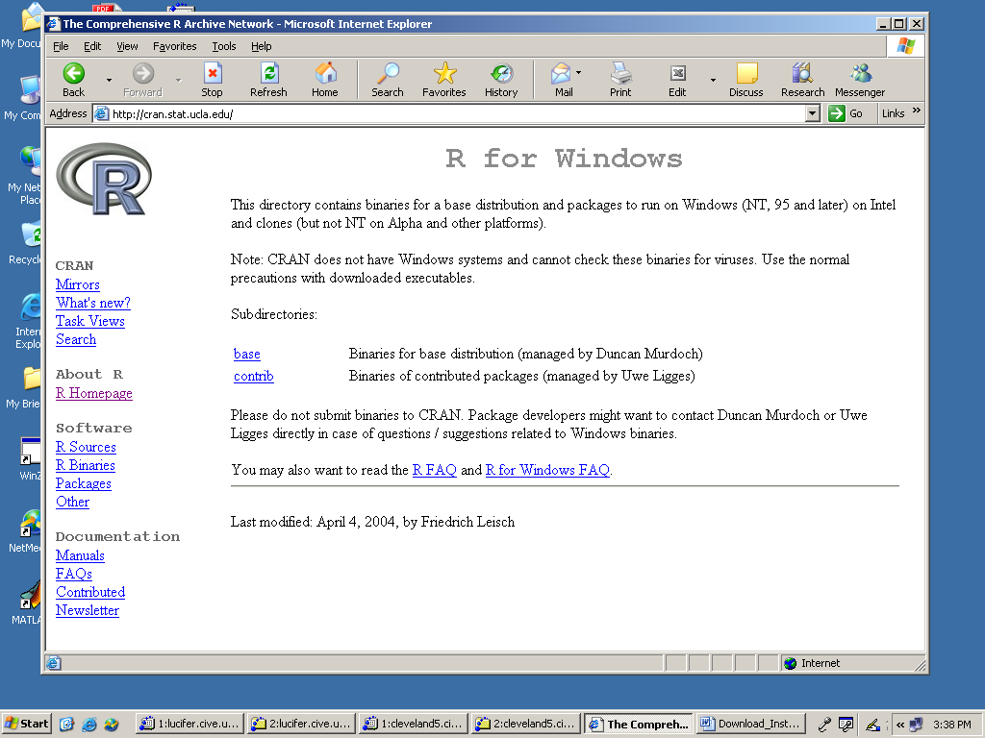

Step 7: Download the installer

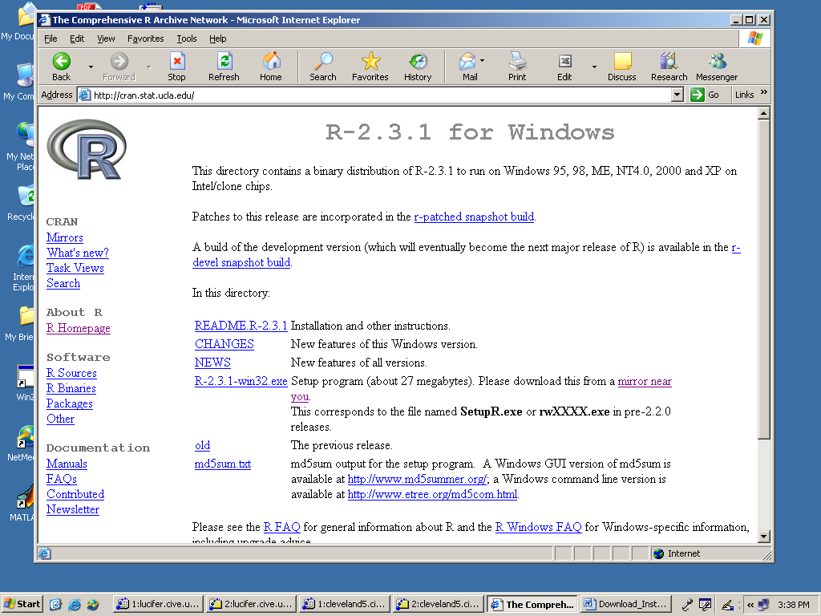

Step 8: Downloading

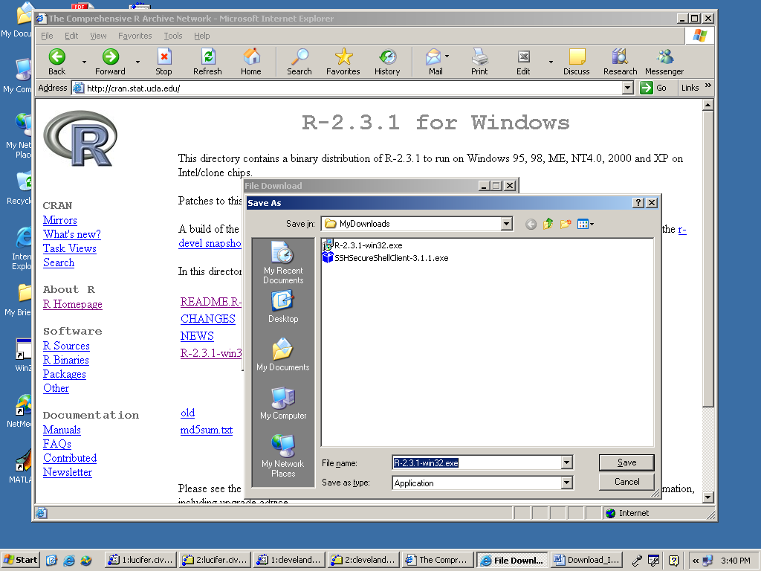
Step 9: Installer running (Run as Administrator)

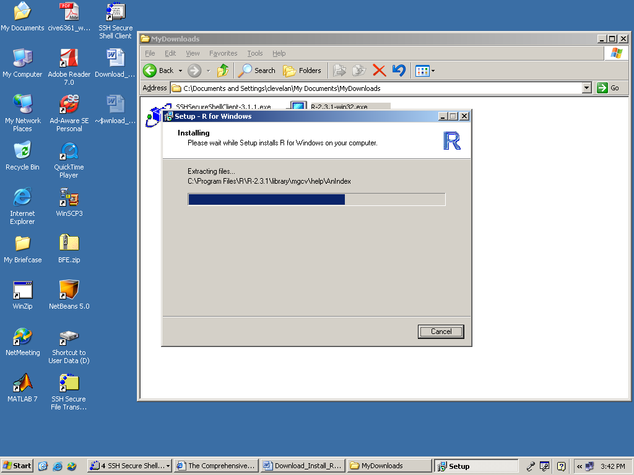

Step 10: Verify the Install by trying to run the program and doing something simple.

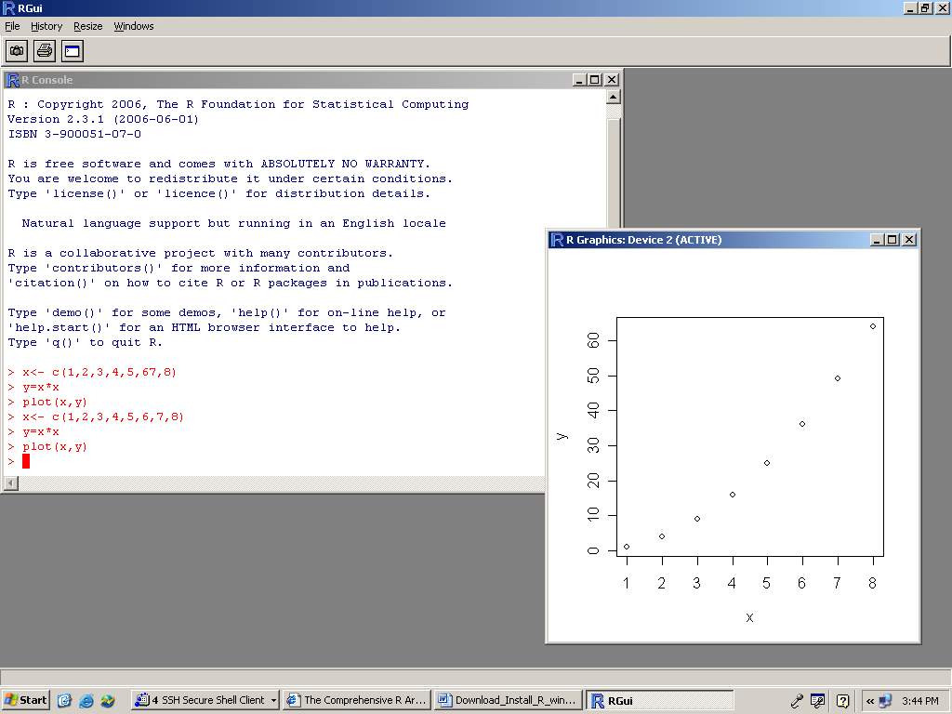

Yipee! It is running. You can install additional packages now or later.

You should now have sufficient computation capability for much of the course.

You may still need FORTRAN or PERL for data file formatting.

A GNU-FORTRAN compiler for Windows is available; it is sort of hard to use, but more than adequate for this class and it is the subject of another How-to.

