Purpose: This document explains how to generate plots of cumulative and incremental hydrographs using DPlot graphics calls.

Requirements: This document assumes you will generate the files on a Windows machine with a copy of DPlotJr (http://www.dplot.com) installed and running. The program is freeware and allows simple graphics to be generated from FORTRAN, C, C++, and Visual Basic. In the present we use it to generate plots of all storms analyzed. If a specific storm is of interest, or more sophisticated single plots are needed, use Excel and load the particular data file of interest.

Instructions: I have written two windows programs called cum_plot.exe and incr_plot.exe that generate cumulative hydrographs and incremental hydrographs. The program and DPLOTLIB.DLL are copied into the directory where the plots are to be stored. Then a file named filelist.dat is created that contains the names of the files to be plotted. These files must be iuh1 or iuh2 files, otherwise the program will produce garbage (if it runs at all). Once the plots are generated they are “saved” by printing each plot to an Acrobat file using Acrobat Distiller as the printer. An example is presented to illustrate how to generate the plots.

Example: The example that follows uses the /dallas/ashcreek watershed as an example. By way of background, the data in this file are the result of running the digital terrain model to generate a single IUH and then this single IUH is used to model the runoff from 5 actual events. The results (in this example) are located in the iuh_sta080####.dat files.

Figure 1 is the directory of interest, in this presentation sorted so the iuh1 files are at the top.
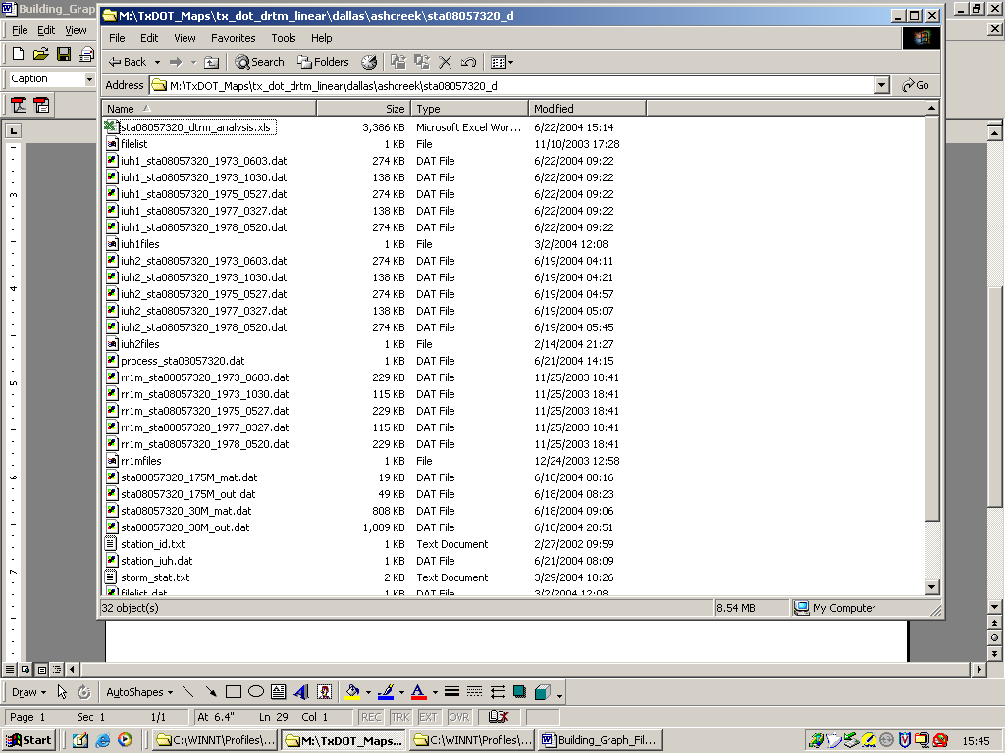
Figure 1. Directory with data and plot file destination.

Next copy the programs and the .DLL into the directory.

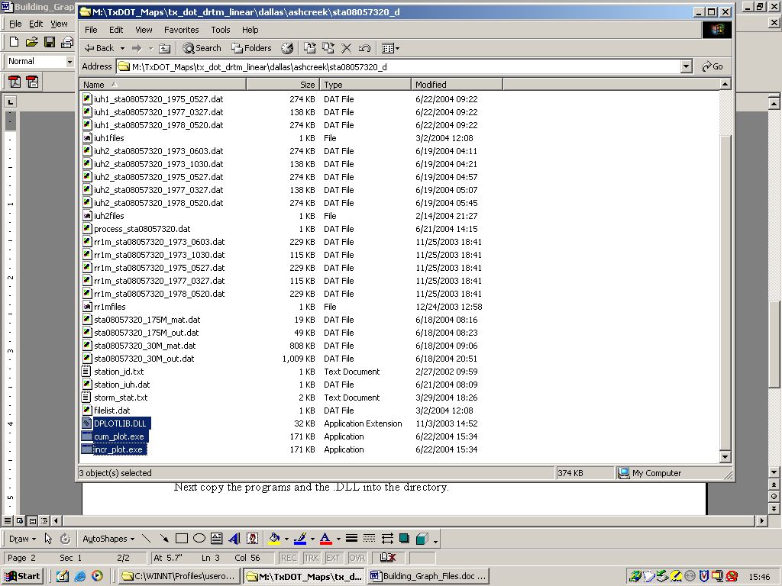
Figure 2. Inserting the program and .DLL

Now simply run the program, we will start with incr_plot.exe. We double click the program or run it from a CMD window.

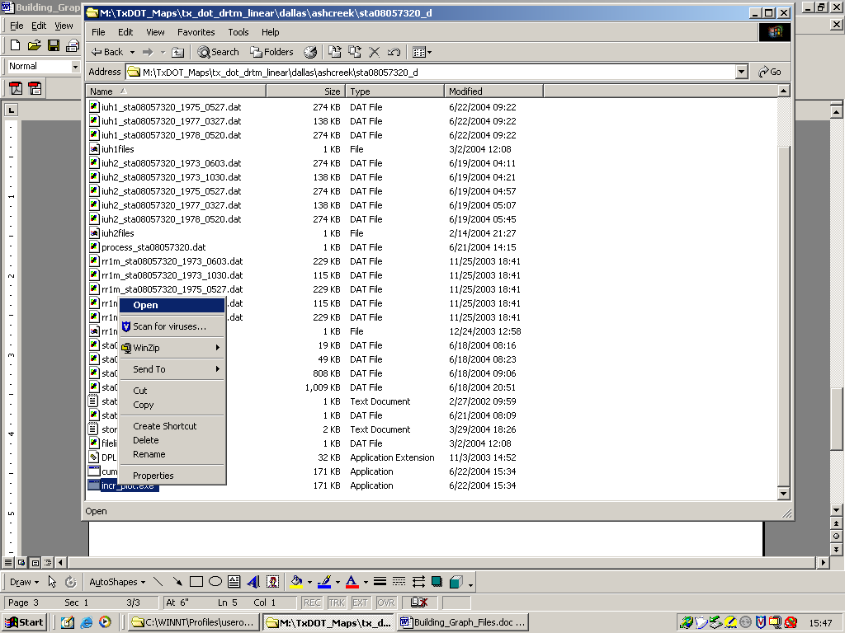
Figure 3. Running the program.

Very rapidly you will see a CMD window for a brief period of time, then DPlot will open and many windows will be generated. When all the plots are done (seconds of it works correctly) we can then begin to save .PDF images.

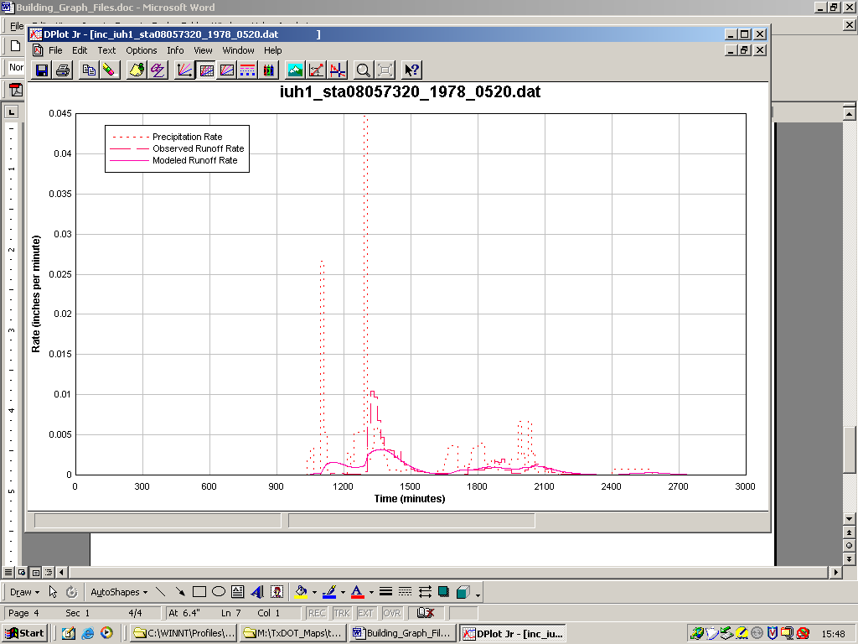
Figure 4. Program output (note, we are now in DPlot Jr)

To save the plot, choose print from the DPlot Jr menu.
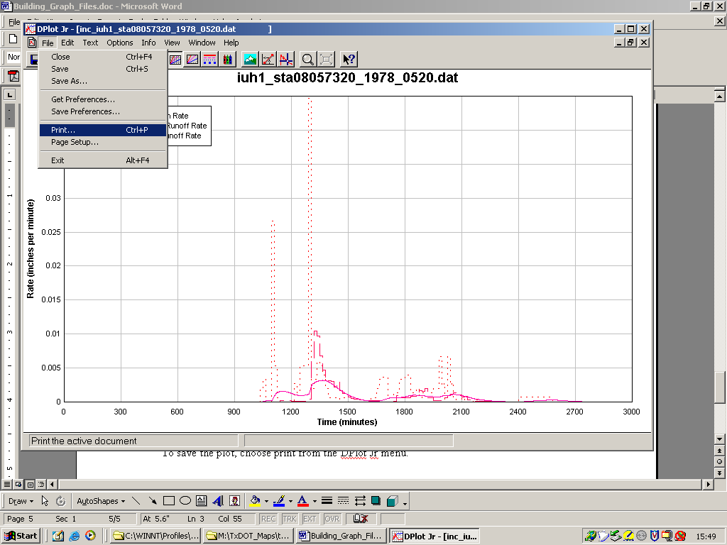
Figure 5. Printing the active window

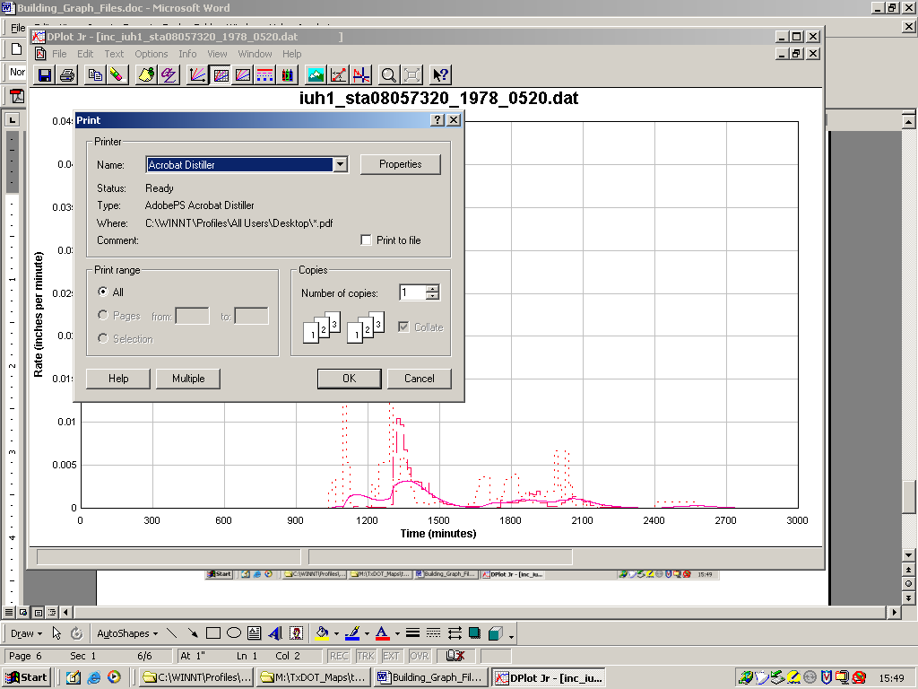
Figure 6. Select Acrobat Distiller

Now set the Adobe program to the correct directory, and the file name should be automatically generated.

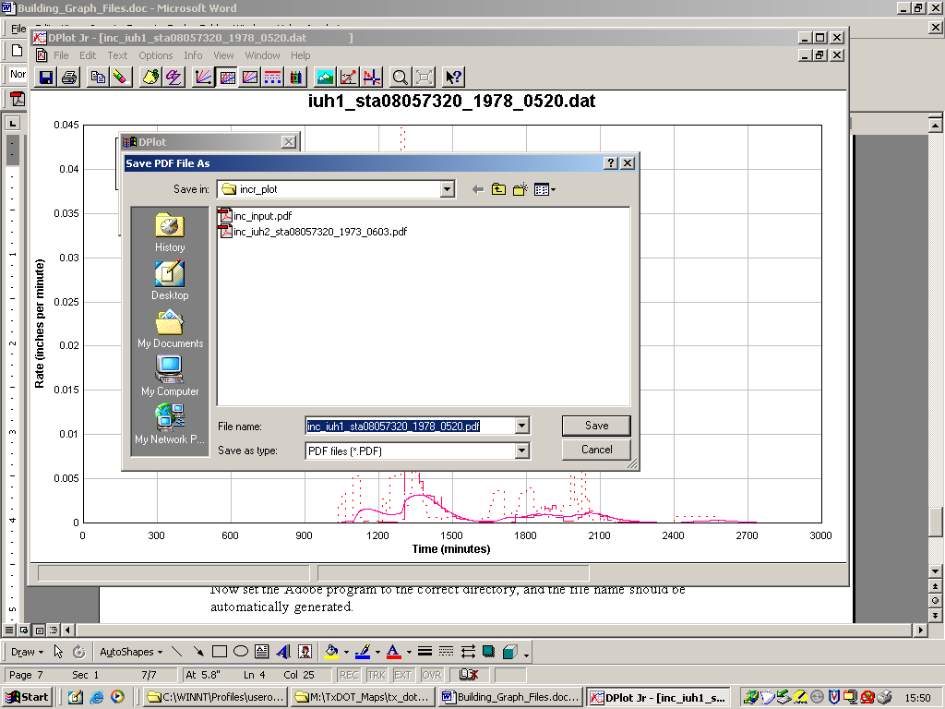
Figure 7. Wrong destination directory, browse to correct directory.

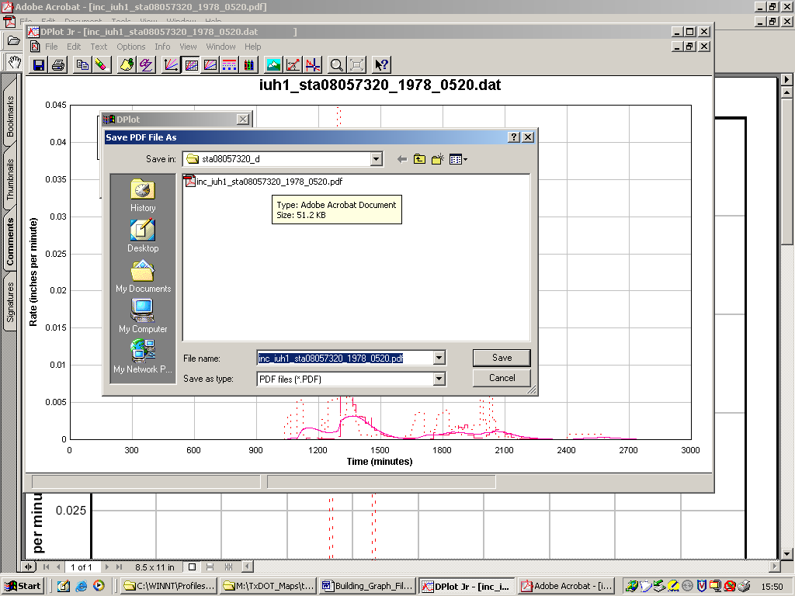
Figure 8. Correct directory, note filename is automatically generated by the program.

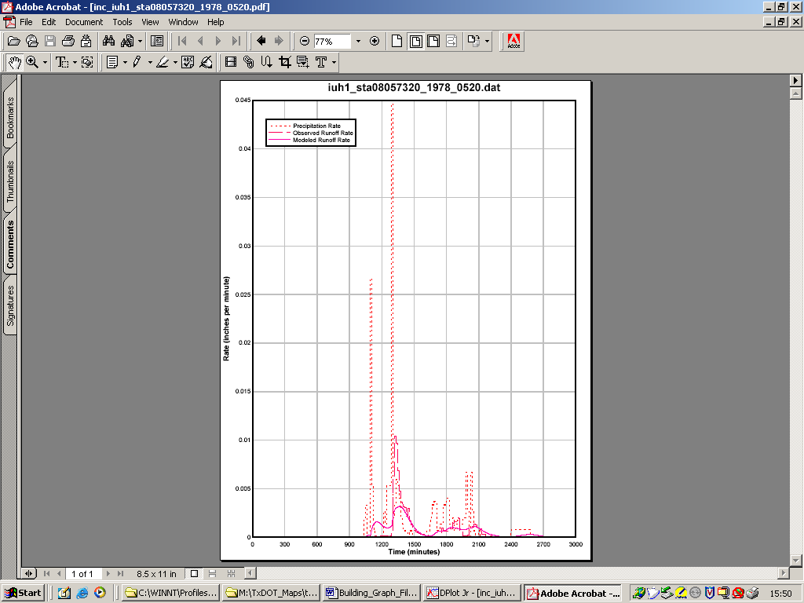
Figure 9. Typical acrobat result.

Close the plot and then “print” the next plot. Continue until all plots for the directory are printed.

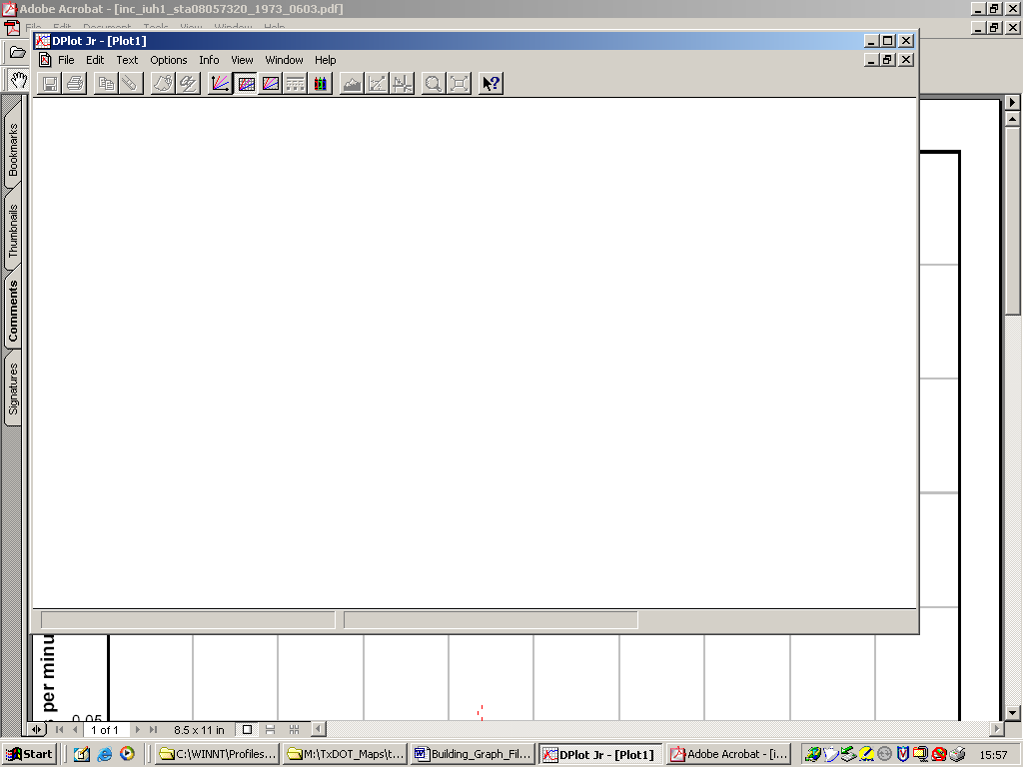
Figure 10. All plots done (Close files as you go)
Exit the program, and repeat using the other program (file names automatically reflect whether plots are inc_ or acc_ files).

This procedure should permit one person to generate plots for the entire database in a manner of days. Obviously, keep track by directory of any errors so we can modify the plotting program if needed.

