Purpose: This document explains how to prepare DEM map mosaics (multiple adjacent maps) for building DTRM maps.

Requirements: DEM maps of adjacent quadrangles, converted into asciiXYZ format. SURFER program for grid generation and image manipulation.

Preparing a File

Step #1 Identify the maps needed, for example, austin/boggysouthcreek/sta08158880_d lies part in the Austin East and part in Pflugerville West quadrangles, respectively.

Step #2 Copy the ###.XYZ files for each quadrangle into the destination directory where the mosaic will be constructed.

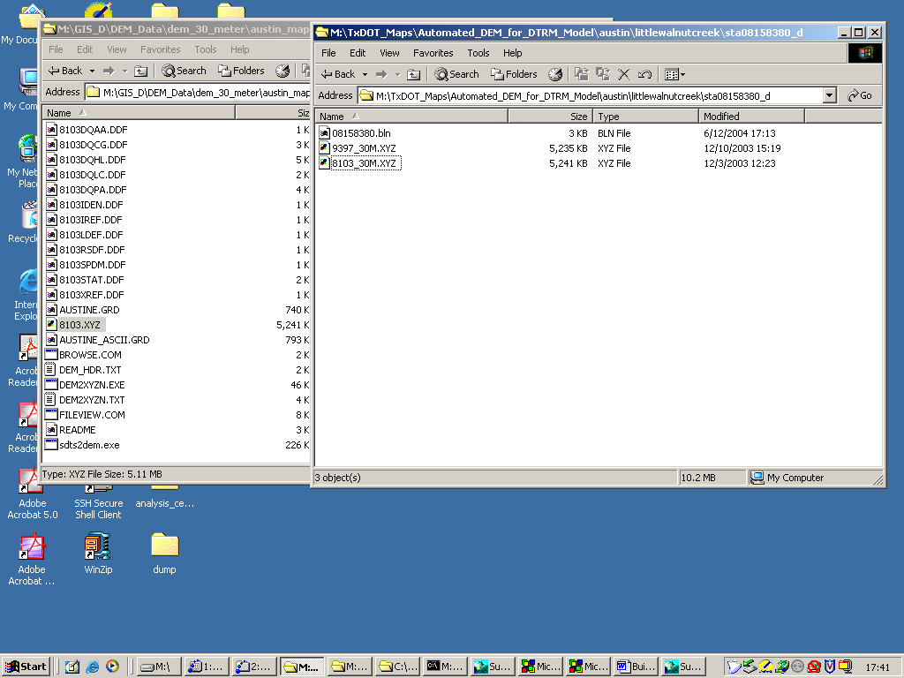
Figure 1. Copy the two XYZ files into the destination.

Step #3 Use the program joinXYZfiles.exe to join two adjacent files. If you need to join 4 files, run the program in several sequences. The program uses a command line interface, if using UNIX the cat command should work well, especially for odd numbers of files.

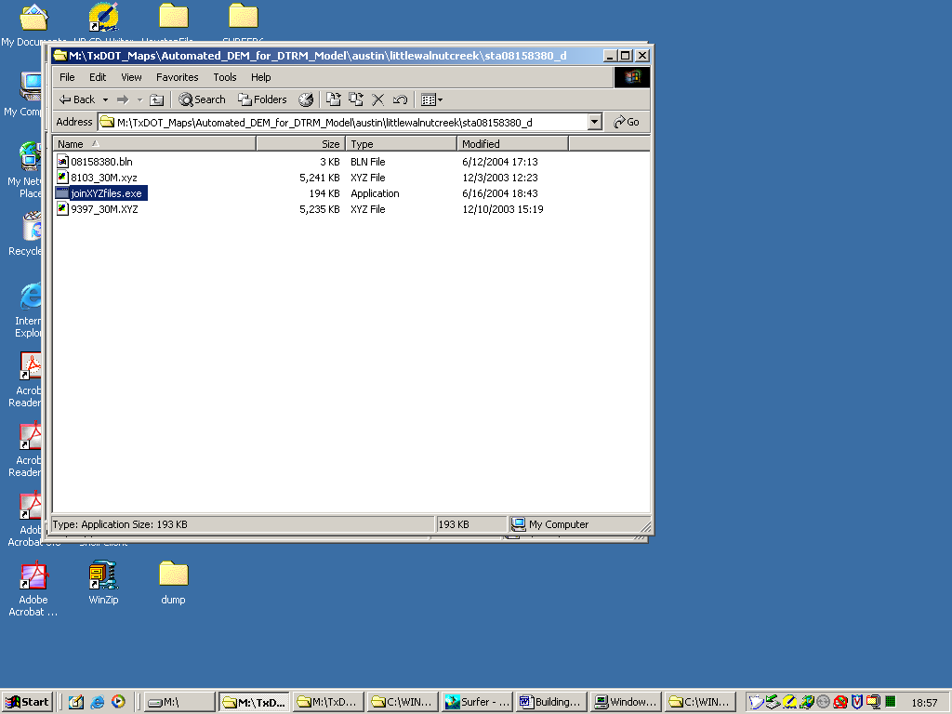
Figure 2. Copy the program into the working directory and start the program.

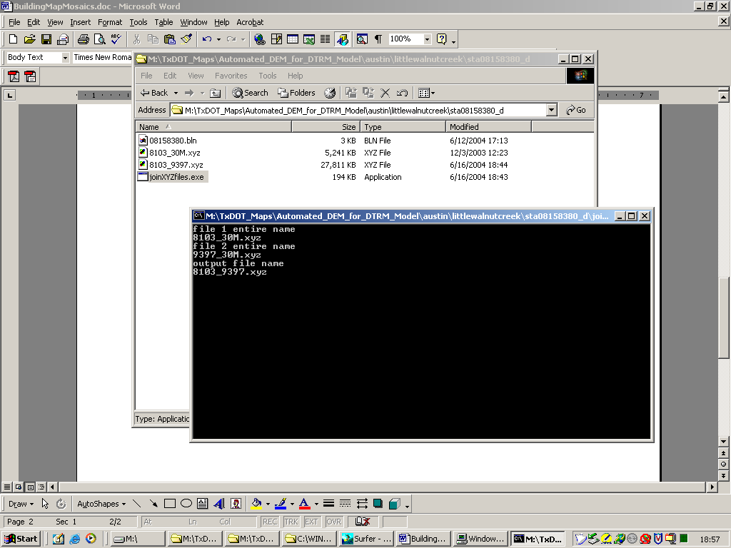
Figure 3. Enter file names, include extentions.

Step #4. Use SURFER to construct a grid file from the new XYZ file just created.

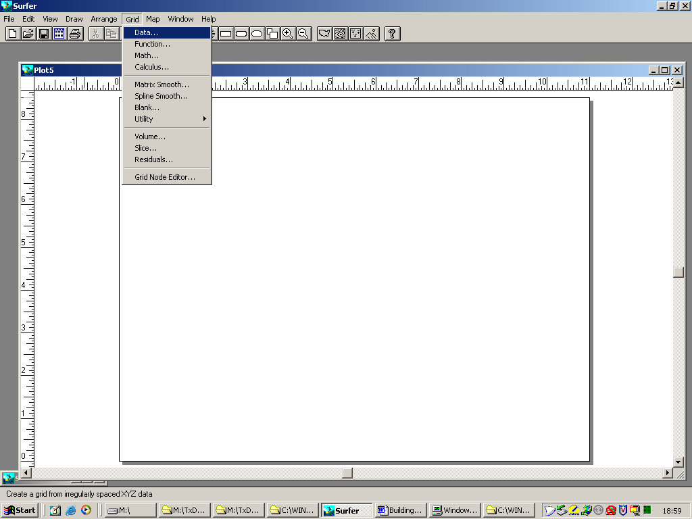
Figure 4. Grid/Data then select data set.
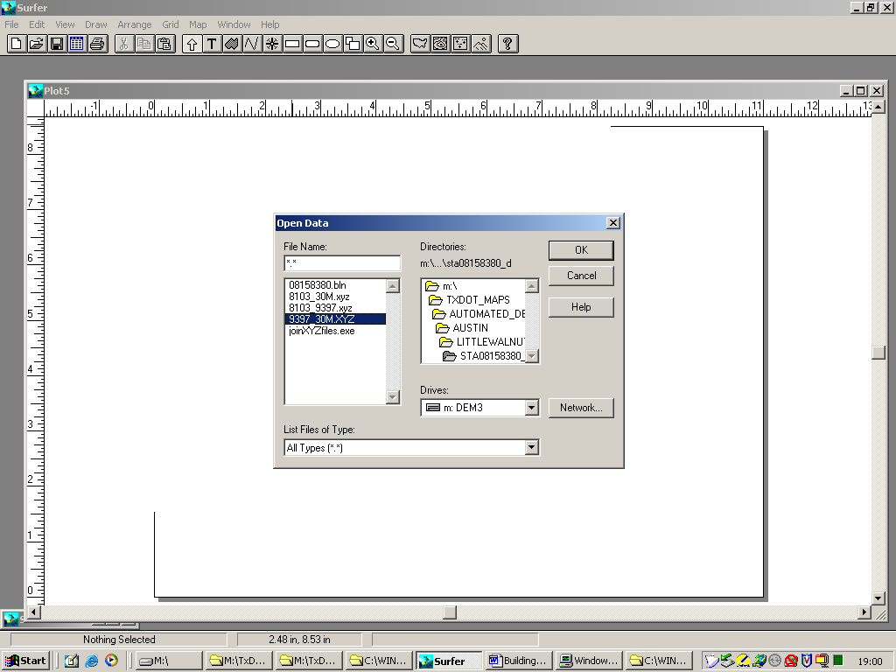
Figure 5. Choosing data, note selected All File Types.

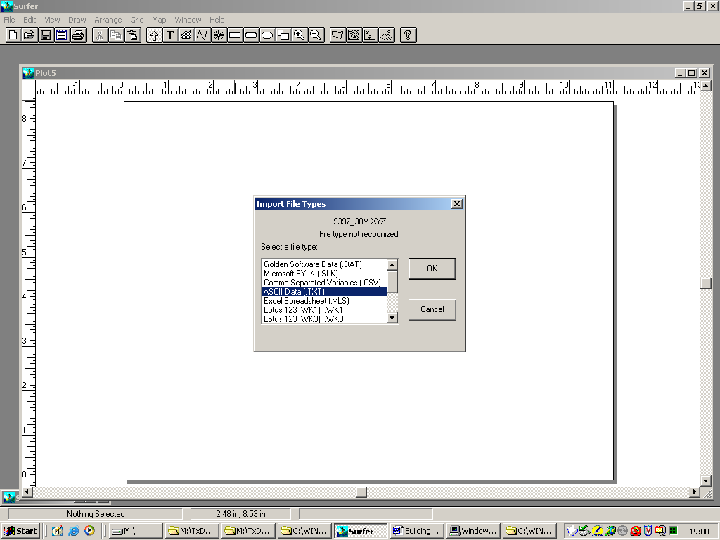
Figure 6. Tell SURFER that a .xyz file is an ASCII file

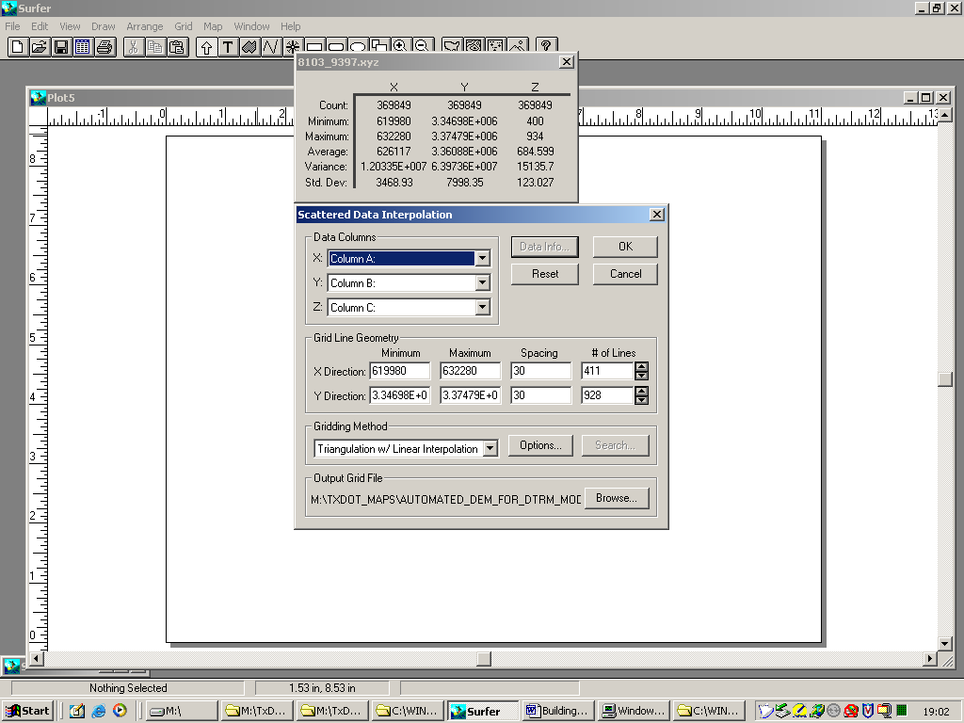
Figure 7. Check the data info then grid. Triangulation is fast and exact if the grid size and data scatter are on same spacing. In our work, be sure the grid sizes are set to 30M otherwise the result will be garbage.

Step #5. Construct the DEM as if it were on a single map. The new grid should be a mosaic of both original data sets, use SURFER to verify than proceede.

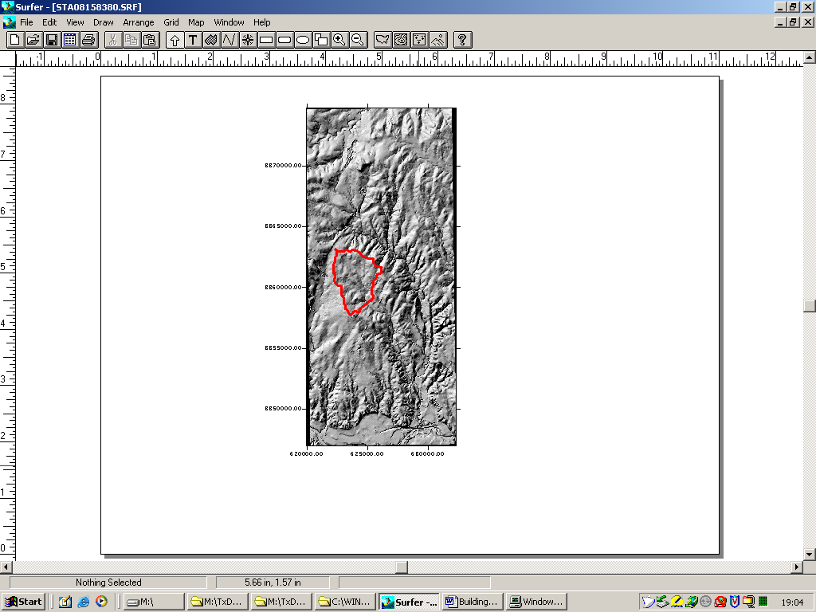
Figure 8. Build .SRF files and other files as before.

