Purpose: This document explains how to prepare the DEM files for input to the Digital Topographic Runoff Model (DTRM).

Requirements: This document assumes you will manipulate data using the SURFER program. While SURFER is not required, it greatly simplifies to data array manipulation. Entirely manual methods are not explained here.

Preparing a File

First be sure you have the DEM quadrangle for the watershed and the boundary definition file. These files will typically have extension .dem and .bln respectively. Both are ASCII files, but not particularly human readable. In this document I will use /dallas/duckcreek/sta08061620 as an example.

Step #1. Locate the DEM for the watershed in our map table. Joes Creek is entirely contained on the Garland, TX quadrangle.

Figure 1. Excerpt of map cross reference sheet.

Step #2. Copy the DEM into the directory where the input files are to be assembled.

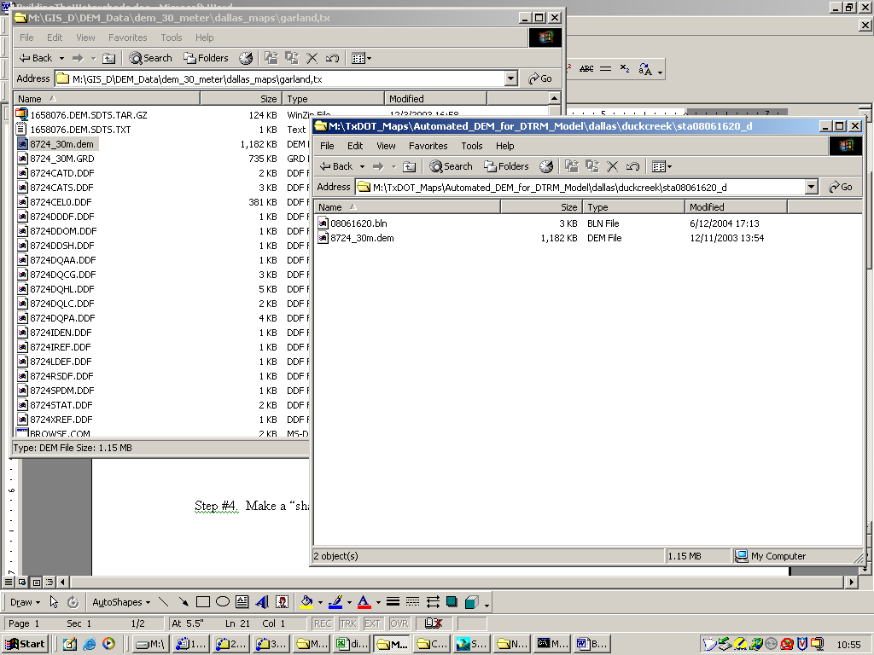
Figure 2. Image of File System on Back-Up disks. Copy (not move) the .dem file for the quadrangle.

Step #3. Start SURFER.

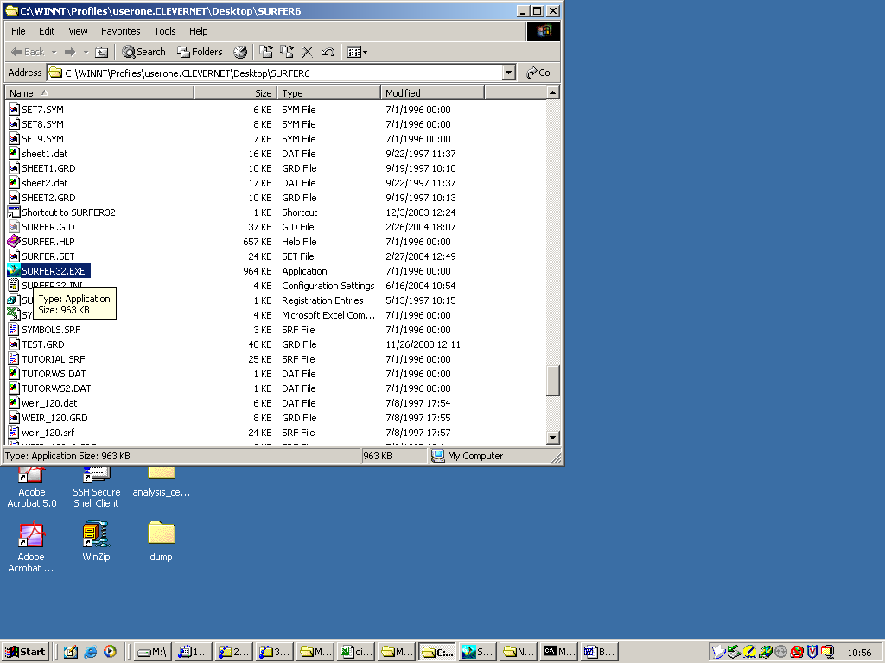
Figure 3. Find and start SURFER.

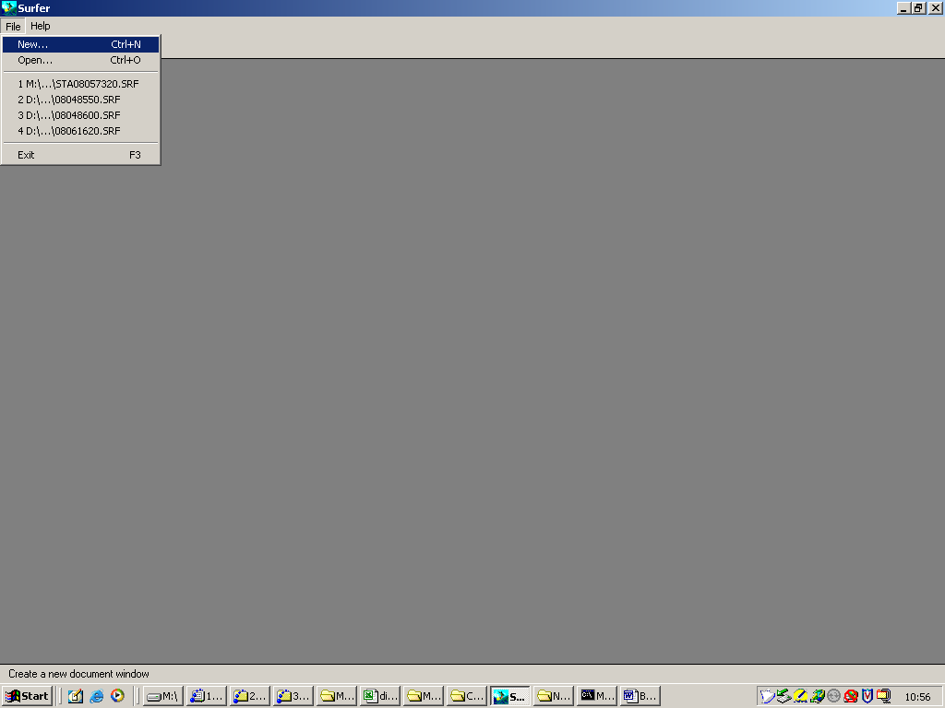
Figure 4. Blank SURFER window.

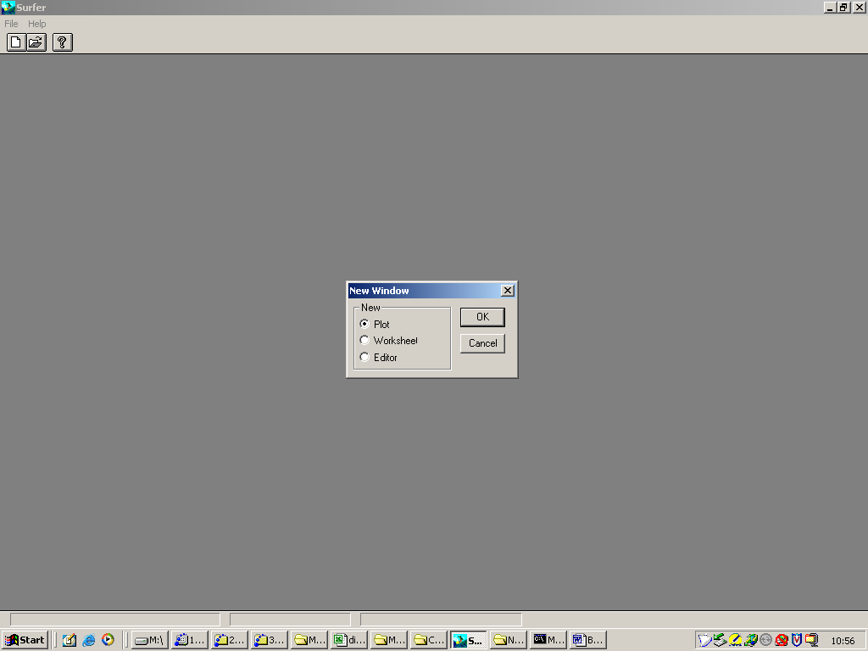
Figure 5. Select File/New/Plot

Step #4. Make a “shaded relief map” using the DEM file.

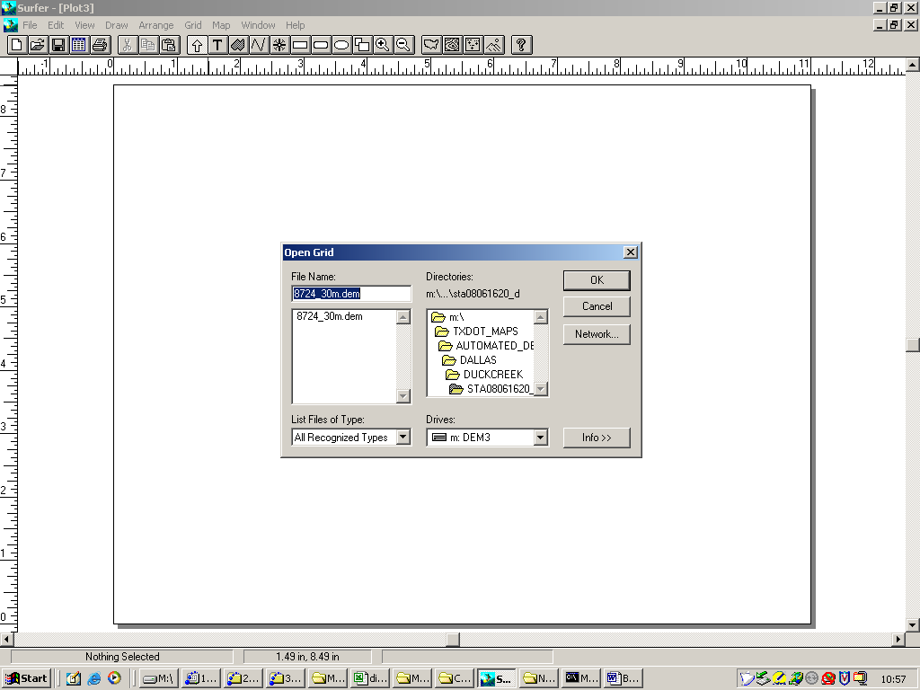
Figure 6. Select Map/Shaded Relief/filename

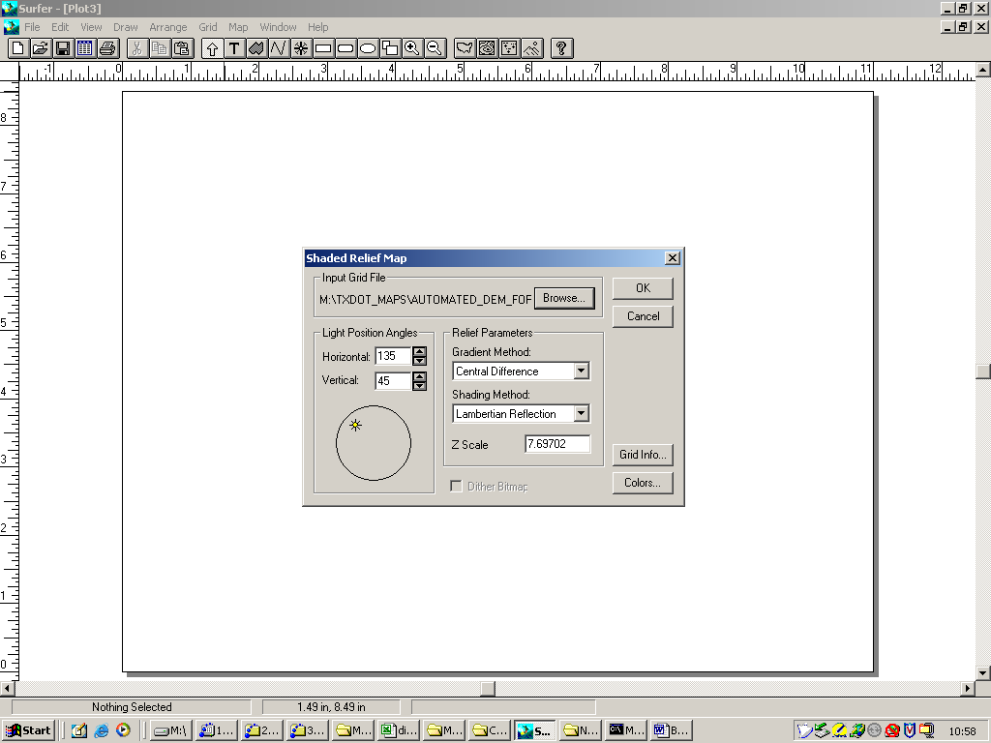
Figure 7. Use the default settings (choose OK)

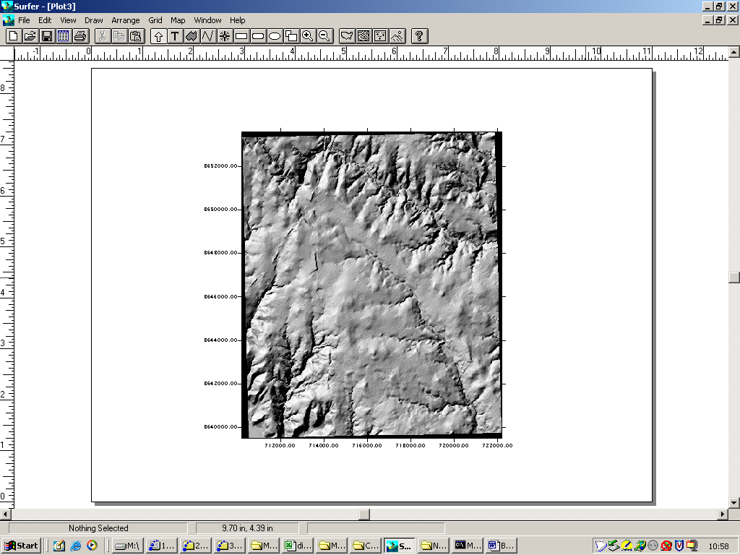
Figure 8. Result map, compare to paper map to be sure have correct watershed map.

Step #5. Compare the image on the screen with the paper map or a digital raster map of the watershed to be sure the correct DEM is mapped. You are looking to be sure the topographic features look correct. Assuming this step is fine, then move to the next step.

Step #6. Choose “load base map” from the surfer map menu, and select the .bln file as the base map. The image will look strange at this point.

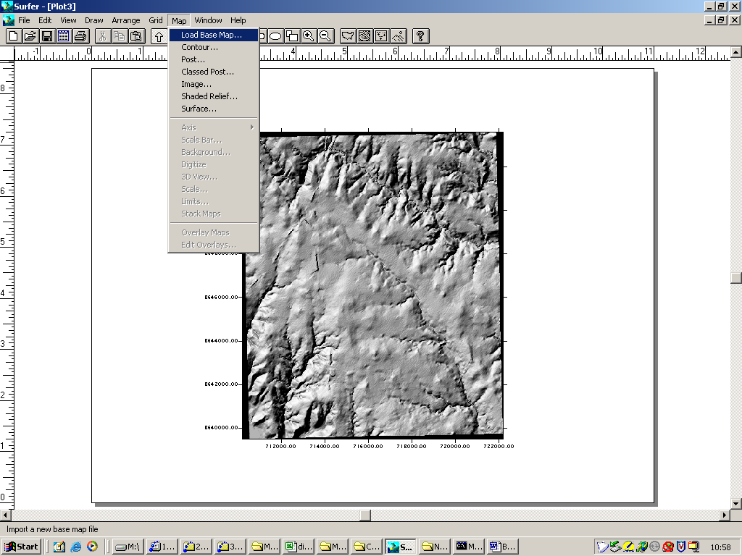
Figure 9. Select Map/LoadBaseMap

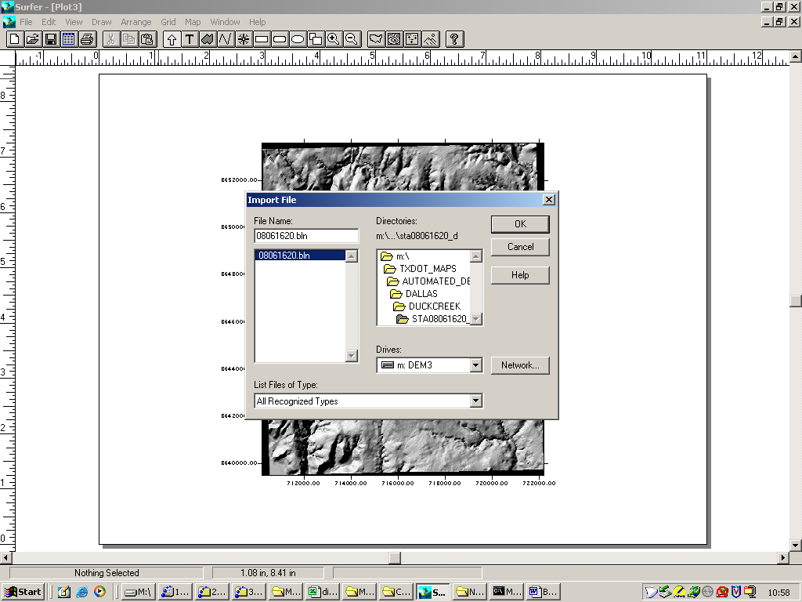
Figure 10. Choose .bln file.

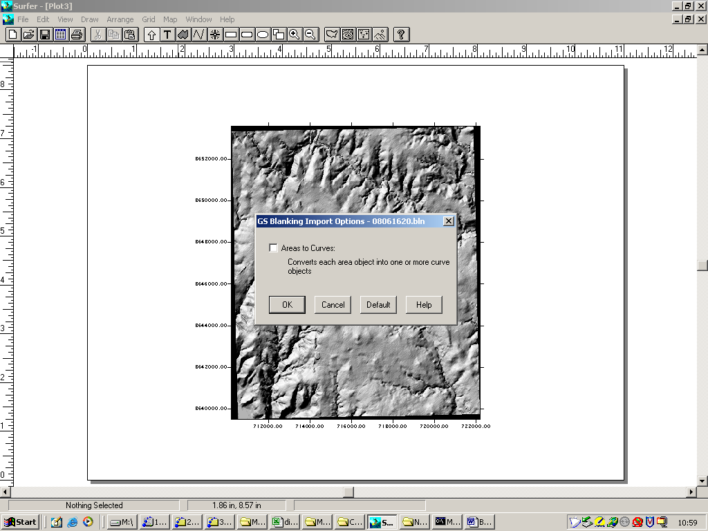
Figure 11. Use the defaults (Choose OK)

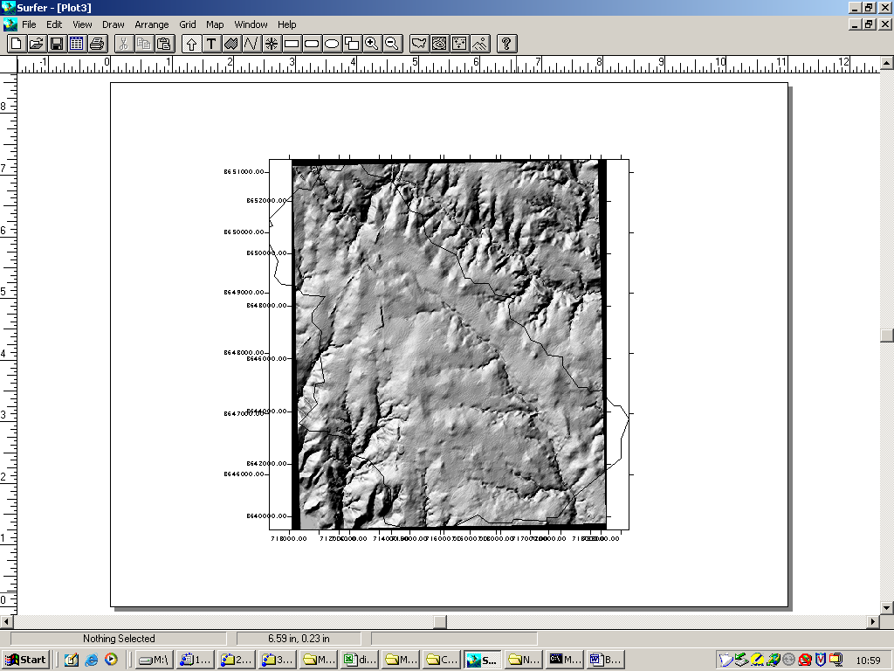
Figure 12. Two maps on same paper, but not yet geo-referenced.

Step #7. Select both maps in surfer, then choose “Overlay Maps”. The image should then properly geo-reference both maps. Edit the overlay so that the boundary renders as a red line (for later use in a report). Compare the overlay with the paper map to be sure the watershed boundary looks like the paper boundary. If needed, edit the .bln file to repair blatant errors. Look for missing digits, most errors I have found are missing zeros in the UTH coordinates at a handful of points.

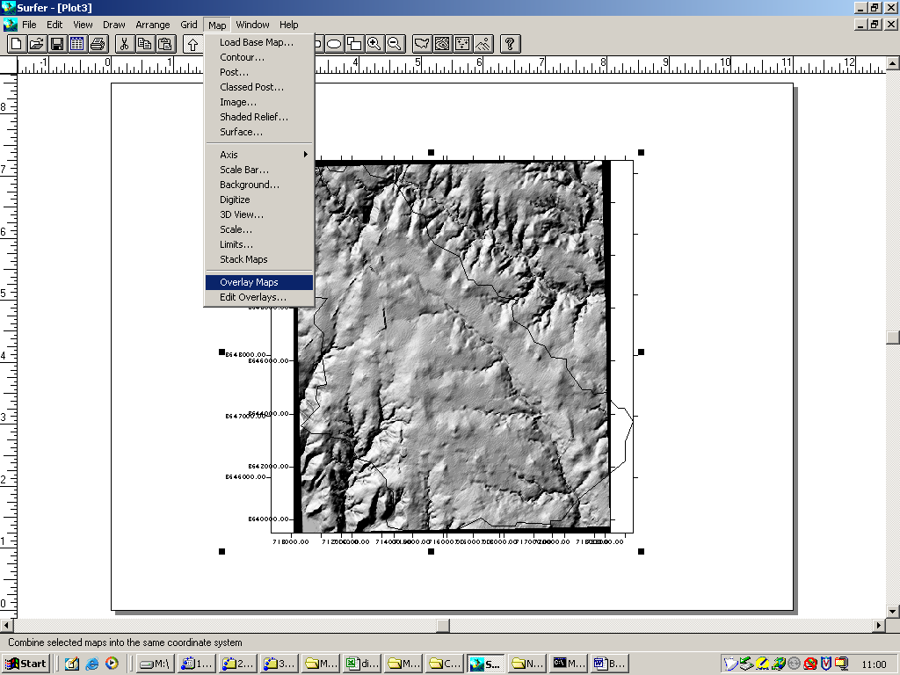
Figure 13. Select both maps, and choose Map/OverlayMaps

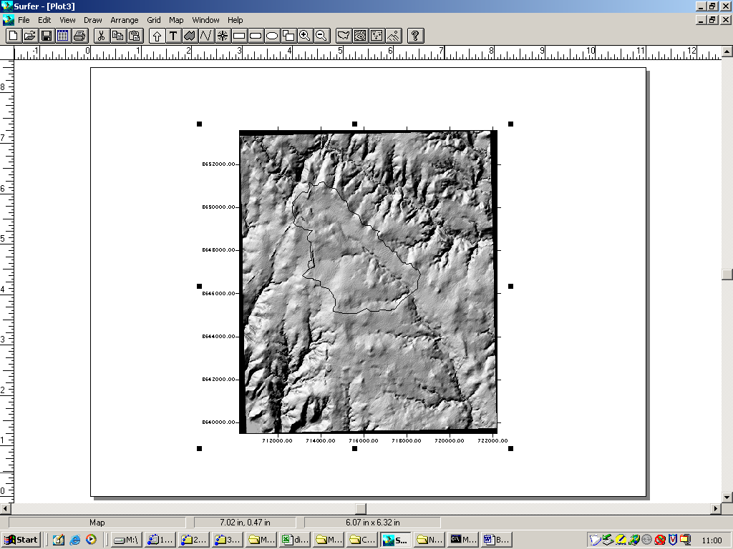
Figure 14. Overlay completed, now edit the overlay for viewing.

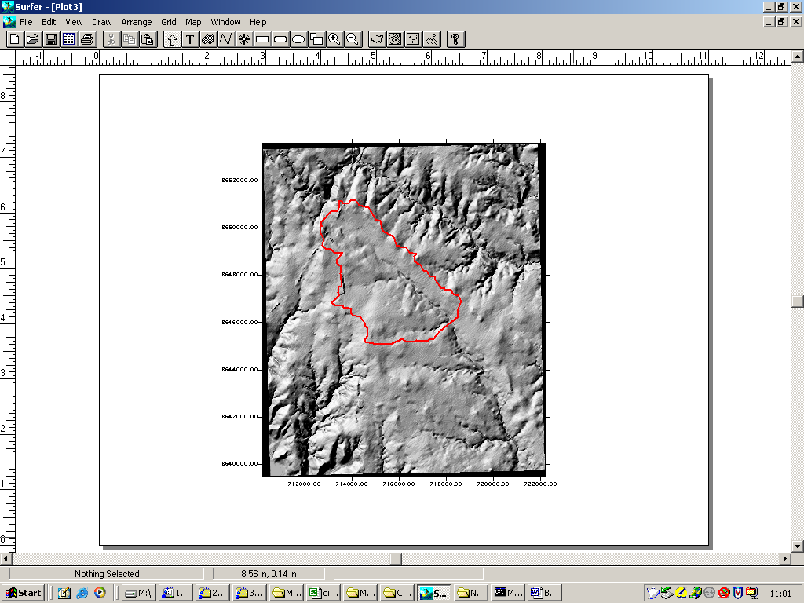
Figure 15. Done! Simply changed boundary to red, and thicker.

Once you decide the .bln file properly represents the watershed boundary, then save the image as a .srf file in the data directory, this file will be used later to prepare a report on each watershed.

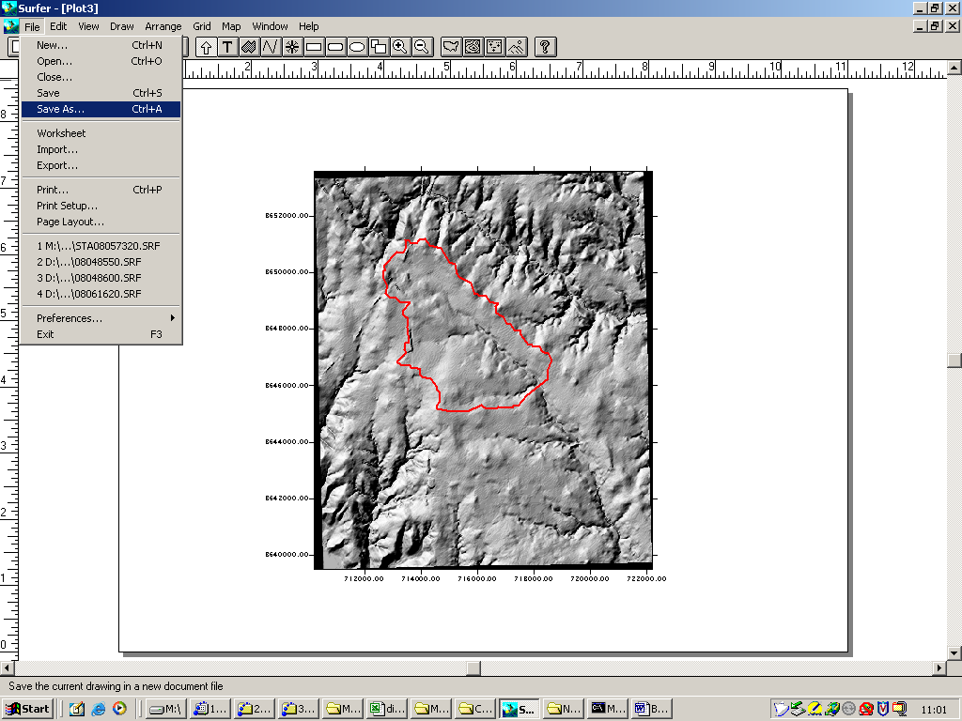
Figure 16. Save the image as a .srf file.

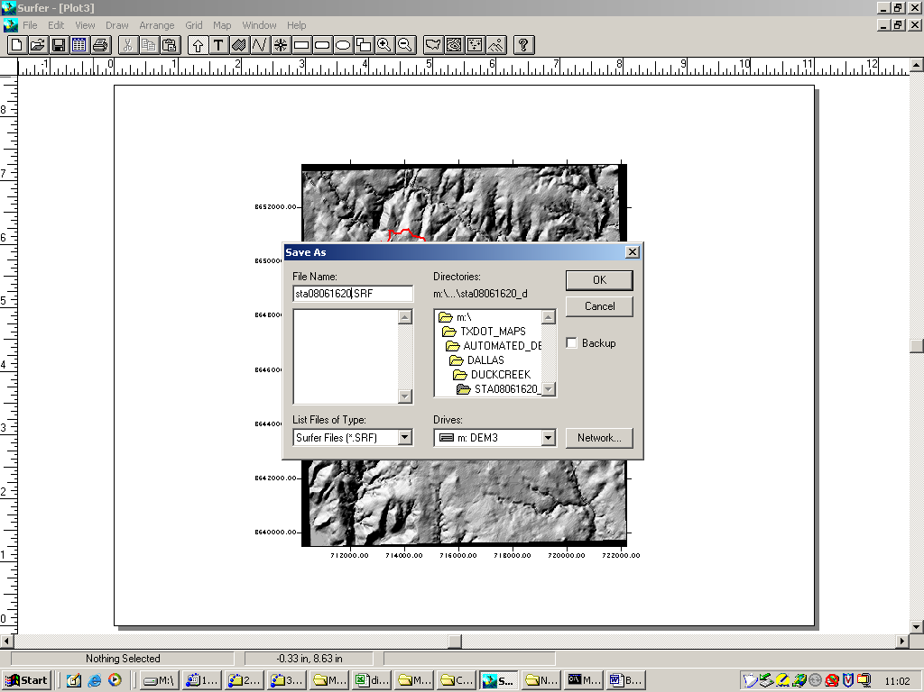
Figure 17. Type the filename based on station ID.

Step #8. Now use the “blank” utility to edit the DEM for the DTRM model. The input grid is the original .dem file. Output grid is sta08061620_raw.grd. Once the output grid is prepared, map the file to be sure the blanking is correct.

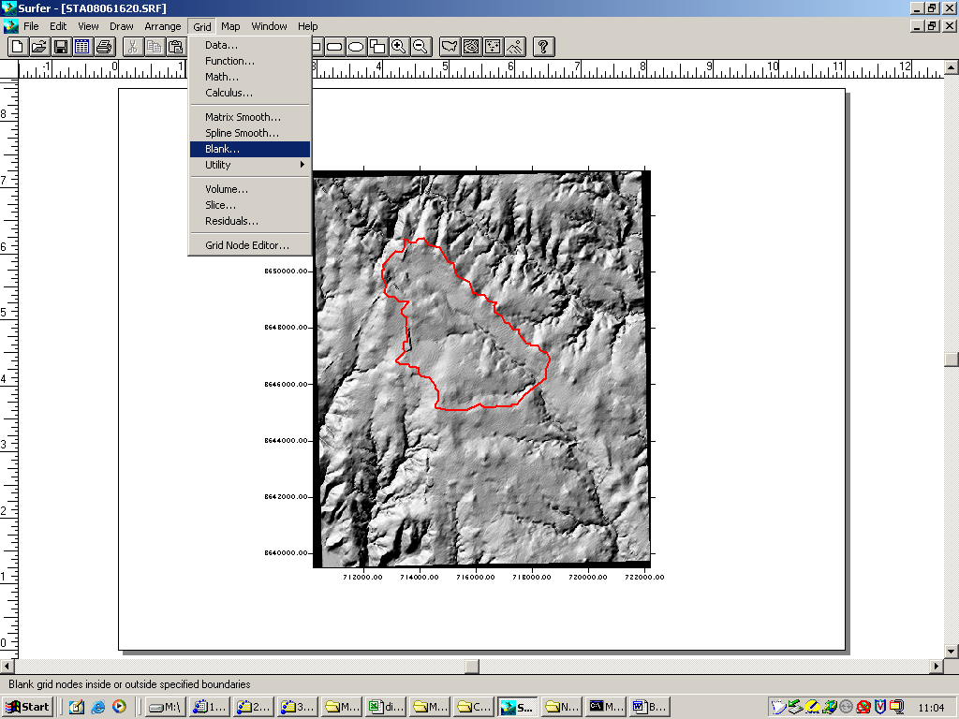
Figure 18. Grid/Blank utility

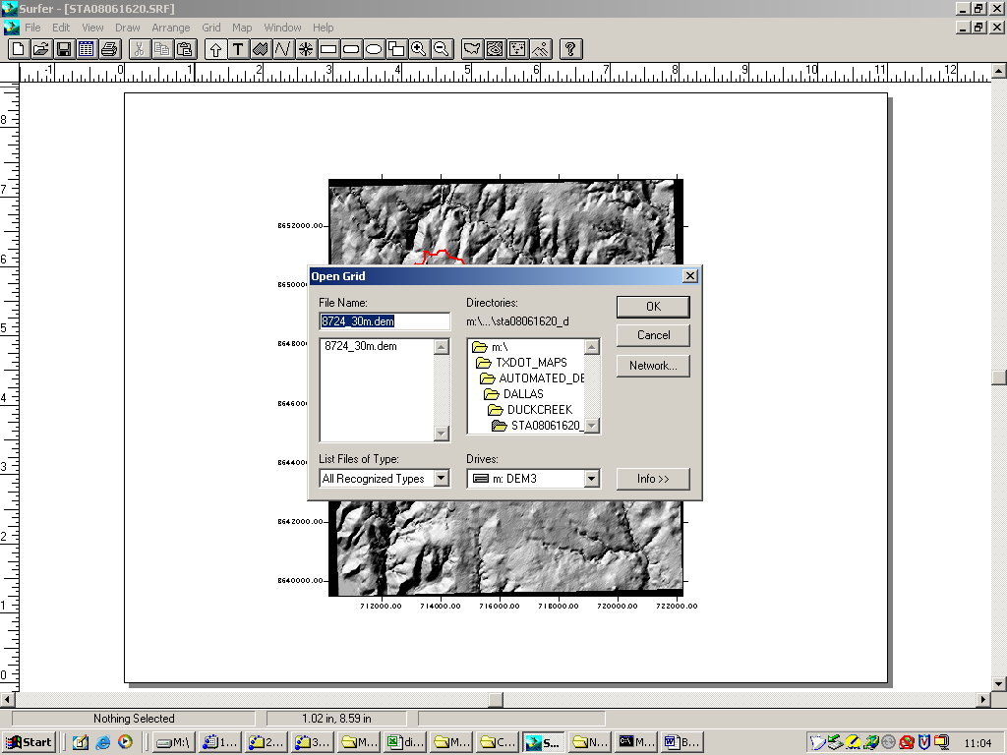
Figure 19. Select the correct grid.

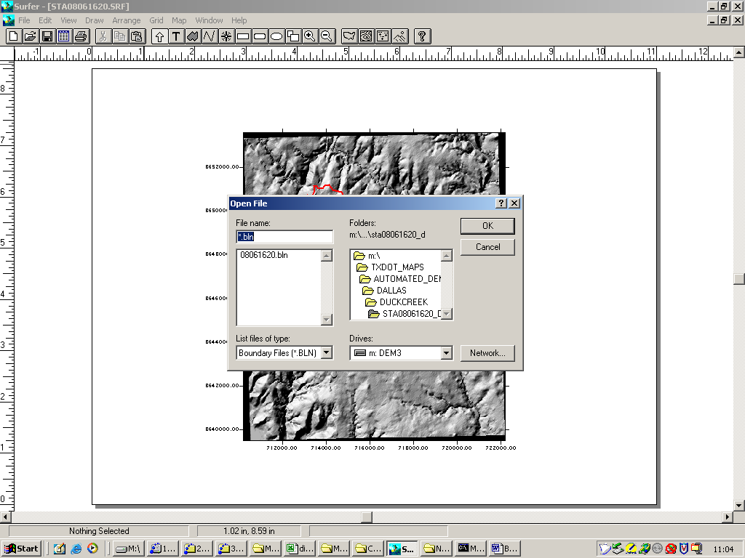
Figure 20. Select the blanking (.bln) file.

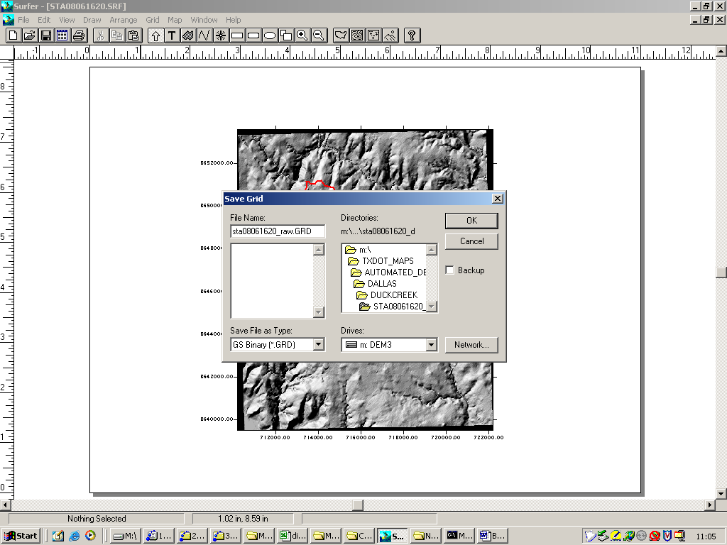
Figure 21. Name the output grid based on station ID.

Step #9. Use the gird node editor to find the boundary rectangle that just encloses the watershed. The concept is to find the Xlow, Xhigh,Ylow,Yhigh that encloses the watershed with one row and column entirely surrounding the watershed. SURFER greatly simplifies this task, although it could be handled manually. You will need to write down the UTM coordinates of this rectangle for the next step.

Figure 22. Bounding rectangle definition sketch.

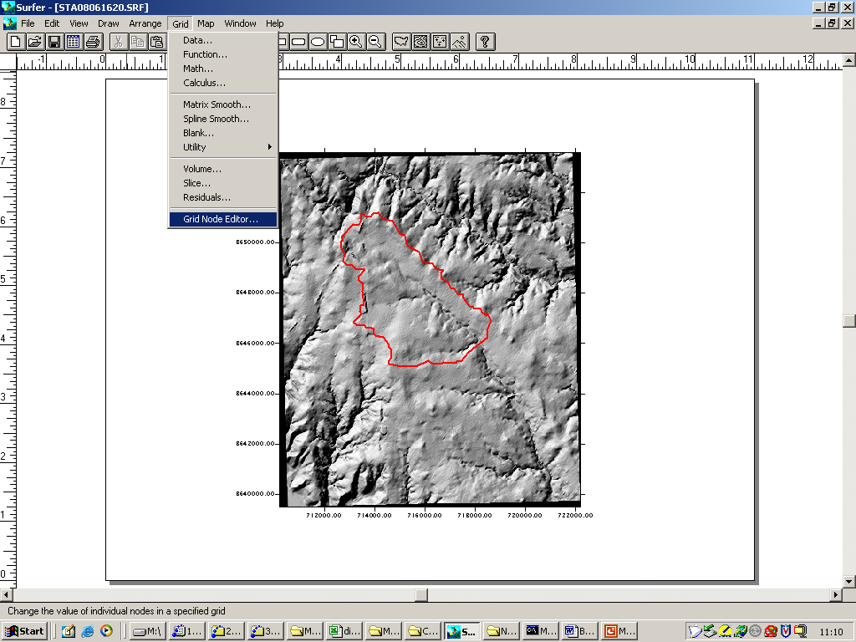
Figure 23. Data/Grid Node Editor

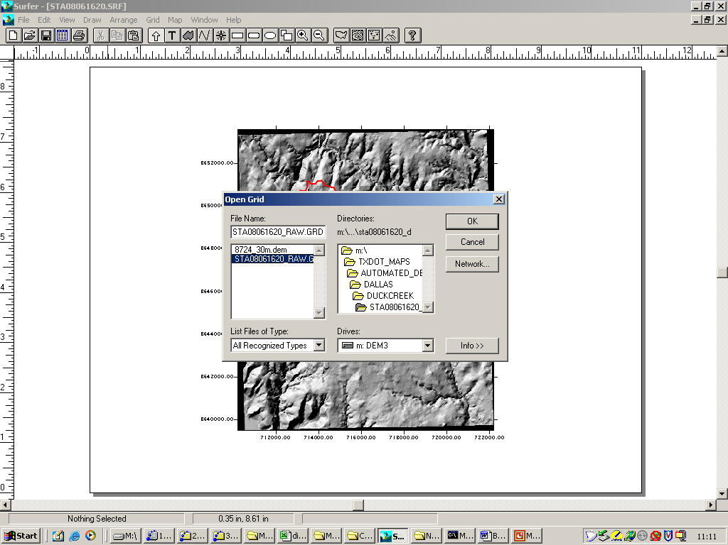
Figure 24. Select which grid to edit - needs to be the blanked grid.

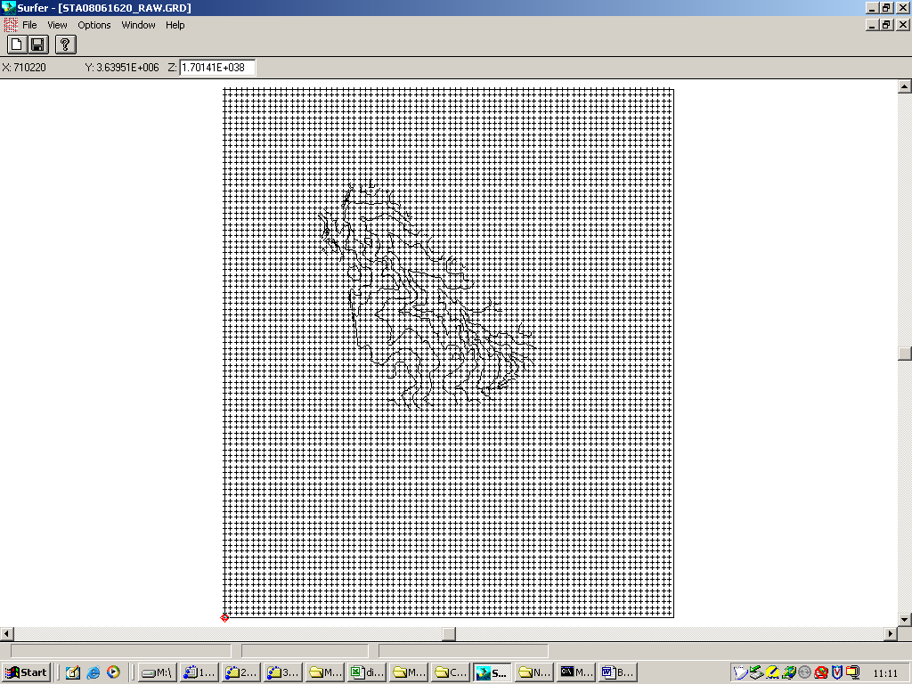
Figure 25. Grid node editor window.

In the gird node editor, data extends beyond the contour map picture, so you need to scan using the arrow keys at the edges to find the rows and columns that just enclose the watershed. Observe that the upper left corner of the editor shows X Y and Z values. The blanking value is a very large number, you will look for the first realistic numbers to locate the rectangle.
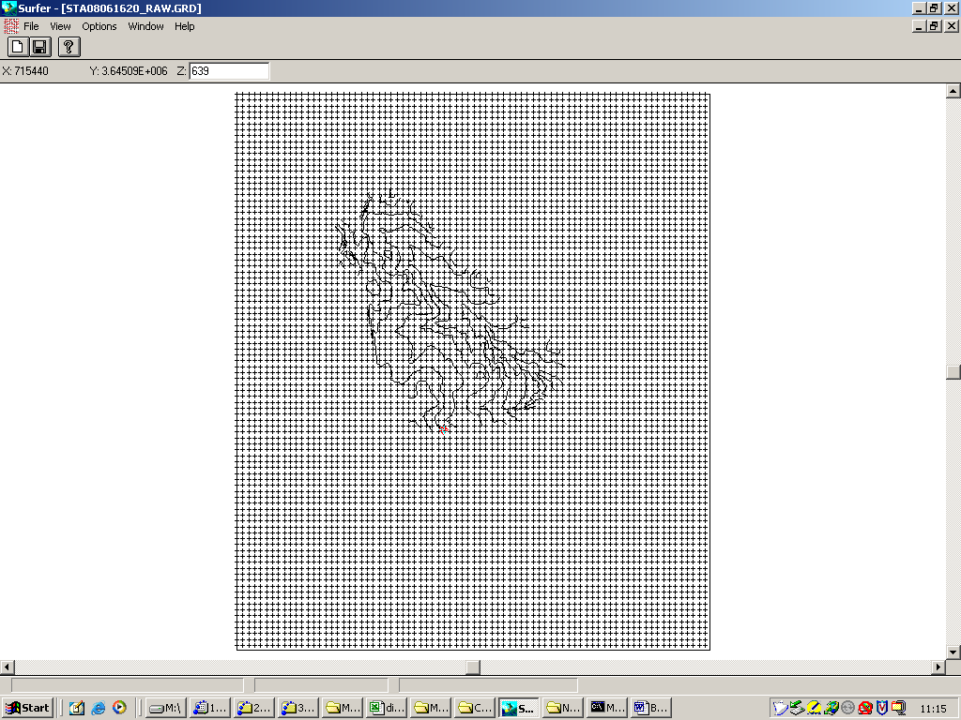
Figure 26. Finding a low Y-value

In the above figure, a Z value of 639 is near the lower left corner. The row just below is all (left to right) the blanking value, thus this is a row we want to include. The Y-value of this row will be Ylow. We perform similar searching on the left, top, and right edges resulting in the following rectangle definition values:

Xlow = 712650
Ylow = 3.64506E6
Xhigh =718650
Yhigh =3.65121E6

Step #10. Use the extract utility to extract the data from station sta08061620_raw.grd to sta08061620_big.grd. You will use the dialog box to remove rows and columns using the Xlow, Xhigh,Ylow,Yhigh values from the previous step.

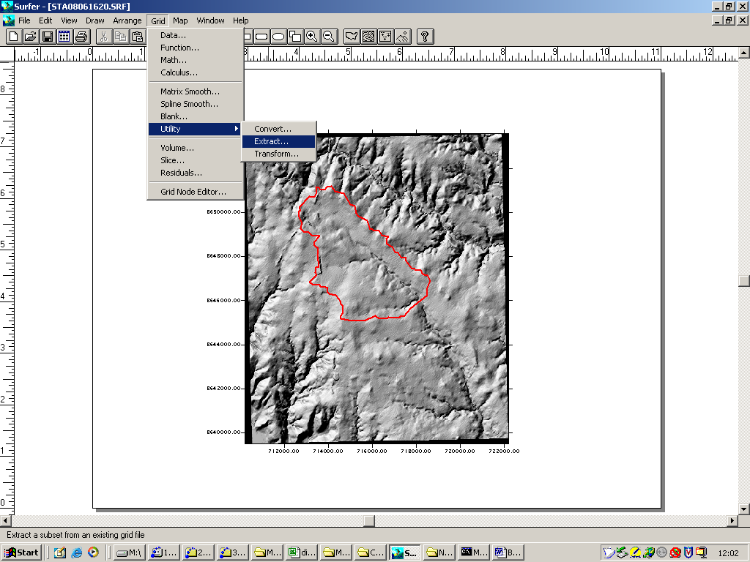
Figure 27. Grid/Extract Utility

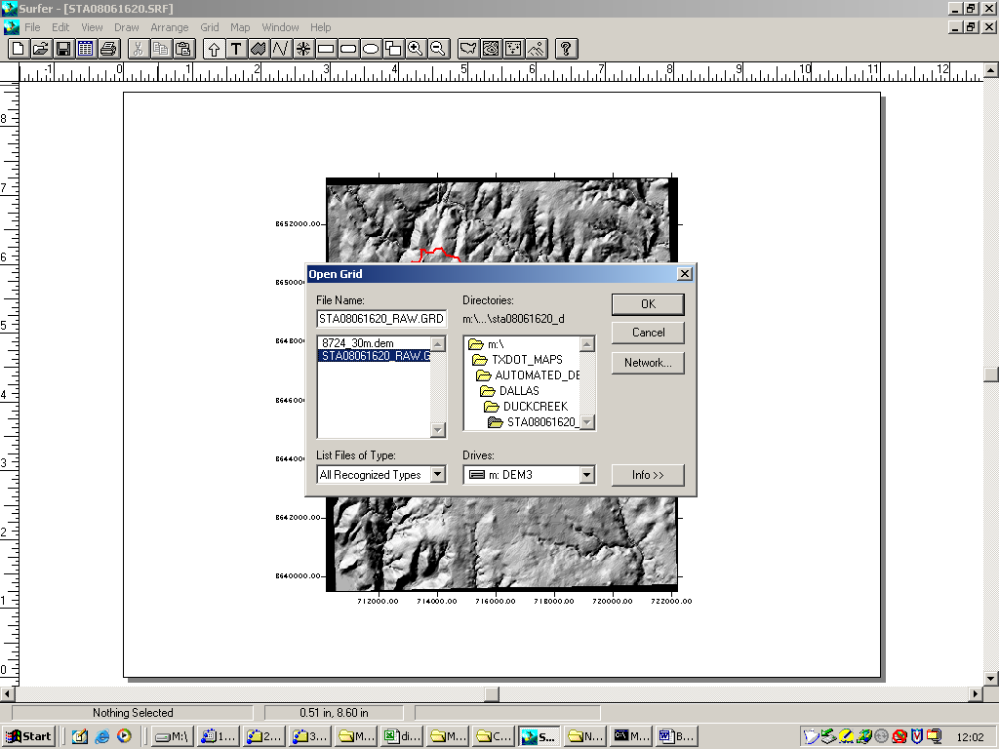
Figure 28. Select Input Grid

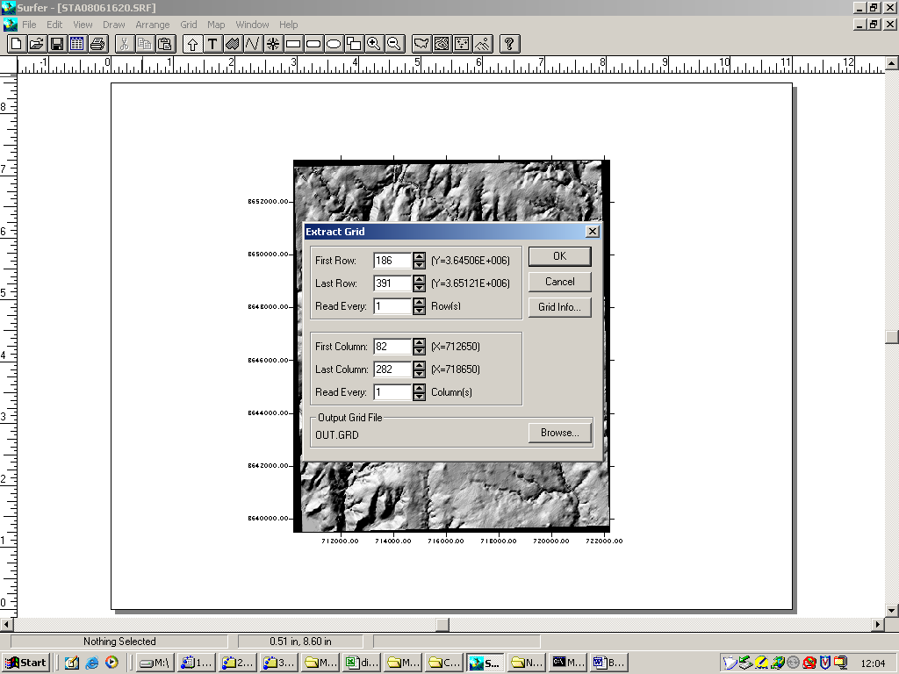
Figure 29. Use the dialog to find the correct X and Y values that you just wrote down.

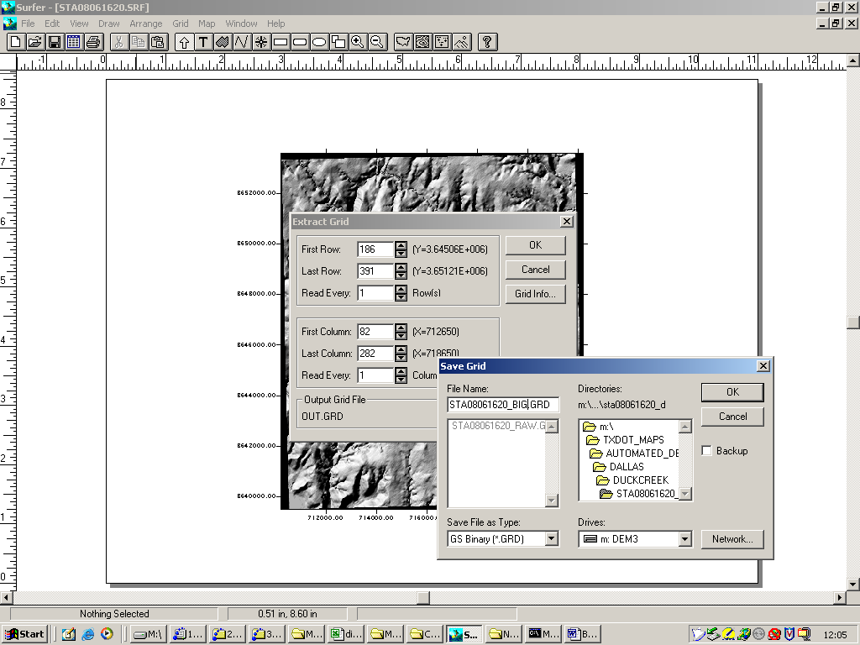
Figure 30. Name the output file. The default is OUT.GRD, but we need named files to keep track of the data.

Step #11. Now map sta08055580_big.grd to be sure it properly reflects the watershed. Once you are satisfied the map is correct, then use the grid convert utility to create an ASCII file of the grid. In this case the output file is sta08055580_ASCII.grd, and the file format is ASCII. When the conversion is complete, change the file name to sta08055580_ASCII.dat and open the file with a text editor. The file should be human readable and the first line should contain the characters DSAA.

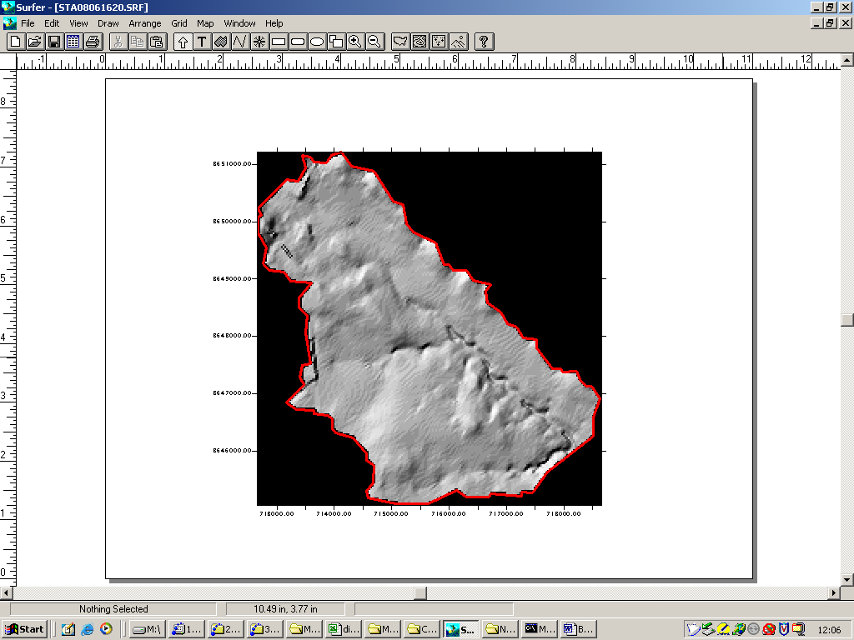
Figure 31. Map to check the extraction results.

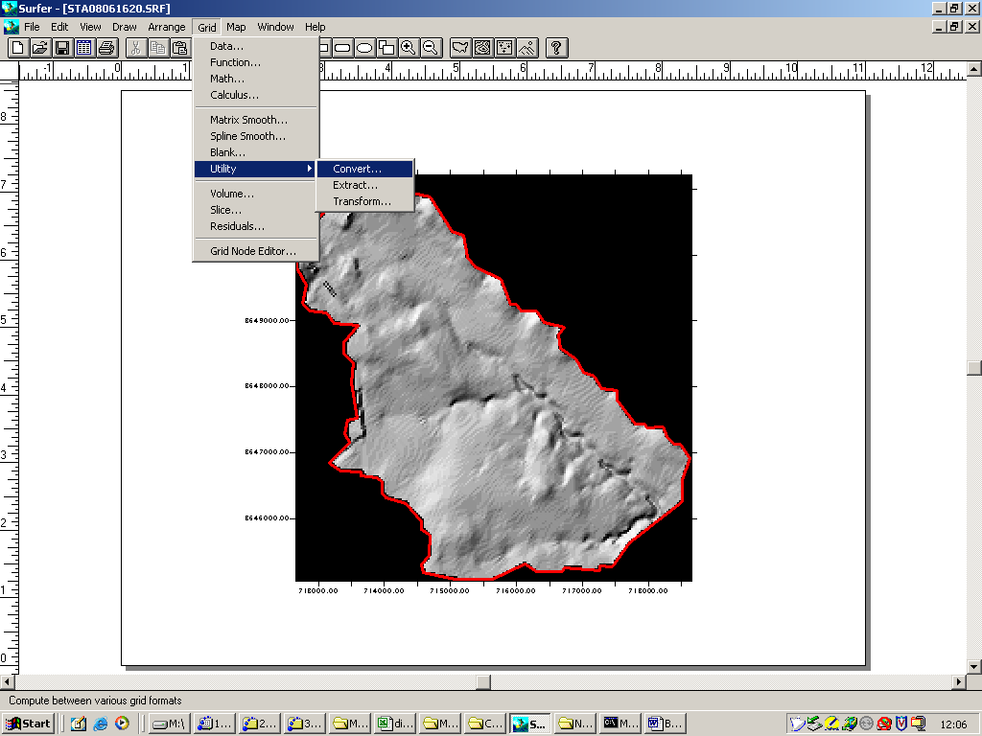
Figure 32. Grid/Transform to ASCII file.

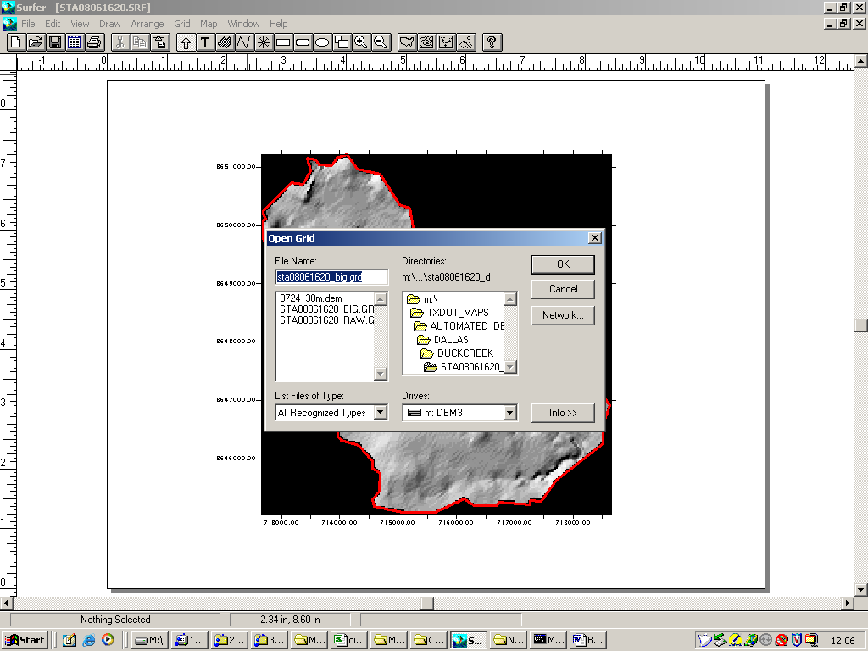
Figure 33. Type the file name.

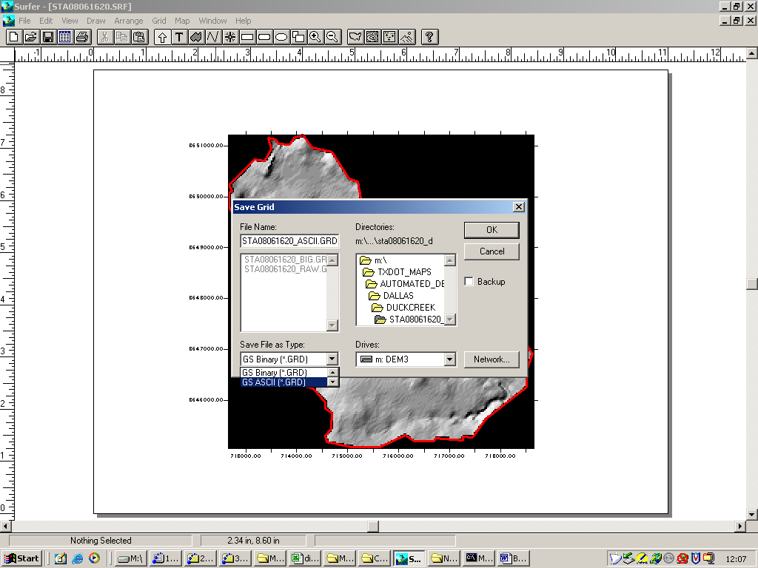
Figure 34. Set the file type to ASCII.

Check the file conversion by looking at the new file just created in a text editor. I use the MSDEV editor.

Figure 35. Open the file with appropriate editor.

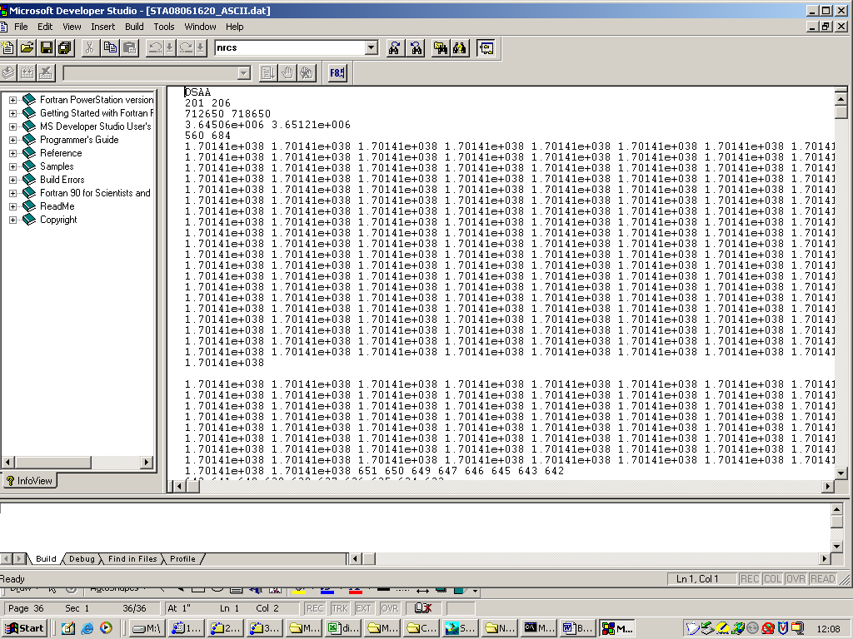
Figure 36. Typical correct content.

At this point you have prepared a grid for input into the dtrm pre-processor program.

