Regressions Relating Watershed Physical Characteristics to Unit Hydrograph Parameters for Rainfall-Runoff Modeling in Central Texas

Theodore G. Cleveland, AND Xin He
University of Houston, Houston, Texas 77204
Phone: 713 743-4280, Fax: 713-743-4260
Email: cleveland@uh.edu; hexinbit@hotmail.com

Xing Fang
Lamar University, Beaumont, Texas 77710-0024
Phone: 409 880-2287, Fax: 409 880-8121
Email: Xing.Fang@lamar.edu

David B. Thompson
Texas Tech University, Lubbock, Texas. 79409
Phone: 806 742-3485
Email: David.Thompson@ttu.edu

ABSTRACT

This paper is presents a regional-regression analysis that provides equations for estimating dimensionless hydrograph shape parameters (n) and estimation of time to peak (T_{p}). These equations use straightforward to compute watershed physical characteristics as well as a binary watershed development classification. The regression equations are based on observed rainfall-runoff data from over 1,600 storms on watersheds in Texas ranging in size from 0.5 to 100 square miles. Two geometric measures of watershed size, the main channel length, and the dimensionless slope, and a binary indicator variable of undeveloped or developed, are found to be the most appropriate predictors of unit hydrograph behavior. An adjustable shape hydrograph is deemed unnecessary for the study watersheds. Significant differences in timing and consequently peak discharge behavior were found for undeveloped and developed watersheds.

Key Words: Unit hydrograph, time to peak, hydrograph shape, regional regression, development classification.

INTRODUCTION

The runoff hydrograph, a time-series of discharge at a given location on a stream, is an important component of hydrologic-engineering design as the peak discharge, the runoff volume, and the time distribution of runoff are represented. The unit hydrograph method is a well-known approach used by engineers and others, including those within the Texas Department of Transportation (TxDOT, 2004). A consortium of researchers at Texas Tech University, Lamar University, the University of Houston, and the U. S. Geological Survey has been conducting investigations of hydrologic methodologies in use by TxDOT. This paper describes one component of a study on unit hydrograph estimation for applicable Texas watersheds.

RAINFALL-RUNOFF DATABASE

A digital database of previously published rainfall and runoff values for over 1,600 storms from 93 developed and undeveloped watersheds in Texas was used for the unit hydrograph research. The database is described and tabulated in Asquith and others (2004). A watershed properties database was developed from 30-meter digital elevation models. The watershed properties database is described in Roussel and others (2005). Figure 1 is a map of the study watershed locations.

PRIOR STUDIES

Use of regression equations to determine unit hydrographs is a well established hydrologic method. Gray (1962) used power-law models and correlation methods to develop a synthetic hydrograph procedure for 46 watersheds, mostly in Iowa and Missouri. Wu (1963) used power-law models based on selected watershed properties as predictor variables for unit hydrographs in Indiana. Meadows and Ramsey (1991) used power-law models to develop regional synthetic unit hydrographs for South Carolina. Weaver (2003) also used a power-law regression for estimating unit hydrograph behavior in North Carolina. Common to all these studies is a set of physical (and in some cases descriptive characteristics) and a need to estimate model parameter values for modeling rainfall-runoff behavior on un-gaged watersheds (or for future storms on a gaged watershed). This research adopted this well established approach.

UNIT HYDROGRAPH MODELING APPROACH

This research used a distribution-based unit hydrograph with the expectation that a variable-shape hydrograph would be important in the research, in contrast to a fixed shape unit hydrograph such as the Natural Resources Conservation Service (NRCS) dimensionless unit hydrograph (NRCS 2004).

Leinhard (1964) derived a unit hydrograph model using a statistical-mechanical analysis and two important assumptions. The first is that the travel time taken by an excess raindrop on the watershed to the outlet is proportional to the path-line distance the excess raindrop must travel. The second assumption is that the area swept by any characteristic distance is proportional to some power of that characteristic distance. The Leinhard hydrograph model was selected both for its adjustable shape and because Leinhard’s derivation gives meaningful physical insight into the resulting parameter values.

The Leinhard hydrograph distribution is a generalized gamma distribution (Leinhard, 1964;1967) and is expressed as,

[1]

The parameters n and t_{rmβ} in the distribution have physical significance: t_{rmβ} , is a mean residence time of an excess raindrop on the watershed, conceptually similar to the conventional term of time to peak (but numerically different); n, is an accessibility number roughly equal to the exponent on the distance-area relationship (a shape parameter). β, is the degree of the moment of the residence time, β=1 would be the arithmetic mean, and the distribution becomes the gamma hydrograph distribution that has been used extensively in hydrology, while for β=2 the residence time is a root-mean-square time, and the distribution becomes a different gamma distribution. The Rayleigh hydrograph distribution (Cleveland and others, 2003; He, 2004) is a special case of the generalized gamma distribution, and for integral values of the ratio n/β the distribution is a Weibull distribution.

Equation 1 can also be expressed as a dimensionless hydrograph using the following transformations (Leinhard, 1972) to express the distribution in conventional dimensionless form:

[2]

[3]

Expressed as a dimensionless hydrograph distribution equation 1 becomes,

$\frac{Q}{Q_{p}}={\left(\frac{t}{T_{p}}\right)}^{n−1}\text{exp}\left[−\frac{n−1}{β}\left({\left(\frac{t}{T_{p}}\right)}^{β}−1\right)\right]$ [4]

Figure 2 is a plot of the NRCS dimensionless unit hydrograph and the Leinhard unit hydrograph for two particular values of n. β in this figure is two. The figures illustrates that the dimensionless hydrograph, Equation 4, mimics the behavior of the NRCS-DUH. To implement the unit hydrograph model a rainfall loss model is required. A proportional loss model was selected (McCuen, 2005). In this loss model some constant ratio of precipitation becomes runoff. The model was selected for simplicity with regards to automated analysis. The model is represented as

[5]
[6]

where L(t) is a rainfall loss rate (depth per time), p(t) is observed rainfall rate (depth per time), C_{r} is fraction of rainfall that is converted to runoff (C_{r} is bounded by 0 and 1), the numerator is the cumulative runoff (depth) of the storm, the denominator is the cumulative rainfall volume for the storm, and A is the watershed area. Using this loss model, an excess rainfall hyetograph is computed and is convolved with the unit hydrograph model in Equation 1 to generate simulated hydrographs in the database for each watershed.

An optimization approach was used to analyze observed rainfall-runoff events to infer the unit hydrograph parameters, n and t_{rmβ} . The analysis was based on a method used by Weaver (2003) and described by O’Donnell (1960), where each rainfall increment is treated as an individual storm and the runoff from these individual storms is convolved using a unit hydrograph to produce the model of the observed storm. The approach required that both the rainfall and runoff data be converted through linear interpolation to a 1-minute interval. The 1-minute interval was selected because Equation 1 was originally derived as an instantaneous unit hydrograph (IUH), and this interval was deemed to be small enough to closely approximate the conditions of an IUH. Exploratory analysis (not reported here), confirmed that this assumption was adequate.

The hydrograph parameters for each storm (C_{r}, n and t_{rmβ} ) are systematically adjusted until the maximum absolute deviation at peak discharge (QpMAX) is minimized—a merit function. The merit function is

[7]

where Q is the discharge (cubic length per time), the subscripts m and o represent model and observed discharge, respectively, t_{p} is the actual time in the observations when the observed peak discharge occurs. Although a peak time is expressed, the nomenclature of t_{p} is different from T_{p} to distinguish between observed peak of the storm (t_{p}) and time-to-peak of a unit hydrograph model (T_{p}). The merit function is designed to favor matching the peak discharge magnitude with little regard for the rest of the hydrograph.

A search technique was used instead of more elegant adaptive methods to ensure a result. The search systematically computes the value of a merit function using every permutation of model parameters described by the set-builder notation

$t_{\text{rm}β}∈\left\{1,2,3,⋯,\text{720}\right\}$ [8]
$n∈\left\{1\text{.}\text{00},1\text{.}\text{01},1\text{.}\text{02},⋯,9\text{.}\text{00}\right\}$ [9]

Fractions of a minute were ignored (hence the 1-minute interval in Eqn. 8) and sub 0.01 resolution in the shape parameter was considered unnecessary. The set of parameters that produces the smallest value of the merit function is retained as the optimal set for a storm. This approach, although computationally expensive, is robust. The n and t_{rmβ} parameters were computed using a purpose-built Linux cluster computer constructed from discarded PCs to speed up the computational throughput.

Application of this procedure produces an n and t_{rmβ} value for each storm. These results are called “storm optimal” values. The mean values for n and t_{rmβ} for each watershed are computed from the storms recorded on each watershed. Then Q_{p} and T_{p} are computed, and provide the basis for statistical analysis to generate regression models to estimate hydrograph parameters for similar Texas watersheds.

To conclude this section, several observations on the approach are useful. First, the approach reported here was designed to be entirely automated. Once the database is prepared, the computations are run without analyst intervention in contrast to other approaches (Asquith and others, 2005). Second, some of the storms were pathologically unsuitable (peak rainfall rate after peak runoff rate); however, because of program robustness the program still produces a result. These storms were manually removed when detected by graphical data analysis. Third, each storm is analyzed in its entirety; multiple peaks in a storm that could potentially serve as sub-set storms and analyzed independently are not used.

REGIONAL ANALYSIS

Multiple-linear regression analysis is used to establish the statistical relations between the shape parameter n and T_{p}, and various watershed characteristics such as drainage area, watershed perimeter, main channel length, watershed shape, dimensionless main channel slope, and others. An additional predictor variable is a factor or state variable representing a binary classification of watershed development (undeveloped and developed). The procedures employed generally follow those described in Asquith and others (2005), but the results here are more recent. After extensive exploratory analysis, only main channel length (MCL), dimensionless main channel slope (MCS), and watershed development classification (D = 0 or 1) were formally considered. The determination of MCL and MCS are explained in detail in Roussel and others (2005).

The mean watershed optimal values of n for undeveloped and developed watersheds are 4.96 and 3.48. The difference in values is statistically significant. A correlation analysis showed that n was correlated to MCL, D, and MCS. Figure 3 is a plot of the relation of the shape parameter n and MCL for developed and undeveloped watersheds. An appropriate regional regression equation for n is

$n={\text{10}}^{(0\text{.}\text{91}−0\text{.}\text{37}D)}⋅{\text{MCL}}^{(−0\text{.}\text{24}+0\text{.}\text{24}D)}⋅{\text{MCS}}^{(0\text{.}\text{06}−0\text{.}\text{05}D)}$ [9]

Examination of the exponents on MCL and MCS indicate that for all practical purposes these variables vanish for developed watersheds and a constant value of n=10^{(0.91-0.37)} (about 3.47) is appropriate. For undeveloped watersheds, the range of estimated n values is about 2 to 5.

The mean values of t_{rmβ} for undeveloped and developed watersheds are 329 minutes and 130 minutes. The difference in values is statistically significant. A correlation analysis showed that t_{rmβ} was correlated to MCL, D, and MCS, and the correlation coefficient are all of the same magnitude, thus all variables were used in the regional regression model. An appropriate regional regression equation for t_{rmβ} is

$t_{\text{rm}β}={\text{10}}^{(1\text{.}\text{62}−2\text{.}\text{21}D)}⋅{\text{MCL}}^{(0\text{.}\text{37}+0\text{.}\text{30}D)}⋅{\text{MCS}}^{(−0\text{.}\text{247}−0\text{.}\text{72}D)}$ [10]

T_{p} is then computed from equation 2 using these regional regression equations.

Figure 4 is a plot of the relation of the timing parameter T_{p} computed using the watershed optimum values of n and t_{rmβ} (not the regional regression values) and MCL for developed and undeveloped watersheds, as well as the regression results. The mean values of T_{p} for undeveloped and developed watersheds are different and the difference is statistically significant. The difference in mean values of T_{p} for undeveloped and developed watersheds is about 2.75 hours, with developed watersheds having the smaller T_{p}. Over the range of characteristic lengths studied, T_{p} in developed watersheds ranges from 3 times smaller (small watersheds) to 1.2 times smaller (large watersheds).

Figure 5 is a plot of the relation between peak discharge obtained using the regression equations and the storm optimum values, and the observed peak discharge for each storm. An equal-value line is also displayed on the figure. The mean value of relative difference between the peak discharge from the regression model and observed peak discharge is about 40% (regression predicts higher peaks). The corresponding mean value for the storm optimum results is about -32% (optimum results have lower peaks). Although there is considerable variability in the individual storm values for either set of computations, the figure displays over 3,200 markers, most of which are clustered about the equal-value line.

CONCLUSIONS

This study analyzed 1,600 storms to infer unit hydrograph parameters for watersheds in Texas ranging in size from 0.5 to 100 square miles. Regression equations were developed to relate two geometric measures of watershed size, the main channel length, and the dimensionless slope, and a binary indicator variable of undeveloped or developed (surrogate for rural and urban). These equations are valid only for similar watersheds in the area, although the structure (power-law models) and the predictor variables (MCL, MCS) are probably useful elsewhere.

The regression model for developed watershed shape parameter, n, is essentially a constant. The model for undeveloped watersheds is a variable, but the range of values is not large and the authors believe that it is essentially constant and about the same value. The dimensionless Leinhard hydrograph at n=3.66 (the average value) is nearly identical to the NRCS DUH until a dimensionless time ratio of 1.7. At dimensionless time ratios larger than this value the NRCS DUH has larger values of dimensionless discharge -- the tail of the distribution decays slower in dimensionless time. The authors conclude that variable shape hydrographs are not necessary for these watersheds and that the NRCS-DUH hydrograph would produce the same results as the Leinhard dimensionless unit hydrograph.

The time to peak is about two times smaller for a developed than for an undeveloped watershed of the same characteristic dimension. The consequences of ignoring the difference in T_{p} for developed versus undeveloped watersheds are illustrated in Figure 6. Figure 6 is a plot of the relation of the peak discharge parameter Q_{p} from equation 3 using the regression values for n and t_{rmβ}. The developed watersheds having smallest T_{p} for a given characteristic dimension have correspondingly higher dimensionless peak discharge values, about twice that of an equivalent undeveloped watershed, although the difference decreases with watershed size.

One potential explanation for the difference is that the slopes of the watersheds studied could be different, and all other features being equal a steeper watershed would be expected to have smaller T_{p} and larger Q_{p}. The undeveloped watersheds on average are steeper (greater slope), the difference is statistically significant, yet the undeveloped watersheds have larger values of T_{p}, and smaller Q_{p}. Thus the difference in timing values for undeveloped versus developed watersheds is not explainable by a slope difference, but instead the characteristic velocity on undeveloped watersheds must be different. This subject is an area of on-going study by the authors.

ACKNOWLEDGEMENTS

The authors would like to acknowledge the support of the Texas Department of Transportation, and TxDOT program coordinator David Stolpa, P.E., project directors Jaime E. Villena, P.E., and George R. Herrmann, P.E. The authors also acknowledge contributions from their colleagues, Dr. William Asquith, Meghan Roussel, and Amanda Garcia at the U.S. Geological Survey, Austin, Texas. This study is supported through Texas Department of Transportation research projects 0-4193,0-4194, and 0-4696. The contents of this paper reflect the views of the authors, who are responsible for the facts and accuracy of the data presented herein. The contents do not necessarily reflect the official view or policies of the Texas Department of Transportation (TxDOT). This paper does not constitute a standard, specification, or regulation.

REFERENCES

Asquith, W. H., Thompson, D. B., Cleveland T. G. and X. Fang. 2004, “Synthesis of Rainfall and Runoff Data used for Texas Department of Transportation Research Projects 0-4193 and 0-4194” U.S. Geological Survey , Open File Report 2004-103, p 50.

Asquith, W. H., Thompson, D. B., Cleveland T. G. and X. Fang. 2005, “Unit Hydrograph Estimation for Applicable Texas Watersheds ” Texas Department of Transportation Research Report 0–4193–4, 71p.

Cleveland, T.G., Thompson, D.,Fang,X. 2003. "Instantaneous Unit Hydrographs for Central Texas" Proceedings of Texas Section Spring 2003 Meeting, Corpus Christi, Texas.

Gray, D. M., 1961, Synthetic unit hydrographs for small watersheds: Journal of the Hydraulics Division, American Society of Civil Engineers, vol. 87, no. HY4, p. 33−53.

Roussel, M.C., Thompson, D. B., Fang, X., Cleveland, T.G., and Garcia, A.C., 2005. “Timing Parameter Estimation for Applicable Texas Watersheds.” Texas Department of Transportation Research Report 0–4696–2, 28p.

Leinhard, J.H. 1972. “Prediction of the dimensionless unit hydrograph.” Nordic Hydrology, 3, pp 107-109

Leinhard, J.H., 1964. “A statistical mechanical prediction of the dimensionless unit hydrograph.” Journal of Geophysical Research, Vol 69. No. 24., pp 5231-5238.

Lienhard, J.H., and P.L. Meyer, 1967. “A physical basis for the generalized gamma
distribution.” Quarterly of Applied Math. Vol 25, No. 3. pp 330-334.

McCuen, R. H., 1998. Hydrologic Analysis and Design, 2nd. Ed. Prentice Hall New Jersey 814p.

Meadows, M.E., and Ramsey, E.W., 1991, South Carolina regional synthetic unit hydrograph study methodology and results: U.S. Geological Survey Project Completion Report, vol. 2, 33 p.

Natural Resource Conservation Service, 2004, National Engineering Handbook, Part 630, chapter 16, http://www.nrcs.usda.gov/technical/eng/neh.html, accessed on July 28, 2004.

Weaver, J.C., 2003, Methods for estimating peak discharges and unit hydrographs for streams in the city of Charlotte and Mecklenburg County, North Carolina: U.S. Geological Survey Water Resources Investigations Report 03–4108, 50 p.

Wu, I., 1963, Design hydrographs for small watersheds in Indiana: Journal of the Hydraulics Division, American Society of Civil Engineers, vol. 89, no. HY6, p. 35−65.

Xin, He. 2004. Comparison of Gamma, Rayleigh, Weibull and NRCS Models with Observed Runoff Data for Central Texas Small Watersheds. Master's Thesis. Department of Civil and Environmental Engineering, University of Houston, Houston, Texas. 92p
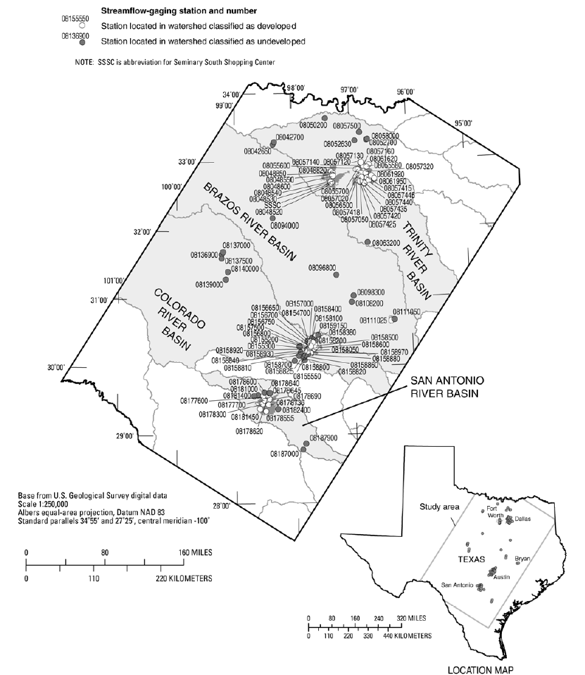
Figure 1. Locations of USGS streamflow-gaging stations represented in the database. (Roussel and others, 2005)
Figure 2. NRCS DUH and Leinhard DUH (L-DUH).
N=3.66 is mean value applicable for the study watersheds.
Figure 3. Plot of relation between observed N of 1-minute unit hydrograph and main channel length for undeveloped and developed watersheds.
Figure 4. Plot of relation between observed T_{p} of 1-minute unit hydrograph and main channel length for undeveloped and developed watersheds.
Figure 5. Plot of relation between peak discharge from convolution of observed rainfall versus observed peak discharge.
Figure 6. Plot of relation of Q_{p} and main channel length for undeveloped and developed watersheds.

