Instantaneous Unit Hydrographs for Small Watersheds in Texas Using Digital Elevation Data and Particle Tracking

Theodore G. Cleveland, AND Xin He
University of Houston, Houston, Texas 77204
Phone: 713 743-4280, Fax: 713-743-4260
Email: cleveland@uh.edu; hexinbit@hotmail.com

Xing Fang
Lamar University, Beaumont, Texas 77710-0024
Phone: 409 880-2287, Fax: 409 880-8121
Email: Xing.Fang@lamar.edu

David B. Thompson
Texas Tech University, Lubbock, Texas. 79409
Phone: 806 742-3485
Email: David.Thompson@ttu.edu

ABSTRACT

Characterization of hydrologic processes of a watershed requires estimation of the specific time-response characteristics of the watershed. The time-response characteristics of a watershed frequently are represented by two conceptual time parameters, the time of concentration and the time to peak discharge. An exploratory assessment of a particle-tracking approach for estimating time of concentration for selected Texas watersheds is presented.

The method is applied to 92 selected watersheds considered for the study. The 92 watersheds analyzed had drainage areas ranging from approximately 0.25 to 150 square miles, main channel lengths ranging from approximately 1 to 50 miles, and dimensionless main channel slopes between approximately 0.002 and 0.02. The resulting timing parameters are used in a performance test against historical storms on the same watersheds and qualitatively evaluated. Furthermore, the resulting timing parameters are compared to those timing parameters determined by other methods applied during the conduct of this research. The parameters estimated using the particle tracking approach are within two-standard deviations of the mean value for time-of-concentration estimated by five other methods in the research project.

Key Words: digital terrain models, unit hydrograph, time to peak, time of concentration, rainfall-runoff

INTRODUCTION

Estimation of the time-response characteristics of a watershed is fundamental in hydrologic analysis and rainfall-runoff response modeling. Responses to real or design rainfall, such as peak discharge, hydrograph recession, and the time evolution of cumulative runoff, are greatly influenced by time characteristics. Rainfall-runoff models that incorporate timing parameter variables are used by engineers and others for hydrologic design purposes, including the design of bridges, culverts, and detention facilities. Therefore, during 2004-2005, a consortium of researchers in cooperation with the Texas Department of Transportation (TxDOT), investigated timing parameter estimation approaches for selected Texas watersheds (TxDOT Research Project 0-4696).

The time-response characteristics of the watershed frequently are represented by two conceptual time parameters, time of concentration (T_{c}) and time to peak (T_{p}). T_{c} is typically defined as the time required for runoff to travel from the most distant point along a hydraulic pathline in the watershed to the outlet. T_{p} is defined as the time from the beginning of direct runoff to the peak discharge value of a unit runoff hydrograph. Conversion between the two is required as most hydrograph models use T_{p} but hydrologic engineers often first consider T_{c}.

For this study, 92 watersheds with USGS streamflow-gaging stations were selected for estimation. The necessary rainfall and runoff data (Asquith and others, 2004) for investigation are available for these watersheds. For the 92 watersheds selected for study, drainage areas are between approximately 0.25 to 150 square miles, main channel lengths are between approximately 1 to 50 miles, and dimensionless main channel slopes range approximately from 0.002 to 0.02.

This paper presents an independent estimation of T_{c} and T_{p} for comparison to the several other methods examined in the research project and reported in Roussel and others (2005). This paper was documented separately because is substantially different from the empirical approaches considered in the Roussel report and is not likely to be directly used by applications-oriented personnel. However, the results are important because they support estimates derived using empirical approaches and those estimates backwards-extracted from the measured rainfall-runoff responses. Furthermore, the work in this paper was not considered to be sufficiently refined enough for generalization. Despite these limitations the work constitutes an independent consideration of timing parameters consistent with the timing parameters reported in Rousseau and others (2005).

RAINFALL-RUNOFF DATABASE

A digital database of rainfall and runoff values for over 1,600 storms from 93 developed and undeveloped watersheds in Texas was used for the research. The database is described and tabulated in Asquith and others (2004). A watershed properties database was developed from 30-meter digital elevation models. The watershed properties database is described in Roussel and others (2005). Figure 1 is a map of the study watershed locations.

PRIOR STUDIES

Clark (1945) presented a method for developing unit hydrographs for a watershed based on routing a time-area relationship through a linear reservoir. Excess rainfall covering a watershed to some unit depth is released instantly and allowed to traverse the watershed and the time-area relation represents the translation hydrograph. The linear reservoir is added to reflect storage effects of the watershed. Most time-area techniques trace their origin to Clark’s method.

Using digital elevation maps the determination of travel distance from a point on the watershed to the outlet is straightforward and the present challenge is to specify the travel speed along these paths, and consequently the travel time, and finally the use the ensemble of travel times to infer a unit hydrograph. Typically geographic information systems (GIS) are used because the GIS greatly simplifies the requisite grid arithmetic for the path length and time determination. In this paper, a GIS was to delineate the watershed boundaries, but the computations were performed independently of a GIS.

Maidment (1993) is one example of this GIS-based approach using the classical time-area method and GIS scripts. Muzik (1996) approached the time-area modeling in a similar fashion. These works were considered limited by use of overland routing based on a constant velocity or subjectively predetermined velocity map.

Kull and Feldman (1998) assumed that travel time for each cell in the watershed was simply proportional to the time of concentration scaled by the ratio of travel length of the cell over the maximum travel length. Thus the velocity from any point to the outlet is uniform and constant. Each cell’s excess rainfall is lagged to the outlet based on the travel distance from the cell. Travel time in overland and channel flow are determined beforehand. This approach is essentially a version of Clark’s (1945) methodology and is implemented in HEC-GEOHMS (HEC 2000).

Saghafian and Julien (1995) derived a time-to-equilibrium approach for any location on a watershed based on a uniform overland flow model. Saghafian and others (2002) used this concept to develop a time-variable isochrone GIS technique to generate runoff hydrographs for non-uniform hyetographs (non-uniform in space and time). Olivera and Maidment (1999) developed a raster-based, spatially distributed routing technique based on a first-passage-time response function (a gamma-type unit hydrograph at the cell scale). These particular techniques were adopted, in concept, for the analysis presented here.

In these studies the time-area relationship is incorporated either directly as a hydraulic relationship (constant velocity, curve-number based velocity, kinematic-wave) or indirectly as a ratio of grid travel time to time-of-concentration.

Leinhard (1964) derived a unit hydrograph model using a statistical-mechanical analysis and two important assumptions. The first is that the travel time taken by an excess raindrop landing on the watershed to the outlet is proportional to the path-line distance the raindrop must travel. The second assumption is that the area swept by any characteristic distance is proportional to some power of that characteristic distance. This particular derivation, which directly relates concepts of distance, time, and shape to watershed response, is entirely compatible with recent approaches using GIS technology. This paper combines the recent techniques using digital terrain descriptions with Lienhard’s unit hydrograph, and by specification of some meaningful grid kinematics provides a technique to directly determine T_{c} and T_{p}.

MODELING APPROACH

Leinhard’s unit hydrograph model is a generalized gamma distribution (Leinhard, 1964; 1967) and is expressed as

[1]

The distribution parameters n and t_{rmβ} have physical significance in that t_{rmβ} , is a mean residence time of a raindrop on the watershed, and n, is an accessibility number, roughly equal to the exponent on the distance-area relationship (a shape parameter). β, is the degree of the moment of the residence time; β=1 would be the arithmetic mean, while for β=2 the residence time is a root-mean-square time. β=2 is used throughout this work. Equation 1 can also be expressed as a dimensionless hydrograph using the following transformations (Leinhard, 1972) to express the distribution in conventional dimensionless form.

[2]

[3]

Expressed as a dimensionless hydrograph distribution equation 1 becomes

$\frac{Q}{Q_{p}}={\left(\frac{t}{T_{p}}\right)}^{n−1}\text{exp}\left[−\frac{n−1}{β}\left({\left(\frac{t}{T_{p}}\right)}^{β}−1\right)\right]$ [4]

The challenge is how to determine values of n and t_{rmβ} from a terrain model, which is conceptually equivalent to determining unit hydrograph parameters from physical watershed characteristics (for example: main channel length, slope, etc.), except this work examines an ensemble of characteristics (all the potential flow paths, slope along these paths, etc.). Specifically this research addressed this task by placing a computational parcel on each cell of a DEM grid, computing the direction this parcel would move from an 8-cell pour point model (O’Calligan and Mark, 1984), and computed the speed of the parcel according to a uniform flow equation. The entire ensemble of particles is moved contemporaneously and the arrival times of individual particles at the watershed outlet are recorded. The cumulative arrival time distribution of the particle ensemble is a residence time distribution of excess rainfall on the watershed and thus this distribution must contain information equivalent to an S-curve hydrograph. By fitting the Leinhard hydrograph (Equation 1 or 4) to this empirical S-curve, unit hydrograph parameters are recovered. Specification of how the particles move in response to their position on the watershed elevation grid determines the specific shape of the S-curve and ultimately the estimates for T_{p} and T_{c}.

Figure 2 depicts the watershed that drains past the U.S. Geological Survey (USGS) gaging station 08057320, also called the Ash Creek watershed in this research. In the figure the solid curve represents the path that a excess raindrop would follow from the northeast part of the watershed to the outlet located in the southwest corner of the watershed. This curve is called the pathline. Any point in the watershed can be represented by its Cartesian coordinates, x and y. A particle at any point in the watershed will lie on its pathline. The particle at any position will have an x-component and y-component of velocity, and these two components can be resolved into a pathline component of velocity. The relationship between the pathline system and the Cartesian system is depicted in Figure 2 as the two velocity vector systems on the Eastern side of the figure, near the peak of a hill.

Over a short time interval, the particle will move a distance determined by the product of the appropriate component velocities and the time interval. Either a Cartesian coordinate system or a path-line coordinate system can be used. In the present case a pathline system is used. The work assumed the square of velocity is proportional to watershed slope, and therefore the velocity field depends on the particle positions. Equation 3 represents the formula in a path line coordinate system used to determine the velocity at any location in the watershed.
$u(ξ)⋅\left|u(ξ)\right|=k^{2}∗\frac{\text{dz}}{dξ}|_{(ξ)}$ [5]
The value of k² represents the square of velocity of the particle on a unit slope. The absolute value formulation is used so that the numerical method preserves correct directional information (flow is always downslope). This approach is similar to existing methods, but makes no distinction between channel and overland flow. All results presented in this paper are based on this velocity model.

In the present work we have adopted a Manning’s-type structure for k resulting in the following kinematics model:
$u(ξ)=\frac{1\text{.}5}{n_{f}}d^{\frac{2}{3}}(\frac{\text{dz}}{dξ}|_{(ξ)})^{\frac{1}{2}}$ [6]
where n_{f} is a frictional term (an adjustable parameter) that is conceptually analogous but not numerically equal to Manning’s n, and d is a mean flow depth (an adjustable parameter). Equation 6 is intended to look like a Manning’s equation (the last term is the local slope of the watershed at the particle location). These kinematics are identical to Wooding’s (1965) kinematic wave analysis for overland flow and similar to the isochrone derivation technique of Sagafian and Julien (1995) who adapted the kinematic wave theory for distributed rainfall-runoff modeling and presented an example (Saghafian and others, 2002) for a single watershed in West Africa.

Figure 3 is the normalized arrival time distribution for the watershed in Figure 2 along with the subsequent fitted curvilinear hydrograph models. The markers in the figure represent the empirical S-curve hydrograph for the watershed. The program that makes these computations in referred to herein as the Digital Terrain Runoff Model (DTRM). The solid S-curve is the cumulative distribution function based on the unit hydrograph function (Equation 1 or 4). The cumulative distribution is “fit” to the empirical S-curve hydrograph using a least square error minimization criterion. Once the distribution parameters, n and t_{rmβ} are recovered, they are then converted into conventional hydrograph parameters using Equations 2 and 3.

In principle, the time of concentration, T_{c}, should be the time at which the cumulative hydrograph is unity, but the cumulative hydrograph approaches unity asymptotically, so the authors’ selected T_{c} as the time when the cumulative hydrograph obtained a value 0.98, a fraction of the total distribution. The choice of the value 0.98 is strictly ad hoc, and no rigorous selection method was applied.

RESULTS

The DTRM was applied to the entire set of watersheds using 30-meter digital elevation data. The values used in equation 5 for generating the cumulative hydrographs are n=0.04 and d=0.2 and were determined by trial-and-error using the Ash Creek watershed and the June 3, 1973 storm to “calibrate” the particle-tracking model. Then these two values were applied to all watersheds regardless of size and location.
Convolving the historical rainfall hyetographs through the unit hydrograph parameterized by the DTRM values and comparing the model hydrograph with the historical hydrograph tested the performance of the method. For each watershed, DRTM was run once and a single Leinhard hydrograph, with two parameters is generated for each watershed. These two values are determined entirely from topographic data and the assumed n_{f} and d; no actual rainfall-runoff data is used by the DTRM. Figure 4 is a representative example of output from this testing using observed data from the authors’ database. The observed hydrograph is the dashed line with the step-wise changes in value, while the smooth curve is the model result using the same hyetograph (input rainfall) and convolving this rainfall with the Lienhard unit hydrograph using the watershed values for n and t_{rmβ} . The plot in Figure 4 is typical, but not all storms were reproduced equally well.

Figure 5 is a plot of the relationship of main channel length (a characteristic dimension) and the time to peak, T_{p} for the study watersheds. The solid circles are the values derived using the digital terrain model to compute an arrival time distribution. The open and solid squares are the mean T_{p} values obtained from a storm-by-storm inverse analysis where the hydrograph parameters are extracted from paired rainfall-runoff data for undeveloped and developed watersheds. Because the terrain model was calibrated using a single storm on a developed watershed, the entire set of T_{p} values are smaller than the storm optimum values for most of the undeveloped watersheds. At the time when the DTRM model was constructed, the authors had not yet distinguished between developed and undeveloped, so the model does not reflect such differences. Despite this shortcoming, the entirely synthetic results have a similar trend to the results obtained by analysis of actual storm data. Figure 5 and the typical results in Figure 4 suggest that topographic information alone with a single calibration event is sufficient to produce qualitatively acceptable response hydrographs for the study watersheds.

A quantitative comparison is performed by comparison of the results to timing parameters obtained by other methods (Roussel and others, 2005). Several empirical methods are included in the comparison. These estimates are independent from DTRM, sharing only the same underlying digital elevation data, watershed boundary, and outlet location. Figure 6 is a plot of T_{c} computed by selected methods in Roussel and others (2005) versus watershed area. The T₉₈ values (the DTRM surrogate for T_{c}) are plotted as shaded hexagons. The values plot with the same general trend as the other formulas. The error bars on Figure 6 represent +/- two standard deviations about a mean value for T_{c} for all the methods plotted except for the DTRM. The DTRM results all plot within the error bars for the other methods indicating that the DTRM results are within +/- two standard deviations of an average value computed by the other methods. The dashed line on Figure 6 is an ordinary least squares log-linear regression through the DTRM results. This line also falls within the error bars for the other methods further reinforcing that the DTRM results are comparable.

CONCLUSIONS

The terrain-based runoff model generates qualitatively acceptable direct runoff hydrographs from minimal physical detail of the watershed. The elevation data are available on the Internet, or can be prepared from paper-based maps.

No attempt was made to optimize the friction terms in the DTRM model to account for different land-uses, etc., yet the approach simulated episodic behavior at about the same order of magnitude as observed behavior in terms of peak discharge and timing. Thus, for the small watersheds studied in this research, topography is a significant factor controlling runoff behavior and consequently the timing parameters common in all hydrologic models.

The DTRM ignored distinctions between channel flow and overland flow yet produced estimates within +/- two standard deviations of other methods. The method ignored distinctions between undeveloped and developed watersheds, and this distinction is a subject of on-going research by the authors. The similarity of the results to the other methods increases confidence in the other methods, and indicates that the other methods, while overtly empirical, incorporate similar simplified-physics as does DTRM.

T₉₈ is a reasonable surrogate for T_{c} when compared to T_{c} computed using the same topographic data. The terrain-based procedure described here requires considerable effort to construct the input data files from the elevation data and to guess values at the friction term and flow depths.

ACKNOWLEDGEMENTS

The authors would like to acknowledge the support of the Texas Department of Transportation, program coordinator David Stolpa, P.E., project directors Jaime E. Villena, P.E., and George R. Herrmann, P.E. The authors also acknowledge contributions from their colleagues, Dr. William Asquith, Meghan Roussel, and Amanda Garcia at the U.S. Geological Survey, Austin, Texas. This study is supported through Texas Department of Transportation research projects 0-4193, 0-4194, and 0-4696. The contents of this paper reflect the views of the authors. The contents do not reflect the official view or policies of the Texas Department of Transportation (TxDOT). This paper does not constitute a standard, specification, or regulation.

REFERENCES

Asquith, W. H., Thompson, D. B., Cleveland, T. G., and Fang, X., 2004, Synthesis of rainfall and runoff data used for Texas Department of Transportation Research Projects 0–4193 and 0–4194: U.S. Geological Survey Open-File Report 2004–1035, 1,049 p.

Clark, C. O. 1945, Storage and the unit hydrograph, Trans. Am. Soc. Civil Engng 110, p. 1419-1446.

Hydrologic Engineering Center (HEC), 2000, Hydrologic modeling system, HEC-HMS, Technical Reference Manual, 149 p.

Kull, D. W., and Feldman, A. D., 1998, Evolution of Clark’s unit graph method to spatially distributed runoff.” J. Hydrologic Engineering, ASCE 3(1), p. 9-19.

Leinhard, J. H. 1972, Prediction of the dimensionless unit hydrograph, Nordic Hydrology, 3, p. 107-109

Leinhard, J. H., 1964, A statistical mechanical prediction of the dimensionless unit hydrograph, Journal of Geophysical Research, Vol 69. No. 24., p. 5231-5238.

Lienhard, J. H., and Meyer P. L., 1967, A physical basis for the generalized gamma distribution, Quarterly of Applied Math. Vol 25, No. 3. p. 330-334.

Maidment, D. R. 1993, Developing a spatially distributed unit hydrograph by using GIS, Proceedings of HydroHIS’93, IAHS Pub. No. 211.

Muzik, I. 1996, Lumped modeling and GIS in flood predictions, In Singh, V.P. (Ed.) Geographical Information Systems in Hydrology, Kulwer Academic Publishers, The Netherlands.

O’ Calligan, J. F., and Mark, D. M. 1984, Extraction of drainage networks from digital elevation data, Computer Vision, Graphics, and Image Processing, No. 28, p. 323-344.

Olivera, F. and Maidment, D., 1999, Geographic information systems (GIS)-based spatially distributed model for runoff routing, Water Resour. Res. 35(4), p. 1135-1164.

Roussel, M. C., Thompson, D. B., Fang, X., Cleveland, T. G., and Garcia, A. C., 2005, Timing parameter estimation for applicable Texas watersheds, Texas Department of Transportation Research Report 0-4696-2. (in review).

Saghafian, B. and Julien, P. Y., 1995, Time to equilibrium for spatially variable watersheds, J. of Hydrology, 172, p. 231-245.

Saghafian, B., Julien, P. Y., and Rajaie, H., 2002, Runoff hydrograph simulation based on time variable isochrone technique, J. of Hydrology. 261, p. 193-203.

Wooding, R. A. 1965, A hydraulic model for the catchment-stream problem, J. of Hydrology. 3, p. 254-267.

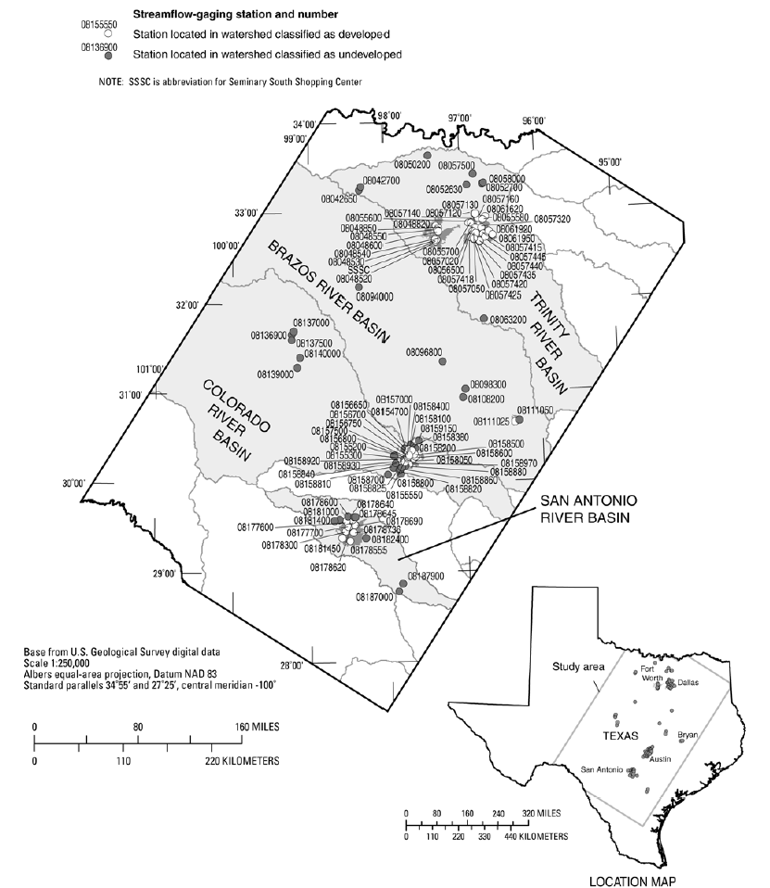
Figure 1. Locations of USGS streamflow-gaging stations represented in the database.
(Roussel and others, 2005)

Figure 2. Shaded relief map of Ash Creek watershed.
Figure 3. Empirical S-Curve and fitted unit hydrograph for Ash Creek watershed.
Figure 4. Observed and Modeled Runoff Hydrograph for Ash Creek Watershed, June 1973 storm.
Figure 5. Relation of main channel length and T_{p} for DTRM, and comparative results from inverse analysis of observed events.

Figure 6. T_{c} versus watershed area for various methods.

